**Ask Cardiff 2023**

**Residents Survey**

**REPORT**

**February 2024**



**Ask Cardiff 2023**

**Contents**

**Methodology** 1

**Response** 2

**City Life & Public Services** 4

**Your Neighbourhood** 12

**Cost of Living** 38

**Housing** 50

**Jobs & The Economy** 54

**Health & Well-being** 62

**Community Safety** 86

**Environment** 97

**Budget Priorities** 104

**Family Services & Social Care** 107

**Any Other Comments** 114

**About You** 117

**Appendix A – Attitudes to Activities & Events in Your Community by Demographic** 125

**Appendix B - How do you prefer to access information about services, events, etc?** 128

**Appendix C – What Services Delivered Within Your Local Hub / Library Do You Find Most Helpful To You?** 131

**Appendix D – Is there anything that is not available to you in your local Hub/Library that you think would be beneficial to you and your community?** 133

**Appendix E – Volunteering** 136

**Appendix F – Other Options for Social Clauses** 138

**Appendix G – Prioritising Social Clauses by Demographic & Deprivation Fifth** 140

**Appendix H - In the last 6 months, have you or anyone else in your household done any of the following because you couldn't AFFORD food by Demographic & Level of Deprivation** 144

**Appendix I – Impact of Increase in Energy Costs by Demographic & Level of Deprivation** 152

**Appendix J – How Do You Plan to Cope With The Increase in Energy Costs: Other Comments** 160

**Appendix K - Reasons for declining invitations for screening** 161

**Appendix L - Reasons for declining invitations for vaccinations** 162

**Appendix M - Community Safety: Trends** 163

**Appendix N – Community Safety: Reasons for Feeling Unsafe** 165

**Appendix O – Community Safety: What could be done to make you feel safer?** 177

**Appendix P – Breakdown of Budget Priorities** 188

**Appendix Q – What support have you accessed for your child?** 194

**Appendix R – Please tell us why you have not accessed support.** 195

**Appendix S – Any Other Comments** 196

**Appendix T – Promotion of the survey** 203

**Appendix U – Map of the Southern Arc of Cardiff** 205

# **Methodology**

Ask Cardiff is Cardiff Council’s annual resident’s survey. The 2023 survey ran from 9th October to 19th November 2023.

The survey was available in hard copy and online in English, Welsh, Arabic, Polish and Bengali, the most commonly-spoken languages in the city.

Hard copies of the survey were made available in Hubs, Libraries and community buildings across the city, and were provided to local councillors to distribute within their communities. Posters with a QR code linking directly to the online survey were also used to promote the survey in community buildings including shops and faith spaces, e.g. churches and mosques.

Respondents to the survey were invited to enter a prize draw to win one of ten £50 FOR Cardiff vouchers, four tickets to watch the Cardiff Devils or a family ticket to skate at the Winter Wonderland over the Christmas period.

The Cardiff Research Centre worked closely with partnership organisations to ensure as representative a response as possible. In a bid to ensure the survey was promoted as widely as possible, the survey was promoted via:

**a) Email**

* Organisations known to work with less frequently heard groups **(see** **Appendix T****)**
* Cardiff’s Citizen’s Panel

**b) Internet/intranet**

The survey was hosted on the Council website, and promoted to Council employees via DigiGov, Intranet and Staff Information.

**c) Social media**

The survey was promoted via Facebook and Twitter throughout the consultation period. Social media ‘boosts’ were made to selected demographics with a focus on younger people and those in the south of the city.

# **Response**

After data cleansing and validation, there were 3,187 responses to Ask Cardiff 2023, broadly reflecting that of previous surveys.

|  |  |  |  |  |  |
| --- | --- | --- | --- | --- | --- |
|  | **Ask Cardiff 2019** | **Ask Cardiff 2020** | **Ask Cardiff 2021** | **Ask Cardiff 2022** | **Ask Cardiff 2023** |
| **Total responses** | **3,834** | **4,715** | **2,704** | **3,856** | **3,187** |

Two thirds (67.6%, or 2,155) of respondents shared their postcode information. The map below shows population representation at ward level for Cardiff residents.

Those that did not provide a postcode are included in overall figures but are excluded from spatial analysis. Similarly, those that did not provide demographic information are included in the overall figures but excluded from subgroup analysis.

The response has been broken down by age, gender, ethnic background, Welsh Speakers, those with a disability, those identifying as LGBTQ+, and those living in the least or most deprived areas of the city.

In addition, the analysis includes the response from those living in the ‘Southern Arc’ of Cardiff which comprises the following electoral wards: Adamsdown, Butetown, Caerau, Canton, Ely, Grangetown, Llanrumney, Riverside, Rumney, Splott, Trowbridge (see map at Appendix U).

**Welsh Index of Multiple Deprivation**

To help gain a better understanding of the experiences and views of Cardiff residents an additional level of analysis has been introduced that looks at responses by deprivation fifth.

The Welsh Index of Multiple Deprivation (WIMD) is the official measure of small area deprivation in Wales and is designed to identify those small areas where there are the highest concentrations of several types of deprivation. Each Lower Super Output Area (LSOA) in Wales is ranked in terms of overall deprivation as well as for several separate domains, with a rank of 1 assigned to the most deprived area.

The 218 LSOAs in Cardiff are ranked from highest to lowest by their overall deprivation rank and then split into five equal bands, ranging from least deprived (i.e. least deprived 20% of LSOAs in Cardiff) to most deprived fifth (i.e. most deprived 20%). Respondents are then assigned to a deprivation fifth according to their postcode. As such, respondents from outside Cardiff or those with a missing/incomplete/incorrect postcode will be excluded from this analysis.

**Weighted Data**

Weighted Data refers to when the data collected from survey respondents are adjusted to represent the population from which the sample was drawn. The overall data for Ask Cardiff survey 2023 was weighted for some of the questions to ensure it was representative in terms of age and gender.

The weighting of the data was found to have no significant impact on the results, with the difference typically no more than one or two percentage points – something that could be explained by standard deviation and should not be cause for concern.

The strong similarity between the observed and the weighted data indicated a high level of robustness in the data collection. As a result we have chosen to report on the ‘observed’ data i.e. the actual response received.

**Section 1:**

# **City Life & Public Services**

1. **Overall, how satisfied or dissatisfied are you with Cardiff as a place to live?**

Around seven out of ten respondents (70.4%) described themselves as satisfied with Cardiff as a place to live, on a par with results from the previous two years, but remaining below levels seen during and before the pandemic.

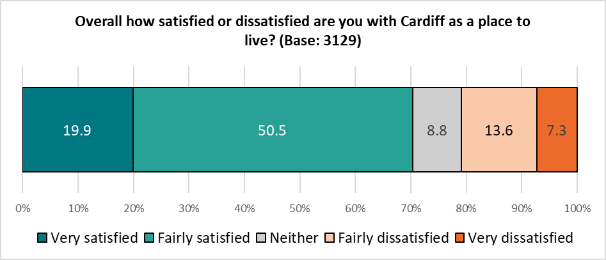

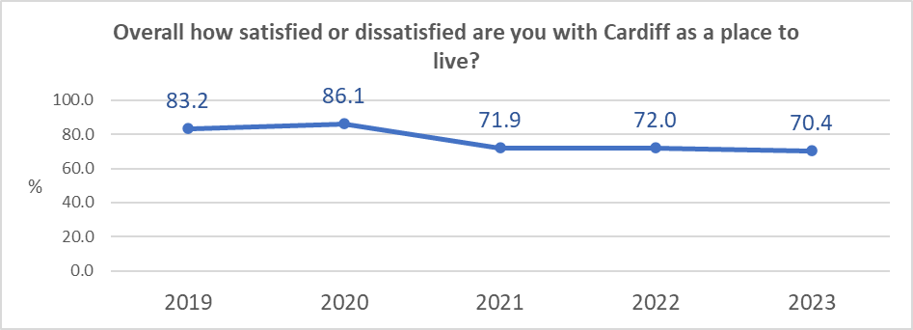

Satisfaction was highest amongst Welsh speakers (78.8%) and under 35s (77.7%); it was lowest amongst respondents who identify as disabled (66.7%) and those living in the Southern Arc (69.5%).

*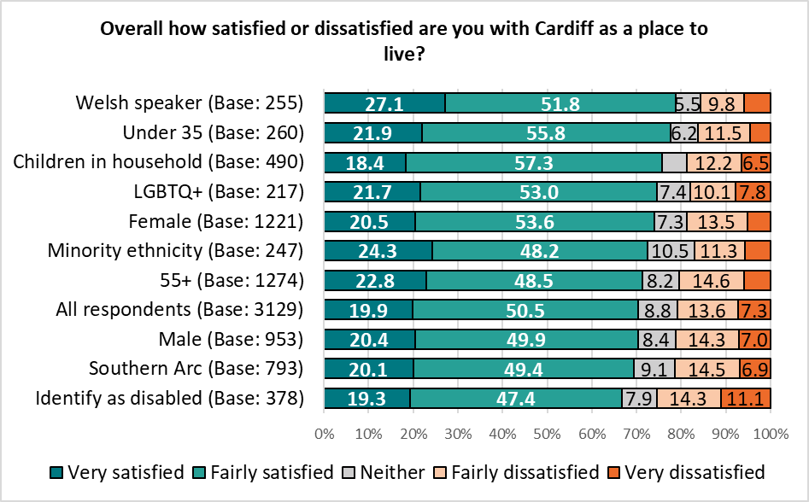 Base sizes shown in brackets; excludes ‘Don’t Know’ responses.*

There was no correlation with level of deprivation:

*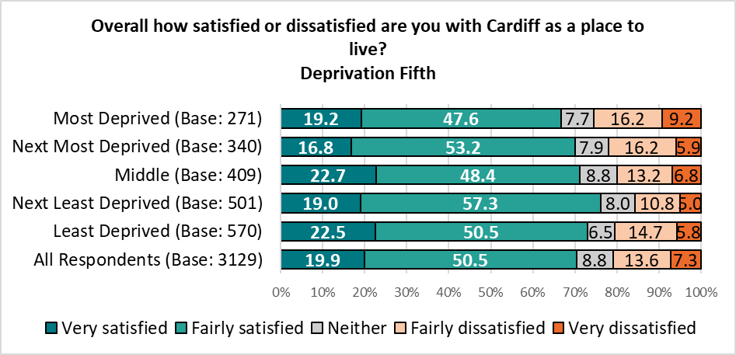Base sizes shown in brackets; excludes ‘Don’t Know’ responses.*

**2. Overall, how satisfied are you with the following?**

Following the lowest scores in a decade in the 2021 survey, satisfaction with the quality of public services in Cardiff continued to fall, with less than half of those answering this question rating themselves as ‘satisfied’ with public services (49.4%).

When asked specifically about the services the Council provides, satisfaction fell further, with 39.2% of respondents declaring themselves to be satisfied, 8.6 percentage points lower than in the 2022 Ask Cardiff survey. A fifth (19.3%) described themselves as ‘very dissatisfied’, up from 13.8% in 2022.

*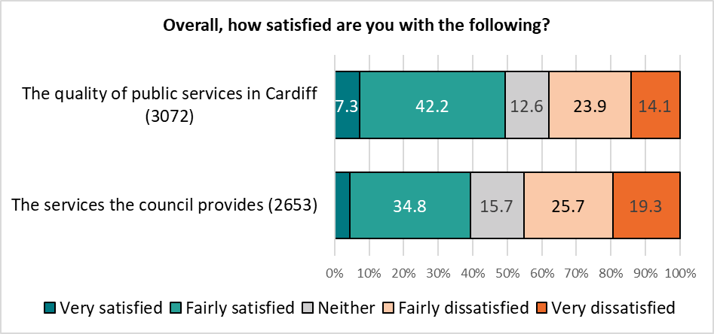 Base sizes shown in brackets; excludes ‘Don’t Know’ responses.*



Similar patterns of satisfaction were seen in other Local Authorities who had published satisfaction data, most notably in Bristol, where satisfaction fell to 34%.

*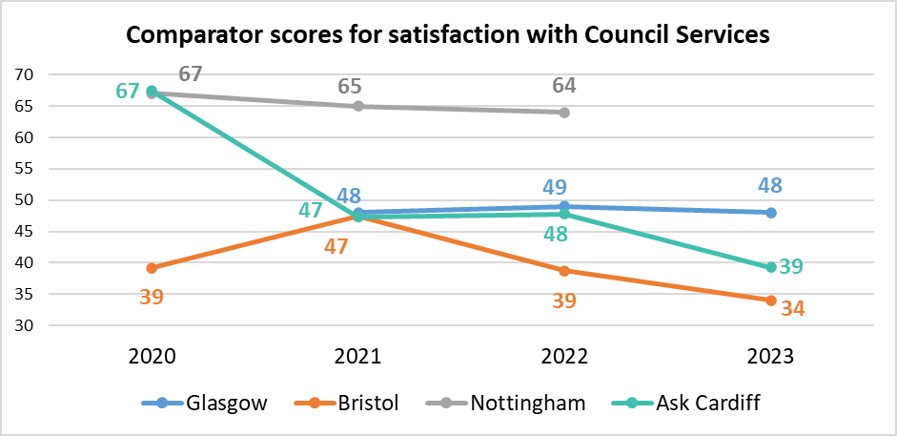No data for Nottingham in 2023 was available at the time of writing.*

There was a variation in levels of satisfaction across the different demographic groups analysed – under 35s were most satisfied with the quality of public services in Cardiff (60.9%), more than 16 percentage points higher than those who identified as disabled (44.0%). The low levels of satisfaction amongst the latter group reflects findings of previous surveys.

*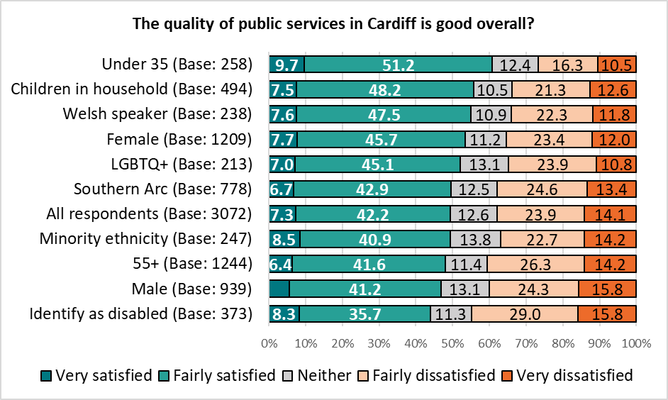Base sizes shown in brackets; excludes ‘Don’t Know’ responses.*

Respondents under the age of 35 also showed the highest levels of satisfaction with the services the council provides (53.3%, down from 58.1% in 2022), again contrasting with those identifying as disabled (34.7%, down from 40.0% in 2022), with half of this group stating they felt dissatisfied (50.6%), and more than a quarter (27.2%) ‘very dissatisfied’, increasing from 21.2% in last year’s survey.

*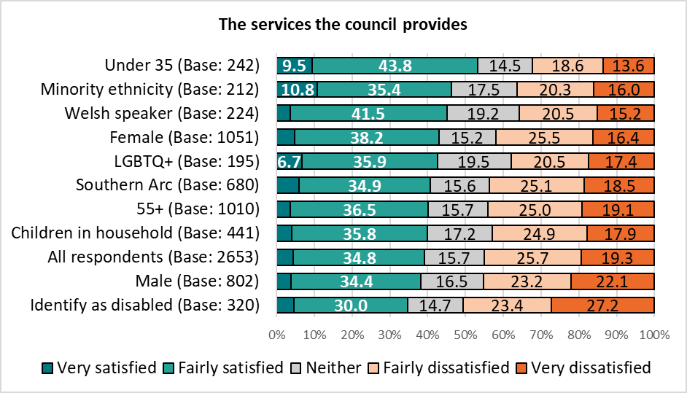Base sizes shown in brackets; excludes ‘Don’t Know’ responses*

There was no correlation with level of deprivation and satisfaction with services.

|  |  |
| --- | --- |
|  | **3. How much do you agree that the Council gives residents good value for money?** |

Three in ten respondents (30.2%) agreed that the Council gives residents good value for money, dropping from 34.9% in 2022, and the lowest level seen for ten years.

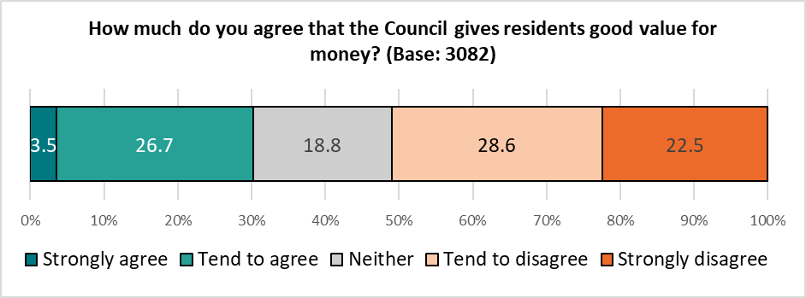

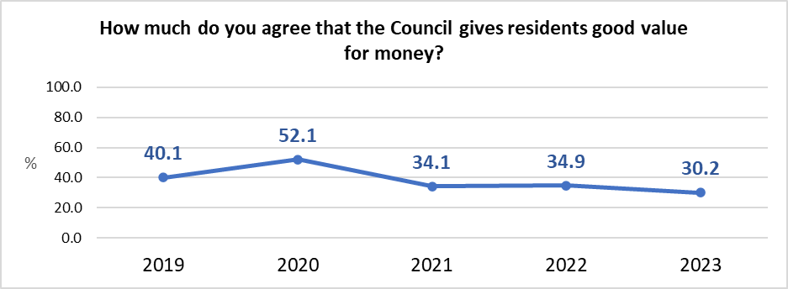

Again, this reflects other local authorities who have published data, with Cardiff Council seen to offer better value for money by its residents than Bristol and Glasgow.

*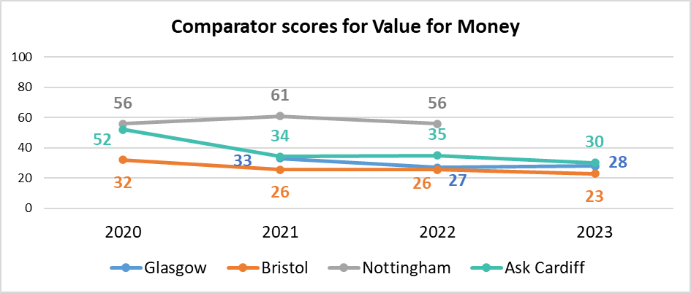 No data for Nottingham in 2023 was available at the time of writing.*

Again, younger respondents were most likely to agree that the council gives residents good value for money (45.7%, on a par with the results of the 2022 survey), whilst those identifying as disabled were most likely to disagree (56.6%, up from 52.3% in 2022).

*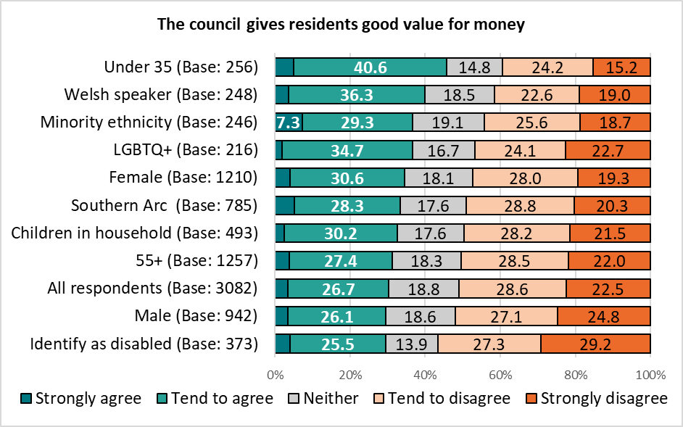Base sizes shown in brackets; excludes ‘Don’t Know’ responses.*

There was no correlation with level of deprivation.

**Section 2:**

# **Your Neighbourhood**

**4. How satisfied or dissatisfied are you with your local community as a place to live?**

Seven in ten respondents (69.6%) were satisfied with their local community as a place to live, reflecting the findings of the 2022 Ask Cardiff survey.

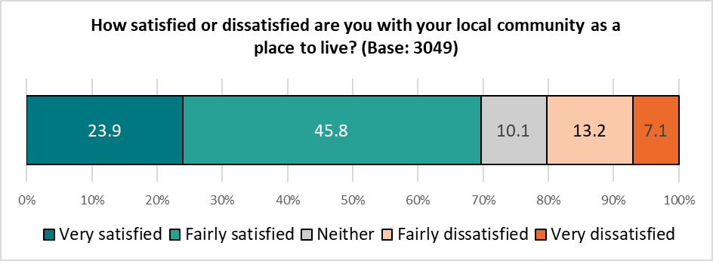

Respondents living in the least deprived areas of the city were notably more satisfied with their local community as a place to live than those in the most deprived areas - with the former more than three times more likely to describe themselves as ‘very satisfied’ than the latter (34.4% compared with 9.9% respectively), reflecting the results of the 2022 survey.

*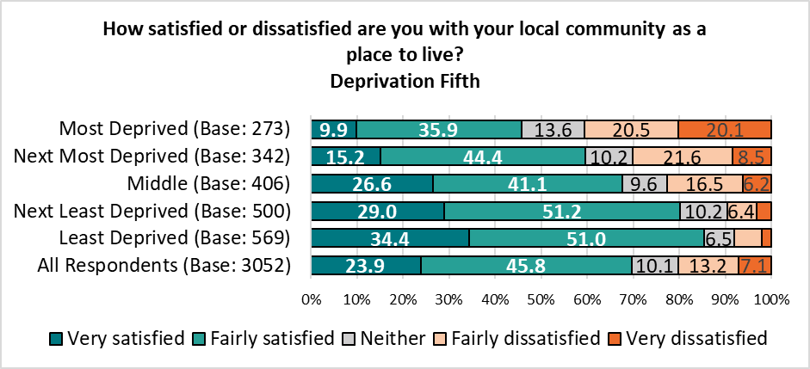Base sizes shown in brackets; excludes ‘Don’t Know’ responses.*

The proportion rating themselves as ‘satisfied’ continued to drop in the most deprived areas (fewer than half of those living in the most deprived areas feeling satisfied with their local community as a place to live, down more than ten percentage points since 2019), with the gap between the two at the widest level since the pandemic:

|  |  |  |  |
| --- | --- | --- | --- |
| Satisfaction with local community | Most deprived | Least deprived | Difference |
| 2023 | 45.8% | 85.4% | 39.6 |
| 2022 | 50.0% | 85.2% | 35.2 |
| 2021 | 56.5% | 89.3% | 32.8 |
| 2020 | 50.7% | 90.5% | 39.8 |
| 2019 | 56.5% | 89.3% | 32.8 |

Satisfaction with the local community as a place to live was highest amongst Welsh speakers (78.7%) and older respondents (74.9%); it was lowest amongst respondents living in the Southern Arc (60.5%), those identifying as disabled (63.0%) and under 35s (68.2%), broadly reflecting the results of the 2022 survey.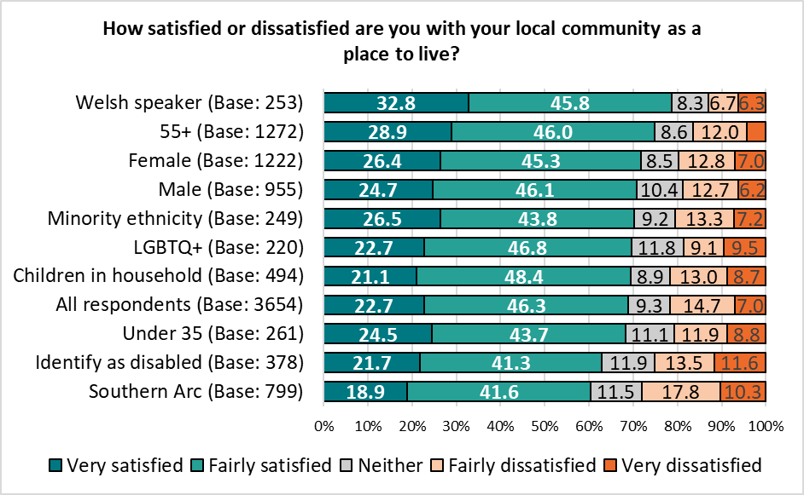*Base sizes shown in brackets; excludes ‘Don’t Know’ responses*

**5. To what extent do you agree or disagree with this statement: My neighbourhood is a place where people get on well together and help each other?**

Three in five (61.2%) of those surveyed agreed that their “neighbourhood is a place where people get on well together and help each other”, up from 49.8% in 2022 but reflecting the findings of previous surveys.

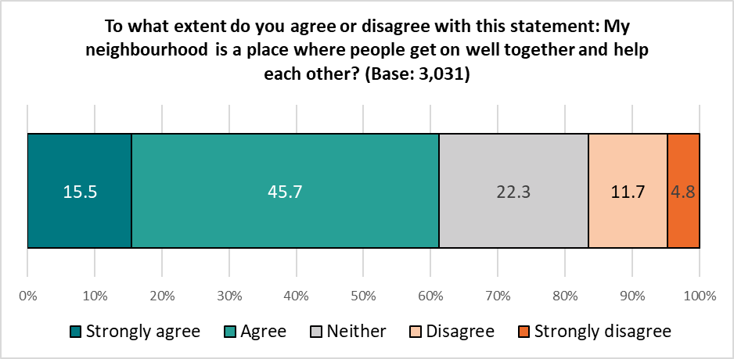

|  |  |
| --- | --- |
| % Agree |  |
| 2023 | 61.2 |
| 2022 | 49.8 |
| 2021 | 61.4 |
| 2020 | 67.2 |
| 2019 | 61.2 |

Welsh speakers (70.9%) were most likely to agree with this statement, those aged under 35 were least likely to agree (53.3%).

*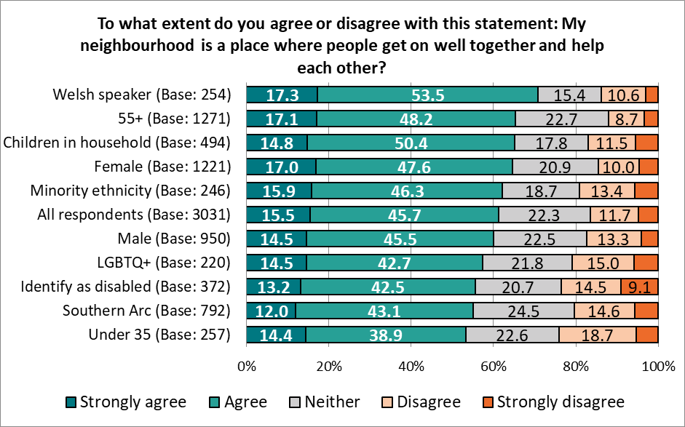Base sizes shown in brackets; excludes ‘Don’t Know’ responses.*

There was a correlation with this statement and the level of deprivation, ranging from 45.6% amongst those living in the most deprived areas to 61.3% amongst those in the least deprived areas. The gap between the two has halved from that seen in 2022 (to 15.7 from 36.0 percentage points).

*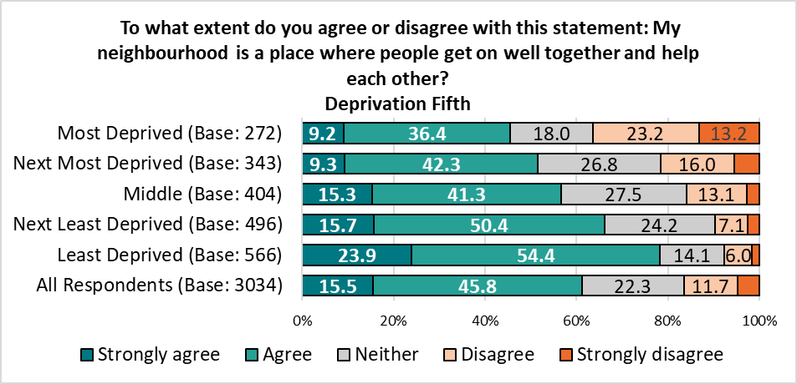 Base sizes shown in brackets; excludes ‘Don’t Know’ responses.*

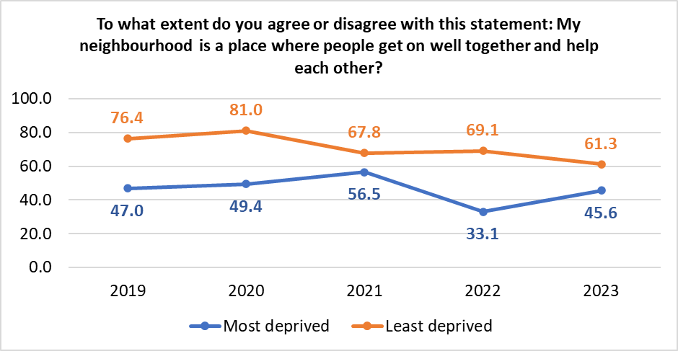

**6. To what extent do you agree that you are able to have a say on local issues or how Council services are run in your community?**

Almost a quarter of respondents (23.7%) agreed that they are able to have their say on local issues or how Council services are run in their community, reflecting the findings of the 2022 survey.

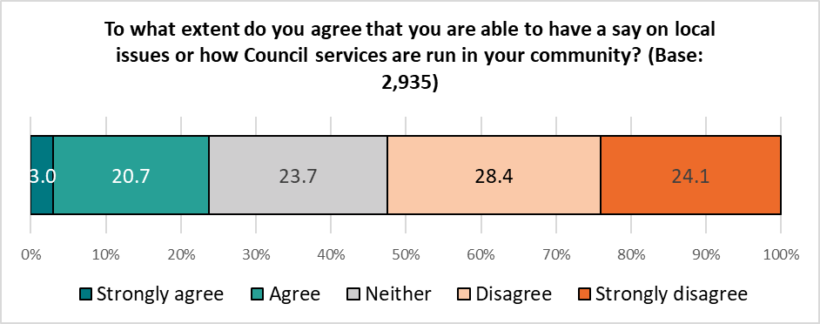

These results were broadly consistent across the different demographic and geographic groups analysed.

**7. How satisfied or dissatisfied are you with the following in your neighbourhood?**

Respondents were given a list of services and asked their level of satisfaction with each.

Reflecting previous surveys, satisfaction was highest for parks and open spaces (72.5%), Libraries/Hubs (69.2%) and street lighting (67.9%). Dissatisfaction was highest for road maintenance (65.7%), pavement maintenance (62.5%), and recycling & waste collections (59.3%, up from 30.4% in 2022, perhaps reflecting the industrial action happening whilst the survey was live).

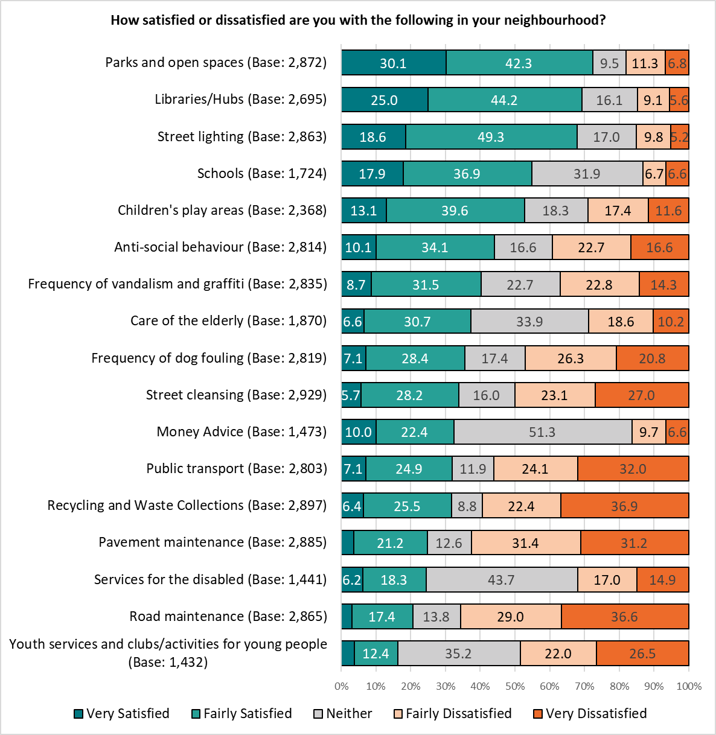

*Base sizes shown in brackets; excludes ‘Don’t Know’ responses.*

Where trend data is available, the top three services were unchanged from the previous year.

Compared with the previous year, there was an increase in satisfaction with libraries/Hubs, street lighting, dealing with anti-social behaviour, the frequency of vandalism and graffiti, and dog fouling, care of the elderly, services for the disabled and youth services.

There were notable declines in satisfaction with public transport, road maintenance and recycling and waste collections:

|  |  |  |  |  |
| --- | --- | --- | --- | --- |
|  | 2023 | 2022 | 2021 | 2020 |
| Parks and open spaces | **72.5** | 74.0 | **74.0** | 79.1 |
| Street lighting | **67.9** | **66.2** | **66.8** | 74.6 |
| Libraries/Hubs | **69.2** | 64.4 | **64.1** | 71.1 |
| Children's play areas | **52.7** | **57.5** | **52.9** | 54.0 |
| Public transport | **32.0** | **48.0** | **43.6** | 57.7 |
| Street cleansing | **33.9** | **37.3** | **39.3** | 52.3 |
| Frequency of vandalism and graffiti | **40.2** | 35.3 | **35.8** | 44.0 |
| Frequency of dog fouling | **35.5** | **30.4** | **35.0** | 36.5 |
| Anti-social behaviour | **44.2** | **39.5** | **34.3** | 38.5 |
| Care of the elderly | **37.4** | **30.9** | **32.4** | 39.8 |
| Pavement maintenance | **24.9** | 27.1 | **26.4** | 34.2 |
| Road maintenance | **20.6** | **28.8** | **23.2** | 28.8 |
| Services for the disabled | **24.4** | **16.0** | **22.0** | 27.5 |
| Youth services and clubs/activities for young people | **16.3** | 14.1 | 14.3 | 14.9 |
| Recycling and Waste Collections | **31.8** | 58.6 | - | - |

*Orange indicates a drop in the % describing themselves as satisfied compared with the previous year, teal indicates an increase in satisfaction.*

The biggest increase in satisfaction was seen for:

* Services for the Disabled, rising 8.4 percentage points from 16.0% to 24.4%.
* Care for the elderly, rising 6.5 percentage points from 30.9% to 37.4%.

The biggest drop in satisfaction was seen for:

* Recycling & Waste collections, falling 26.8 percentage points from 58.6% to 31.8%.
* Public Transport, falling 16.0 percentage points from 48.0% to 32.0%.

Amongst respondents identifying as disabled, satisfaction with services for the disabled was 19.5% (up from 12.4% in 2022), with 54.7% describing themselves as dissatisfied (down from 63.5% in 2022). This group also showed the lowest level of satisfaction with parks and open spaces (66.9%), libraries and Hubs (64.8%), street lighting (64.6%), children’s play areas (43.2%), care of the elderly (30.4%), public transport (28.1%), recycling and waste collections (25.1%), pavement maintenance (20.0%) and road maintenance (17.8%).

Respondents living in the Southern Arc showed the lowest levels of satisfaction with anti-social behaviour (34.8%), frequency of vandalism & graffiti (31.1%) and frequency of dog fouling (30.3%).

Respondents under 35 showed the highest level of satisfaction with youth services/clubs and activities for young people (33.8%).

Four of the services listed showed a correlation between satisfaction and level of deprivation, repeating the findings of the 2022 survey. There were notable gaps in satisfaction with levels of anti-social behaviour and frequency of vandalism and graffiti between the most and least deprived areas:

|  |  |  |  |
| --- | --- | --- | --- |
| % Satisfied | Most Deprived | Least Deprived | Difference |
| Anti-social behaviour | *16.9* | *64.9* | *48.1* |
| Frequency of vandalism and graffiti | *19.7* | *60.9* | *41.2* |
| Frequency of dog fouling | *21.7* | *44.3* | *22.6* |
| Street cleansing | *28.1* | *42.0* | *13.9* |

**8. To what extent do you agree with each of the following statements?**

Respondents were presented with a list of statements concerning activities and events in their neighbourhood, and asked how much they agreed with each.

Just under half of those responding (47.3%) agreed that ‘activities and events are organised in places that are accessible to me’; three in ten agreed that ‘I find the range of events and activities sufficiently varied’ (29.8%) and ‘There is enough information about activities and events in my community’ (31.5%).

An average of three in ten (30.1%) neither agreed nor disagreed with these statements.

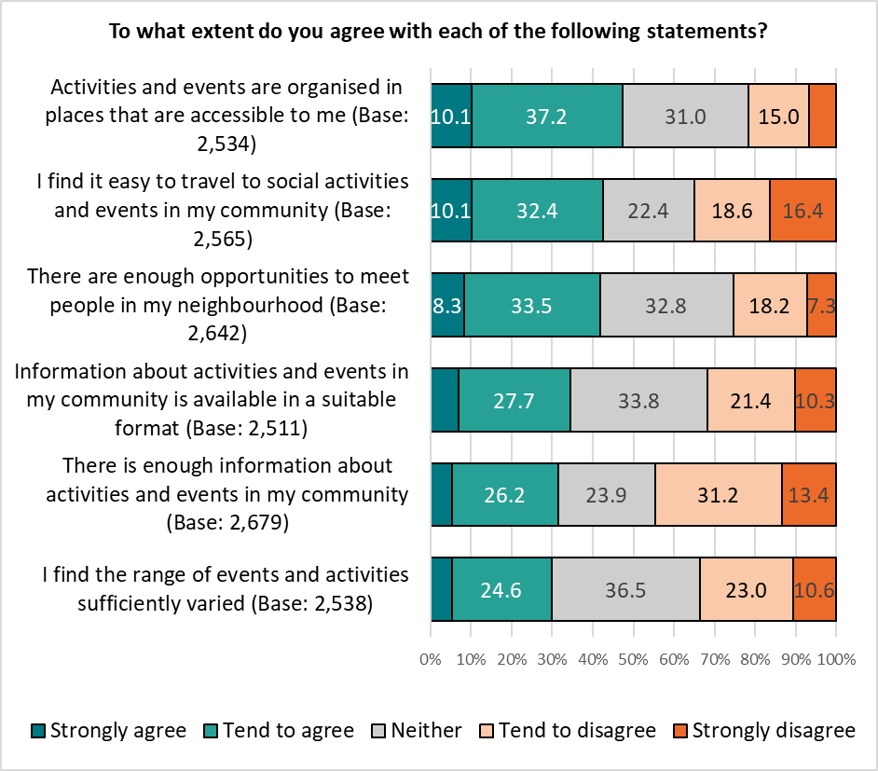

Welsh speakers were most likely to agree with each statement; those identifying as disabled were least likely to agree with each statement (see a full breakdown in Appendix A).

There was no correlation with level of deprivation.

**9. How do you prefer to access information about services, events, etc?**

Respondents were presented with a range of methods, both digital and non-digital, of accessing information about services, events and so on, and asked which they preferred to use.

The top three preferred means of accessing information – websites (73.1%), email (55.8%) and social media (54.4%) – were all digital, with just 3.9% of respondents indicating they ‘don’t want to / can’t access information digitally’. [Note: most respondents completed the survey digitally.]

Half of those answering this question indicated a preference for ‘posters/flyers/leaflets in community buildings’ (49.8%).

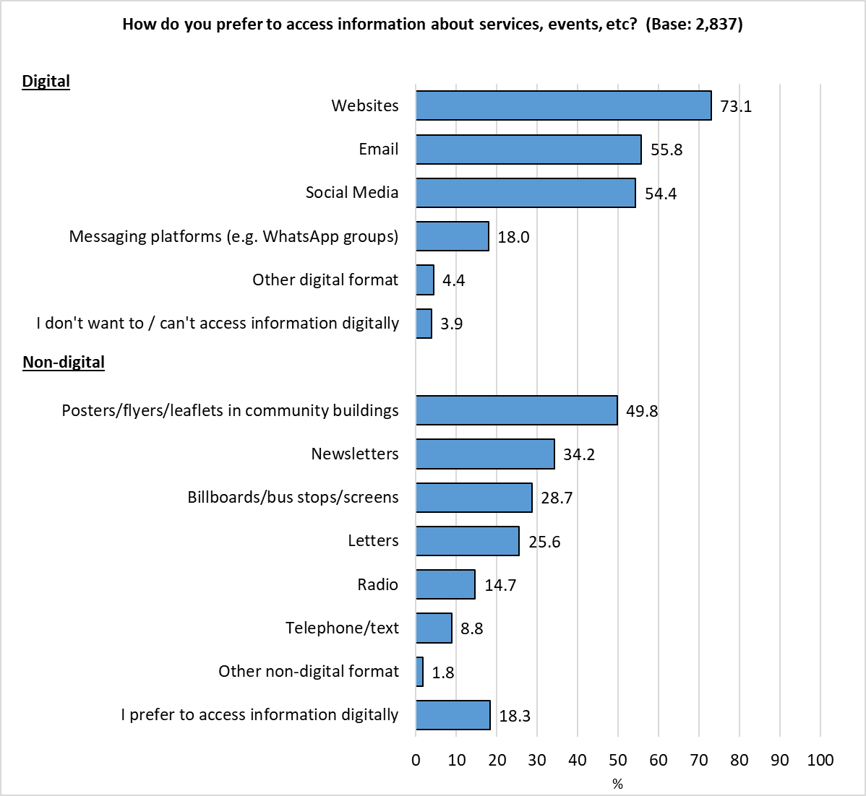

Those answering ‘Other digital format’ were asked to specify how else they would like to access information; 25 responses were received, and grouped into themes:

* Non-digital formats (9 responses)
* Council App (4 responses)
* Social media (3 responses)
* Newsletters (3 responses)
* Chatbot (3 responses)
* Text / SMS (2 responses)
* TV (1 response)

Those answering ‘Other non-digital format’ were also asked to specify how else they would like to access information; 30 responses were received, and grouped into themes:

* Local media (17 responses)
* Posters / Flyers / Leaflets (8 responses)
* Post (5 responses)
* In person (2 responses)
* By phone (2 responses)
* Paper documents in Hubs (1 response)
* Roadside adverts (1 response)
* Council Newspaper (1 response)

Results were generally consistent across the demographic groups analysed, although there were some notable differences by age and sex:

* Websites were the main source of information for all groups analysed, with the exception of under 35s, who were most likely to use social media (73.0%, compared with 69.6% of this group stating websites)
* Younger respondents were more likely to look for information via billboards/bus stops/screens (38.8%)
* They were half as likely as those over 55 to state they chose not to or were unable to access information digitally (2.3% compared with 4.6% respectively); just 0.4% of under 35s wanted information via another non-digital format
* Older respondents were more likely to state ‘email’ (62.7%)
* Women were more likely than men to access information via social media (61.2% compared with 42.6% respectively), posters/flyers/leaflets in community buildings (58.1% compared with 40.4%) and billboards/bus stops/screens (33.5% compared with 25.0%)

Just two of the means of accessing information listed correlated with level of deprivation, namely social media and letters, with those living in the most deprived areas most likely to select these options.

This group was least likely to state that they prefer to access information digitally (12.9%).

A full breakdown of results by demographic and level of deprivation is available in Appendix B.

**Do you have access to affordable broadband?**

Almost all respondents (93.1%) reported having they had access to affordable broadband at home, with 9.5% accessing it elsewhere. One in twenty (5.4%) reported having no access to affordable broadband.

*Respondents could select multiple options so the total will exceed 100%.*

This pattern was consistent across the demographic groups analysed. Looking at results by level of deprivation showed just 1.9% of respondents living in the most affluent areas of the city had no access to affordable broadband, less than a third of the level seen in the most deprived areas.

|  |  |  |  |  |  |  |
| --- | --- | --- | --- | --- | --- | --- |
|  | All Respondents | Least Deprived | Next Least Deprived | Middle | Next Most Deprived | Most Deprived |
| Base | **2,824** | **571** | **501** | **405** | **344** | **268** |
| Yes, at home | *93.1* | *97.2* | *94.2* | *92.6* | *93.0* | *89.9* |
| Yes, elsewhere | *9.5* | *8.6* | *9.6* | *9.9* | *12.5* | *11.2* |
| No | *5.4* | *1.9* | *4.2* | *5.9* | *6.7* | *6.7* |

**10a. Did you visit a library or Hub in the last 12 months?**

Almost two-thirds of respondents (64.4%) reported that they had visited a library or Hub in the last 12 months, a rise of 12 percentage points compared with 2022, but still ten percentage points below the pre-pandemic level.

*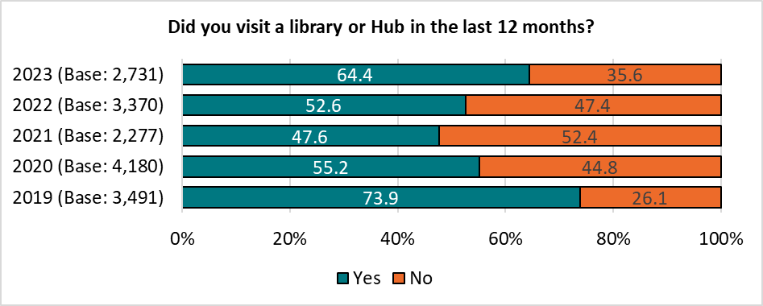Base sizes shown in brackets.*

Respondents with children in their household were most likely to have visited a library or Hub (73.4%, up by ten percentage points from the figure seen in 2022).

*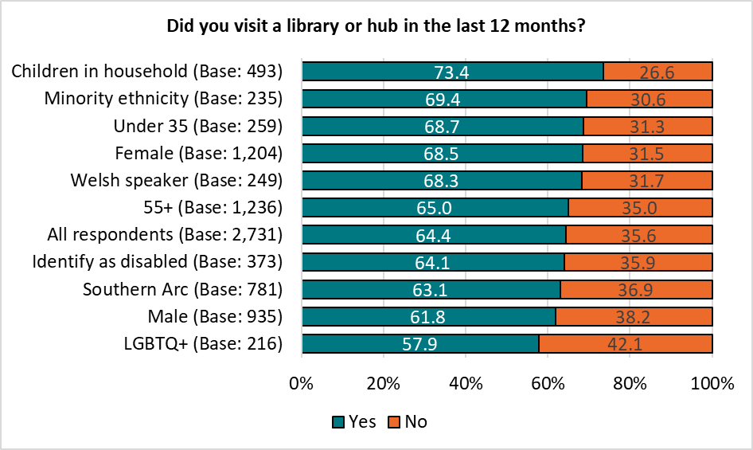 Base sizes shown in brackets.*

There was no correlation with likelihood to have visited a library or Hub with level of deprivation.

**10b. What services delivered within your local Hub/Library do you find most helpful to you?**

Respondents were given a list of services delivered within their local Hub/library, and asked to indicate which they found most helpful.

Just over a quarter (28.1%) of respondents found none of the services to be helpful, lower than the proportion stating they had not visited a Hub or library over the previous year.

Of the services listed, the three most helpful were unchanged from the previous year - ‘Book loan’, selected by 32.1% of respondents, followed by ‘community events’ (10.8%), and ‘children’s activities, including story and rhyme time’ (8.9%).

*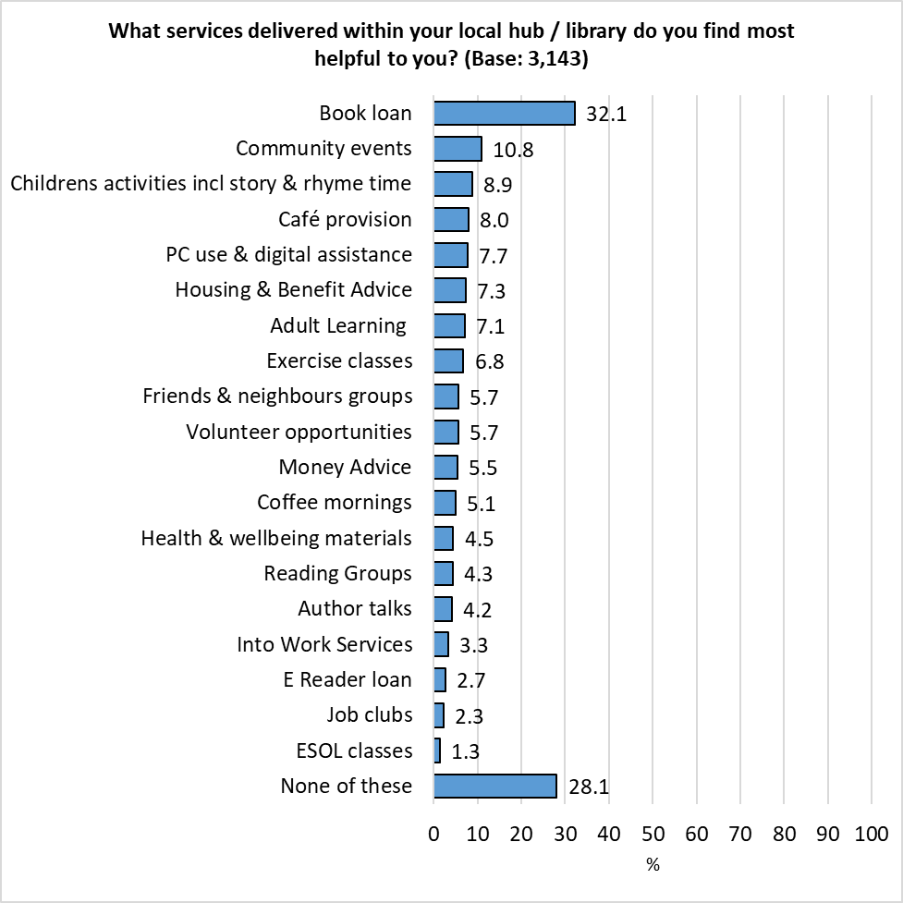Respondents could select multiple options so the total will exceed 100%.*

There were some differences by demographic and level of deprivation:

Males were most likely to state they found ‘none’ of the services listed helpful (34.1%), those from a minority ethnicity were least likely to do so (15.3%).

Respondents with children in their household were most likely to cite book loans (44.2%) and children’s activities (29.0%) repeating the findings of the 2022 survey.

Those identifying as disabled were most likely to find housing and benefit advice helpful (16.3%).

Money advice was seen as more helpful amongst respondents from a minority ethnicity (14.5%) and those under 35 (10.8%).

Respondents from minority ethnicities were most likely to find Adult Learning (14.9%), Into Work Services (12.9%), exercise classes (10.4%), coffee mornings (8.4%), Job Clubs (7.6%) and e-reader loans (6.8%) helpful.

A full breakdown is available in Appendix C.

The proportion of respondents reporting they found the following services to be helpful were correlated with level of deprivation, with those living in the most deprived areas finding them to be more helpful:

|  |  |  |
| --- | --- | --- |
|  | Most Deprived (Base: 268) | Least Deprived (Base: 568) |
| Housing & Benefit Advice | *18.3* | *2.5* |
| PC use & digital assistance | *14.6* | *6.7* |
| Money Advice | *13.8* | *1.8* |
| Into Work Services | *9.0* | *0.9* |

**Is there anything that is not available to you in your local Hub/Library that you think would be beneficial to you and your community?**

Respondents were invited to make suggestions on additional services or facilities not currently available in their local Hub/Library; 439 responses were received, and grouped into themes, with the top three shown below. A full breakdown is available in Appendix D.

|  |  |  |  |
| --- | --- | --- | --- |
| Theme | No. | % | Example Comments |
| Better Variety for  Young / Old / Vulnerable | 79 | *18.0* | * *More activities and groups for pensioners* * *Local groups using it like U3A.* * *Youth Club* * *More mum and baby groups, that don't require booking (drop in)* |
| There is no local Hub/Library - No access | 66 | *15.0* | * *The library is closed and has been for some time, and I am not aware of any hub.* * *No local Hub* * *It would be useful to actually have one in the area.* * *I don't know where the local hub is* |
| Community Activities / Groups | 48 | *10.9* | * *Cultural activities and space for cultural communities to meet* * *More social groups also libraries are so sparse within the city there needs to be more centres* * *Organise walking groups and confidence building / using a bike* |

**Did you know for a small charge you can hire rooms within your local Community Hub i.e. meetings, birthday parties, etc?**

Just a third of respondents (34.7%) were aware that rooms in Community Hubs were available for hire. This was consistent across the demographic and geographic groups analysed.

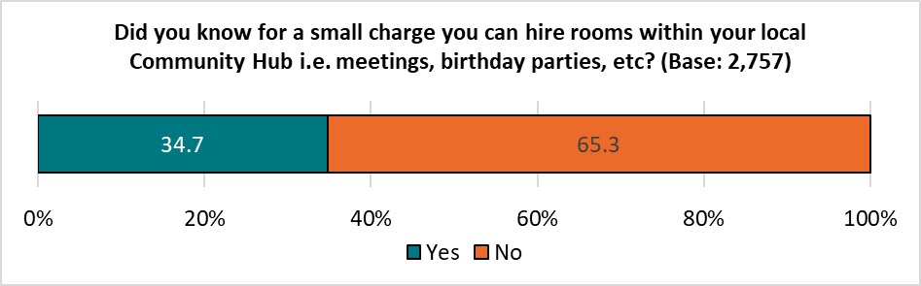

**11. Do you currently volunteer?**

Overall, around a quarter (27.8%) of respondents said they currently volunteer, on a par with the 2022 findings – this rose to 34.9% respondents aged 55 or older, and fell to 19.5% of under 35s.

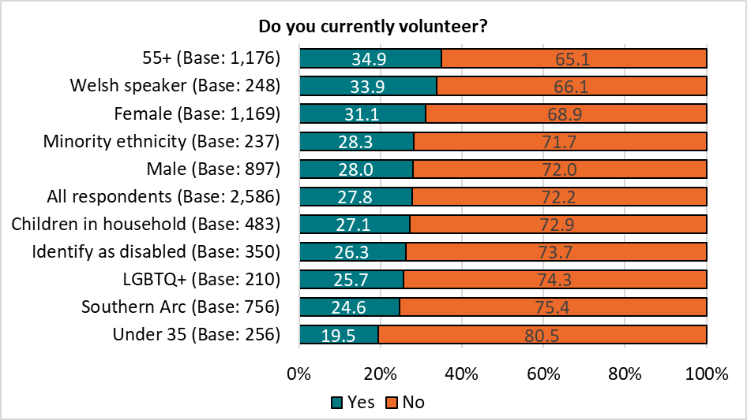*Base sizes shown in brackets.*

Respondents living in the least deprived areas were more likely to volunteer than those in the most deprived areas (34.6% compared with 23.8% respectively), again reflecting previous findings.

*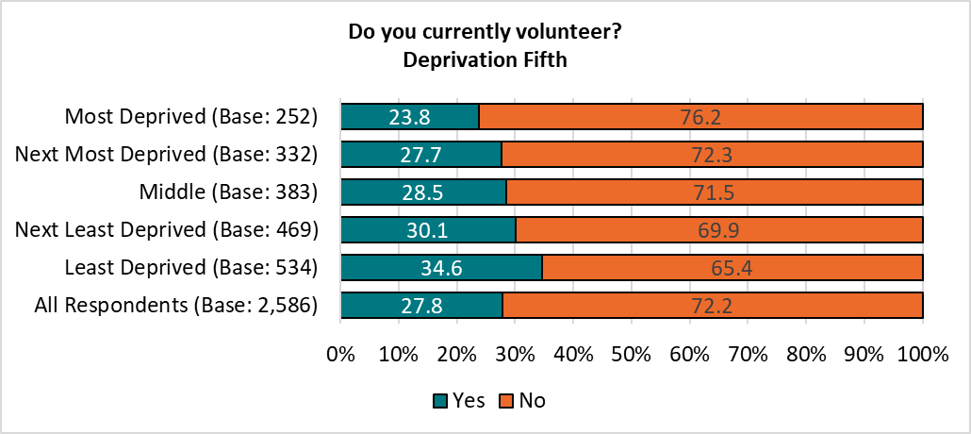Base sizes shown in brackets.*

**Listed below are a number of ways that you could contribute to the wellbeing of your community. Please tell us if you are, or would like to be, involved in each of the following:**

Respondents were most likely to already be involved ‘learning more about how to reduce your carbon footprint’ (16.5%) and Community Volunteering (15.2%).

Of the volunteering opportunities listed, those generating the most interest for future volunteering opportunities were:

* *Community Volunteering (20.2%)*
* *Improving community safety as part of Neighbourhood Watch (19.9%)*
* *Learning more about how to reduce your carbon footprint (18.5%)*

A total of 1,241 respondents expressed an interest in getting involved in contributing to the wellbeing of their community, of whom 870 provided contact details for further information to be sent to them. This has been passed to the relevant teams to take further action.

*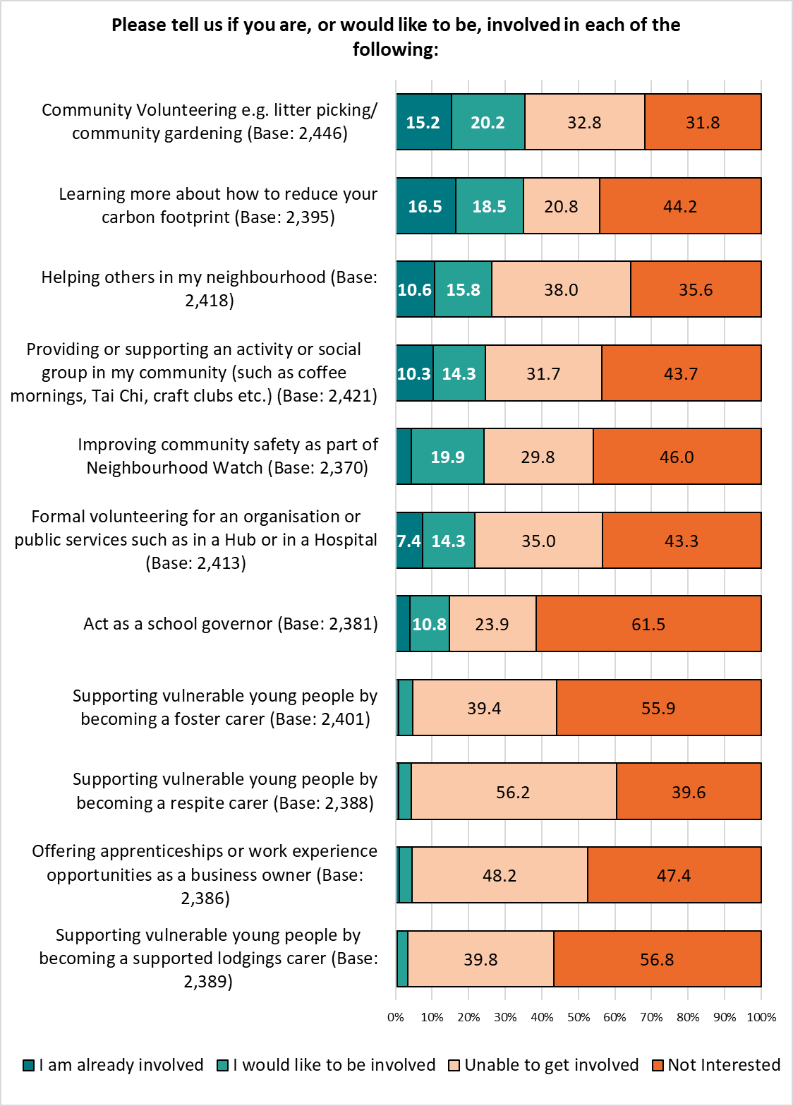 Base sizes shown in brackets; excludes ‘Don’t Know’ responses.*

Respondents were invited to give details of other volunteering opportunities they would be interested in getting involved with – 181 comments were received, and grouped into themes. The top three themes are shown below, with a full breakdown in Appendix E.

|  |  |  |  |
| --- | --- | --- | --- |
| Theme | No. | % | Example Comments |
| Too busy / old / poorly to volunteer | 36 | *19.9* | * *Too busy at work to be able to volunteer* * *I’m the one that needs some help, I’m in my 70’s* * *I can't get involved until the NHS get around to replacing my knees!* |
| Community / Culturally focused | 22 | *12.2* | * *You've failed to mention Local History groups or Family history Societies* * *Urban gardening in Splott and creating activities to encourage a garden festival i.e. Splott in Bloom* |
| Education / Training | 17 | *9.4* | * *Teaching music and art* * *Education volunteering* |

**12. Cardiff Council procures an average of £580 million in goods and services from both the private and voluntary sectors every year, by inviting them to ‘tender’ or bid for this work.**

**As part of the Welsh Government’s Social Partnership & Procurement Act, the Council is able to include ‘social clauses’ in tenders. This means that companies bidding for work valued at £250,000 or more (such as building new schools) are required to make opportunities available for local communities. These can be considered when choosing who to appoint to do the work.**

**Whilst specific details will vary by the needs of individual projects, as a general rule, which of the following options would you prefer to be made available to local communities? Please select your top three priorities.**

Respondents were given a list of options for ‘social clauses’ for the benefit of the local community that the Council could include as part of tenders for large-scale projects, and asked to select the three that they would like to prioritise.

More than half (53.6%) prioritised ‘Training opportunities, Apprenticeships, Job Opportunities and Work Placements’, followed by ‘Supporting communities i.e. community safety, tackling homelessness and health & well-being initiatives’, prioritised by 48.5% of respondents.

Of the options listed, ‘Promoting Welsh culture and language’ received the least support, with 10.8% of respondents rating this as one of their top three priorities.

Respondents were also able to suggest their own priority; 89 comments were received and grouped into themes. The top three are shown below, with a full list available in Appendix F.

|  |  |  |  |
| --- | --- | --- | --- |
| Theme | No. | % | Example Comments |
| More Localised Support / Community Activities / Groups | 15 | *16.9* | * *Community wealth building and supporting a strong local supply chain* * *There is nothing in our local community Pontprennau. No cafes no little shops just massive supermarkets. No community.* * *Supporting community through a local church* |
| Greater Support / Services for the Elderly / disabled / vulnerable | 13 | *14.6* | * *Providing appropriate care and support for disabled people* * *Help for veterans* * *Day centre for lonely OAPs* |
| Health / Well-being | 12 | *13.5* | * *NHS and GP services* * *Providing private health services e.g. physiotherapy* |

*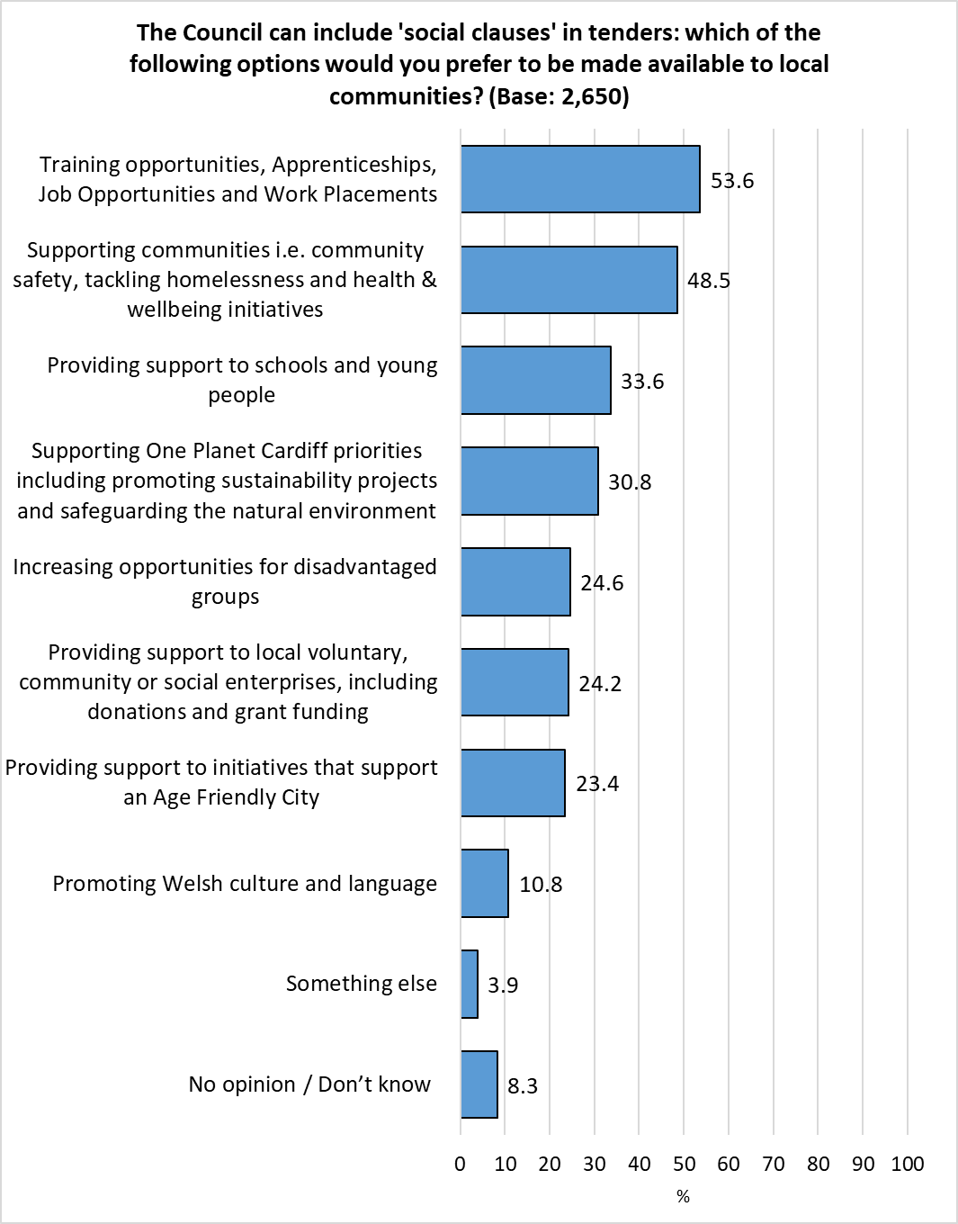 Respondents could select multiple options so the total will exceed 100%.*

Younger respondents were most likely to prioritise ‘Supporting communities i.e. community safety, tackling homelessness, and health & well-being’ (60.1%), ‘Supporting One Planet Cardiff priorities, including promoting sustainability projects and safeguarding the natural environment’ (41.1%) and ‘Increasing opportunities for disadvantaged groups’ (33.7%).

Older respondents were most likely to prioritise ‘Providing support to initiatives that support an Age Friendly City’ (31.4%).

Over two-fifths of Welsh speakers prioritised ‘Promoting Welsh culture and language’ (43.9%), four times the overall figure.

Just one of these options was correlated with level of deprivation – those living in the most deprived areas were most likely to prioritise ‘Supporting communities’.

A full breakdown of results by demographics is available in Appendix G.

**Section 3:**

# **Cost of Living**

**13. In the last 6 months, have you missed paying rent or mortgage payments?**

Overall, 3.7% of respondents reported missing rent or mortgage payments over the past 6 months, reflecting the findings of the previous year.

As in 2022, those living in the most deprived areas were almost ten times more likely to answer ‘Yes’ than those in the least deprived areas. The proportion of those in the most deprived areas who had missed payments almost doubled, from 5.3% in 2022 to 9.3% in 2023.

|  |  |  |
| --- | --- | --- |
| Missed Payments | 2023 | 2022 |
| Most deprived | 9.3 | *5.3* |
| Next most deprived | *4.3* | *3.4* |
| Middle | 2.9 | *3.2* |
| Next least deprived | 3.0 | *2.3* |
| Least deprived | 1.1 | *0.5* |
| All respondents | 3.7 | *3.1* |

Of the demographic groups analysed, respondents identifying as disabled were, again, most likely to report missing rent or mortgage payments (increasing from 6.9% in 2022 to 9.5% in 2023), followed by those under the age of 35 (6.4%). Welsh speakers and men were least likely to answer ‘Yes’ (1.5% and 1.9% respectively).

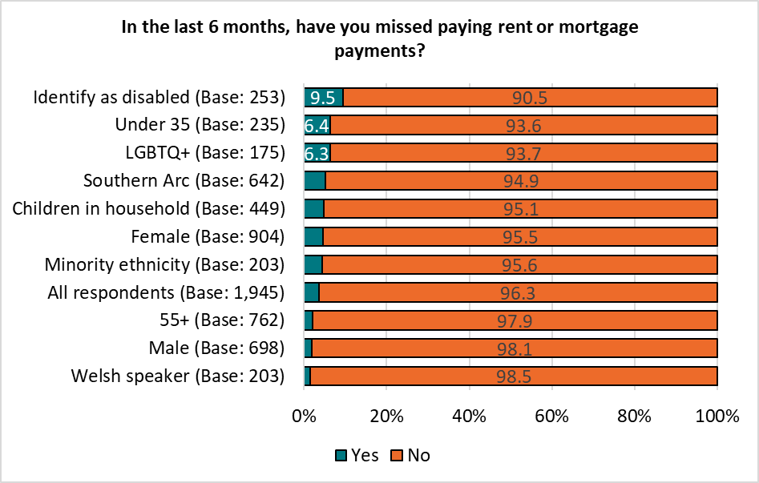

**14. In the last six months, have you or anyone else in your household done any of the following because you couldn't AFFORD food:**

Compared to the 2022 survey results, there was a slight increase in the proportion of respondents ‘eating smaller meals than usual, or skipping meals’ (to 16.2%) or ‘missed meals to afford to pay your bills’ (to 7.5%).

|  |  |  |  |  |
| --- | --- | --- | --- | --- |
| % | 2023 | 2022 | 2021 | 2020 |
| Had smaller meals than usual, or skipped meals | *16.2* | *15.6* | *9.6* | *8.0* |
| Missed meals to afford to pay your bills | *7.5* | *5.9* | *-* | *-* |
| Been hungry but not eaten | *6.2* | *5.8* | *5.2* | *5.2* |
| Not eaten for a whole day | *3.4* | *3.5* | *2.5* | *3.4* |
| Received food from a food bank or charity | *2.5* | *2.6* | *1.8* | *1.6* |

Around a third of respondents who identified as disabled (34.7%) or were under the age of 35 (32.6%) reported at least one of the options listed because they hadn’t been able to afford food in the last six months.

The proportion of respondents under 35 reporting they had ‘missed meals to afford to pay their bills’ almost doubled, from 7.0% in 2022 to 12.8% in 2023.

One in twelve of those identifying as disabled (8.8%) reported that they had ‘not eaten for a whole day’ – the highest proportion of all demographic groups analysed.

Respondents over the age of 55 were most likely to report they had done ‘none’ of the options listed (86.9%).

|  |  |  |
| --- | --- | --- |
|  | Identify as disabled | Under 35 |
| Base | **377** | **258** |
| Had smaller meals than usual, or skipped meals | *27.6* | *28.3* |
| Been hungry but not eaten | *13.0* | *14.3* |
| Not eaten for a whole day | *8.8* | *5.8* |
| Missed meals to afford to pay your bills | *15.6* | *12.8* |
| Received food from a food bank or charity | *4.2* | *3.1* |
| None of these | *65.3* | *67.4* |

There was a correlation with those unable to afford food and the level of deprivation:

|  |  |  |  |  |  |  |
| --- | --- | --- | --- | --- | --- | --- |
|  | Most Deprived | Next Most Deprived | Middle | Next Least Deprived | Least Deprived | All Respondents |
| At least one of the actions listed | *36.8* | *21.8* | *18.1* | *15.3* | *9.0* | *20.1* |

Respondents living in the most deprived areas of the city were notably more likely to report having been impacted by not being able to afford food, with 29.7% ‘eating smaller meals, or skipping meals’ completely; more than one in six (17.5%) ‘missed meals to be able to pay bills’; one in seven (14.5%) had ‘been hungry but not eaten’.

The proportion of those in the most deprived areas reporting they had *not ‘*eaten for a whole day*’* (6.3%) or ‘received food from a food bank or charity’ (4.5%) fell compared with the 2022 survey findings.

|  |  |  |  |  |
| --- | --- | --- | --- | --- |
|  | 2023 | | 2022 | |
|  | **Most deprived** | **Least deprived** | **Most deprived** | **Least deprived** |
| Had smaller meals than usual, or skipped meals | *29.7* | *8.1* | *28.4* | *6.5* |
| Missed meals to afford to pay your bills | *17.5* | *2.0* | *15.5* | *1.0* |
| Been hungry but not eaten | *14.5* | *2.7* | *14.0* | *1.3* |
| Not eaten for a whole day | *6.3* | *0.7* | *10.2* | *0.2* |
| Received food from a food bank or charity | *4.5* | *0.5* | *7.2* | *0.3* |

A full breakdown of these questions broken down by demographics is available in Appendix H.

**In the last 6 months, have you or anyone in your household…?**

Just over half of those responding to this question (52.9%) reported they had not taken any steps to deal with increasing energy costs, up from 48.8% in 2022. More than two in five (43.9%) had ‘purposely not put the heating on because of the cost’, and almost one in seven respondents (13.7%) had ‘struggled to pay gas and/or electric bills’.

|  |  |  |
| --- | --- | --- |
|  | No. | % |
| Purposely not put the heating on because of the cost | 1,146 | 43.9 |
| Struggled to pay gas/electric bills | 358 | 13.7 |
| Applied for support to pay for gas/electric | 56 | 2.1 |
| Been cut off from the electricity/gas supply | 14 | 0.5 |
| Received fuel vouchers from a charity | 14 | 0.5 |
| None of these | 1,383 | 52.9 |
| Total Respondents | 2,612 | - |

*Respondents could select multiple options so the total will exceed 100%.*

As in 2022, older respondents and men were most likely to report they had not taken any of the actions listed with regard to coping with rising energy prices; younger respondents, those with children in the household and respondents identifying as disabled were most likely to state they had done at least one of the options listed in response to rising energy costs.

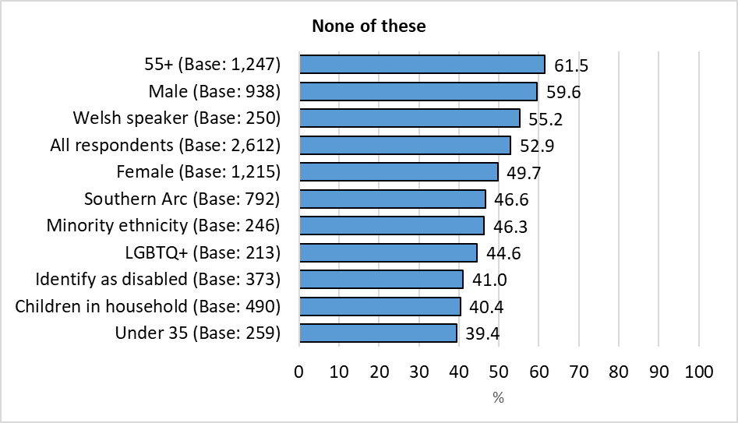

Whilst not directly correlated with level of deprivation, those living in the most deprived areas were least likely to state they had done none of the options listed, with those in the least deprived areas most likely to do so.

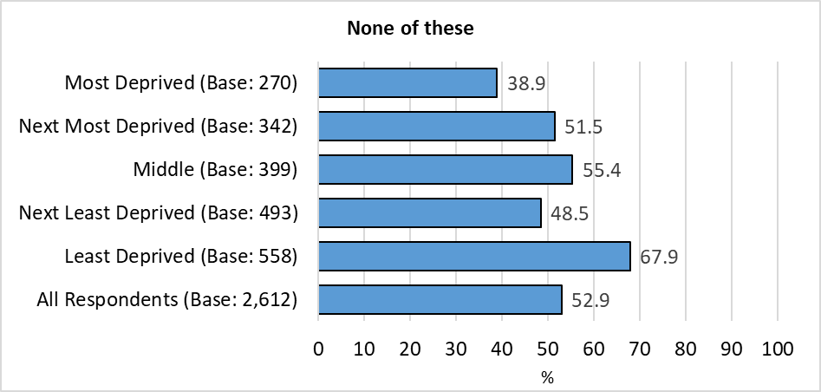

The proportion of respondents living in the most deprived areas of the city who had applied for support to pay their energy bill halved, from 10.0% in 2022 to 4.8% in 2023.

A full breakdown of these questions broken down by demographics is available in Appendix I.

**How will you/your household cope with the expected increase in energy costs this winter?**

Respondents were given a list of options, and asked how they planned to cope with the expected increase in energy costs.

A third of respondents (35.3%) reported they ‘can afford the increase in energy cost’, up from 28.6% in 2022.

More than half (54.5%) said they would ‘significantly cut down on heating’, down from 62.5% in last year’s survey; one in seven (15.4%) planned ‘not to use their heating at all’. One in ten (9.8%) would ‘cut out other essentials such as food’.

|  |  |  |
| --- | --- | --- |
|  | No. | % |
| Significantly cut down on heating | 1,419 | 54.5 |
| I can afford the increase in energy cost | 919 | 35.3 |
| Not use the heating | 401 | 15.4 |
| Cut out other essentials such as food | 255 | 9.8 |
| Borrow money/pay on credit card | 165 | 6.3 |
| Other | 148 | 5.7 |
| Total Respondents | 2,604 | - |

*Respondents could select multiple options so the total will exceed 100%.*

Those answering ‘Other’ were asked to say how they planned to cope with the increase in energy costs; 42 responses were received and grouped into themes. The top three themes are shown below, with a full breakdown in Appendix J.

|  |  |  |  |
| --- | --- | --- | --- |
| Theme | No. | % | Example Comments |
| Make Savings - use less energy - reduce outgoings | 22 | *52.4* | * *Socialise less and eat cheaper food* * *Saving but costs are largely for standing charges not gas for heating (£100-ish)* * *Reduce the time my heating is on. switch off radiators not in use. Keep the thermostat around 20 or below. Wrap -up warm.* * *heat 1 room and then the children's room when they go to bed.* |
| Doesn't affect me | 6 | *14.3* | * *We have a log burner* * *Anticipated increase in pension* * *I'm on a fixed rate - set before the increases - for another year. After then, who knows?* |
| I cannot afford increase | 6 | *14.3* | * *We need to insulate our house, but can’t afford that yet - so cardboard on the floors in the kitchen, thick curtains and blankets for now and hot water bottles* * *not sure how to cope* |

More than half of every group analysed stated they would ‘significantly cut down on heating’, with the exception of men (46.9%).

Respondents identifying as disabled were most likely to report they would ‘significantly cut down on heating’ (63.9%) or that they would ‘cut out other essentials such as food’ (19.9%), and were least likely to feel they ‘can afford the increase in energy cost’ (20.5%).

Respondents aged 55 or over were notably more likely than those under the age of 35 to say they can ‘afford the increase in energy cost’ (42.7% compared with 27.7% respectively).

Respondents with children in their household and those under 35 were most likely to ‘borrow money or use a credit card’ to pay their energy bills (12.9% and 11.5% respectively).

A quarter (26.2%) of those aged under 35 stated they would ‘not use the heating’.

|  |  |  |  |  |  |  |
| --- | --- | --- | --- | --- | --- | --- |
|  | Base | Not use the heating | Significantly cut down on heating | Cut out other essentials such as food | Borrow money / pay on credit card | I can afford the increase in energy cost |
| Identify as disabled | **371** | *24.0* | *63.9* | *19.9* | *10.0* | *20.5* |
| LGBTQ+ | **217** | *16.6* | *58.1* | *13.8* | *7.8* | *32.7* |
| Under 35 | **260** | *26.2* | *55.8* | *14.2* | *11.5* | *27.7* |
| Children in household | **496** | *19.6* | *59.5* | *14.7* | *12.9* | *26.6* |
| Female | **1218** | *15.8* | *59.3* | *11.2* | *7.8* | *30.2* |
| Southern Arc | **790** | *18.2* | *60.0* | *13.2* | *8.9* | *29.5* |
| Minority ethnicity | **245** | *17.1* | *53.5* | *15.1* | *8.6* | *28.6* |
| All respondents | **2604** | *15.4* | *54.5* | *9.8* | *6.3* | *35.3* |
| Welsh speaker | **248** | *8.5* | *59.3* | *8.5* | *5.2* | *39.9* |
| 55+ | **1248** | *10.1* | *50.6* | *6.0* | *2.1* | *42.7* |
| Male | **932** | *12.2* | *46.9* | *7.0* | *4.2* | *45.8* |

There were correlations between respondents stating they would take action to cope with the expected increase in energy costs and level of deprivation, with those living in the most deprived areas of the city most likely to not use or cut down use of the heating, cut out other essentials or borrow money to pay the bill; they were least likely to feel they could afford the increase:

|  |  |  |  |  |  |  |
| --- | --- | --- | --- | --- | --- | --- |
|  | Base | Not use the heating | Significantly cut down on heating | Cut out other essentials such as food | Borrow money / pay on credit card | I can afford the increase in energy cost |
| All Respondents | **2604** | *15.4* | *54.5* | *9.8* | *6.3* | *35.3* |
| Least Deprived | **562** | *4.3* | *43.6* | *4.3* | *2.5* | *48.9* |
| Next Least Deprived | **595** | *7.7* | *55.8* | *7.7* | *5.3* | *38.4* |
| Middle | **381** | *9.8* | *55.4* | *9.8* | *5.3* | *35.6* |
| Next Most Deprived | **393** | *12.8* | *61.4* | *12.8* | *7.4* | *30.6* |
| Most Deprived | **263** | *20.3* | *62.0* | *20.3* | *15.0* | *20.7* |

**15. Are you aware that the Council offers help with benefits and income, help with debts, Into Work and housing advice?**

Awareness of this service was higher than in 2022, with 62.0% of respondents aware of at least one of the options listed, up from 58.2%.

Awareness of support in Hubs/libraries was highest (57.0%), followed by the Cardiff Money Advice website (22.1%), and Adviceline (12.7%), reflecting the pattern seen in previous years.

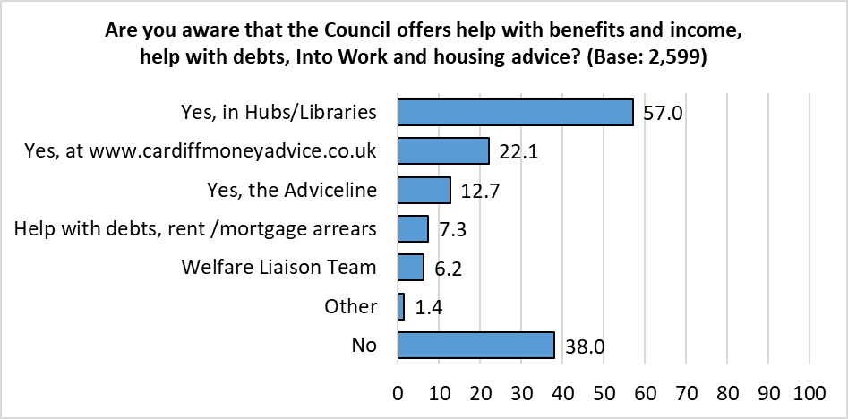  *Respondents could select multiple options so the total will exceed 100%.*

Those answering ‘Other’ were asked to give further details – 25 comments were received:

* Not eligible (11 comments)
* Aware advice is available but unsure how to access it (5 comments)
* Advice did not help (3 comments)
* Focus on getting people into work, not on giving benefits (2 comments)
* Job Centre (1 comment)
* Dusty Forge (1 comment)
* Christians Against Poverty (1 comment)
* Citizens Advice (1 comment)

Awareness of this Advice Service was highest amongst females (69.1%) and under 35s (68.6%); it was lowest amongst males (57.3%).

|  |  |  |  |  |  |  |  |  |
| --- | --- | --- | --- | --- | --- | --- | --- | --- |
|  | Base | Yes, in Hubs / Libraries | Yes, at the website | Yes, the Adviceline | Welfare Liaison Team | Help with debts | Other | No |
| Female | **1222** | *63.9* | *13.4* | *7.4* | *2.0* | *7.8* | *2.0* | *30.9* |
| Identify as disabled | **372** | *62.4* | *24.5* | *14.0* | *6.7* | *8.6* | *1.9* | *33.9* |
| Southern Arc | **782** | *61.9* | *24.3* | *15.1* | *7.9* | *9.2* | *1.2* | *34.4* |
| Children in Household | **492** | *59.6* | *23.2* | *13.0* | *5.9* | *5.1* | *1.6* | *34.1* |
| Under 35 | **258** | *62.0* | *30.6* | *13.6* | *9.7* | *7.8* | *0.8* | *31.4* |
| Minority ethnicity | **248** | *56.5* | *20.6* | *8.9* | *7.3* | *6.9* | *1.2* | *38.3* |
| 55+ | **1252** | *60.4* | *19.7* | *13.2* | *4.9* | *7.6* | *1.1* | *35.9* |
| All respondents | **2599** | *57.0* | *22.1* | *12.7* | *6.2* | *7.3* | *1.4* | *38.0* |
| LGBTQ+ | **213** | *60.1* | *22.5* | *13.6* | *7.5* | *6.1* | *0.5* | *37.1* |
| Welsh speaker | **249** | *55.0* | *15.7* | *12.9* | *4.8* | *5.6* | *1.2* | *40.6* |
| Male | **932** | *53.3* | *20.3* | *13..8* | *5.7* | *7.2* | *0.6* | *42.7* |

Awareness of the advice service was higher amongst those living in the more deprived areas of the city:

|  |  |  |  |  |  |  |  |  |
| --- | --- | --- | --- | --- | --- | --- | --- | --- |
|  | Base | Yes, in Hubs / Libraries | Yes, at the website | Yes, the Adviceline | Welfare Liaison Team | Help with debts | Other | No |
| Most deprived | **268** | *67.2* | *29.1* | *14.9* | *7.8* | *10.8* | *1.9* | *29.5* |
| Next most deprived | **337** | *61.7* | *28.5* | *16.9* | *8.6* | *10.4* | *1.2* | *33.8* |
| Middle | **396** | *62.6* | *23.0* | *17.4* | *6.6* | *10.4* | *0.8* | *33.3* |
| Next least deprived | **494** | *59.7* | *21.3* | *12.8* | *6.1* | *8.7* | *1.6* | *35.8* |
| Least deprived | **564** | *52.7* | *19.7* | *9.8* | *3.5* | *3.7* | *1.1* | *42.7* |
| All respondents | **2599** | *57.0* | *22.1* | *12.7* | *6.2* | *7.3* | *1.4* | *38.0* |

**16. Which of the following statements regarding advice on money management, debt, benefits, Into Work or housing advice applies to you?**

More than one in six respondents (17.0%) reported they had sought advice on these services in the past, up from 15.7% in 2022, and 11.7% in 2021. Almost a fifth (18.1%) felt they may need advice in the future, on a par with last year’s survey.

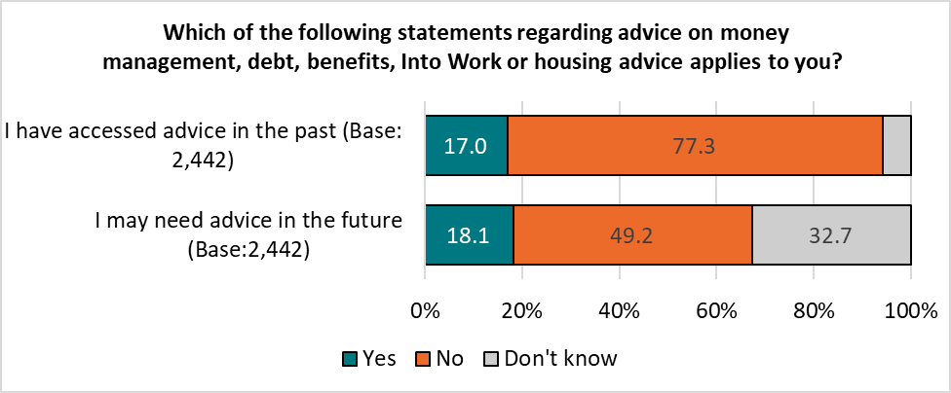*Base sizes shown in brackets.*

Respondents identifying as disabled were most likely to have sought advice in the past (31.5%, up slightly from 30.7% in 2022, after jumping from 10.6% in 2021).

Respondents from a minority ethnicity were most likely to expect to seek advice in the future (33.5%).

|  |  |  |  |  |
| --- | --- | --- | --- | --- |
|  | Have sought advice in the past | | May seek advice in the future | |
|  | **2023** | **2022** | **2023** | **2022** |
| Identify as disabled | *31.5* | *30.7* | *30.1* | *34.0* |
| Children in Household | *18.8* | *22.0* | *23.9* | *25.1* |
| Minority ethnicity | *24.9* | *20.8* | *33.5* | *25.8* |
| Southern Arc | *21.4* | *20.0* | *22.4* | *24.7* |
| Under 35 | *22.7* | *19.9* | *28.0* | *28.1* |
| LGBTQ+ | *26.8* | *18.8* | *28.4* | *23.5* |
| Female | *19.4* | *17.5* | *19.7* | *19.7* |
| All respondents | *17.0* | *15.7* | *18.1* | *18.6* |
| Welsh speaker | *14.9* | *14.9* | *12.8* | *15.4* |
| Male | *11.8* | *12.8* | *14.8* | *16.4* |
| 55+ | *14.7* | *12.1* | *14.0* | *14.6* |

Respondents living in the most deprived areas were over three times more likely than those in the least deprived areas to have sought advice on money management, debt, benefits, Into Work or housing advice, and were five percentage points more likely to report having done so than in 2022; they were also more likely to indicate they may seek advice in the future.

|  |  |  |  |  |
| --- | --- | --- | --- | --- |
|  | Have sought advice in the past | | May seek advice in the future | |
|  | **2023** | **2022** | **2023** | **2022** |
| Most deprived | *32.5* | *27.6* | *31.3* | *27.8* |
| Least deprived | *8.9* | *6.8* | *10.6* | *8.6* |

**Section 4:**

# **Housing**

**17. To what extent do you agree that you have access to good quality housing?**

Three-quarters of respondents (74.3%) agreed they had access to good quality housing, unchanged from 2022.

Also reflecting previous findings, those aged 55 or over (81.7%) were most likely to agree.

Under 35s were most likely to disagree, with a quarter (24.4%, up slightly from 22.2% in 2022) stating they ‘disagreed’ or ‘strongly disagreed’.

*Base sizes shown in brackets; excludes ‘Don’t Know’ responses.*

Agreement with this statement was correlated with level of deprivation, with those living in the most deprived areas least likely to agree.

One in seven (14.4%, up from 11.4% in 2022) of those living in the most deprived areas ‘strongly disagreed’, almost five times that of those in the least deprived areas (2.9%).

*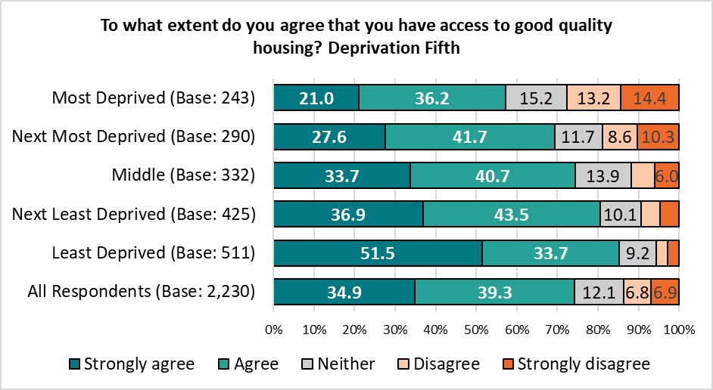Base sizes shown in brackets; excludes ‘Don’t Know’ responses.*

**Over the last 12 months, has your housing situation:**

The majority of respondents (87.6%) stated there had not been a change in their housing situation over the past year, unchanged from the 2022 survey.

As in the previous survey, respondents under the age of 35 were most likely to report a change in their circumstance, with almost one in seven (13.4%) stating it had improved (down from 20.5% in 2022), and one in ten (11.1%) that it had declined.

Respondents identifying as disabled, or those from a minority ethnicity were most likely to report a decline in their housing situation (14.0% and 13.9% respectively).

*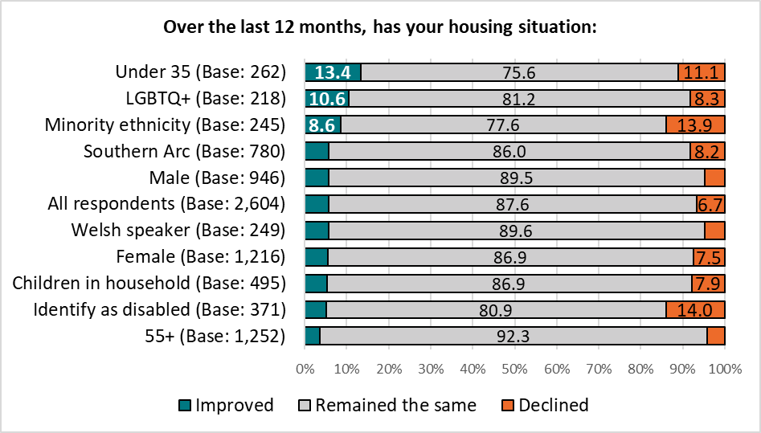Base sizes shown in brackets; excludes ‘Don’t Know’ responses.*

There was a correlation between level of deprivation and the proportion of respondents reporting a decline in their housing situation, from 2.5% of those living in the least deprived areas of the city, to 12.8% in the most deprived areas.



**Section 5:**

# **Jobs & The Economy**

**18. To what extent do you agree or disagree with this statement: Cardiff has a thriving and prosperous economy?**

The proportion of respondents agreeing that Cardiff has a thriving and prosperous economy stabilised after consistent decline for over 5 years. Just over a third of respondents (35.7%) agreed with this statement, slightly less than the proportion who disagreed (39.6%).

*Excludes ‘Don’t Know’ responses.*

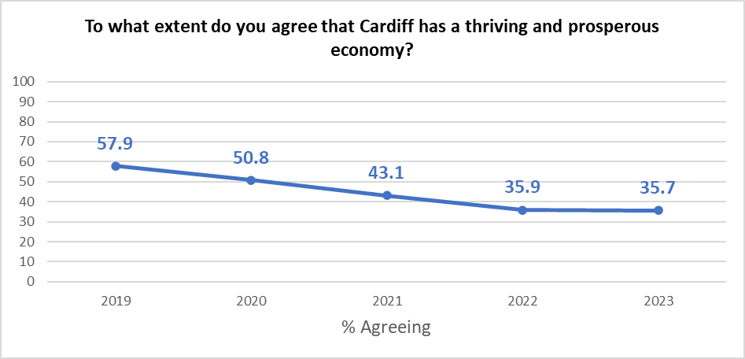

Respondents under the age of 35 were most likely to agree with this statement (43.3%), around eight percentage points higher than for those aged 55 or older (34.9%).

Respondents identifying as disabled were least likely to agree with this statement (31.4%).

*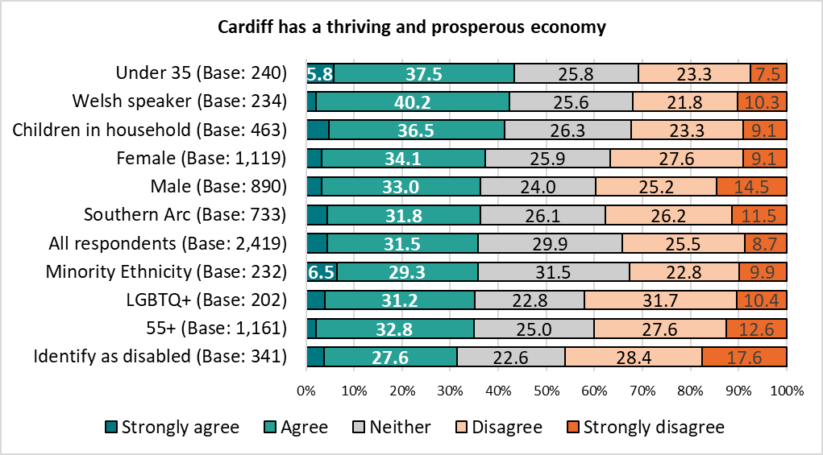Base sizes shown in brackets; excludes ‘Don’t Know’ responses.*

There was no correlation with level of deprivation.

**19. Over the last 12 months would you say your employment situation has:**

Respondents’ employment situation was broadly unchanged since 2021, following higher levels of decline reported during the pandemic, with three-quarters (76.1%) reporting their circumstances had remained the same over the last 12 months.

*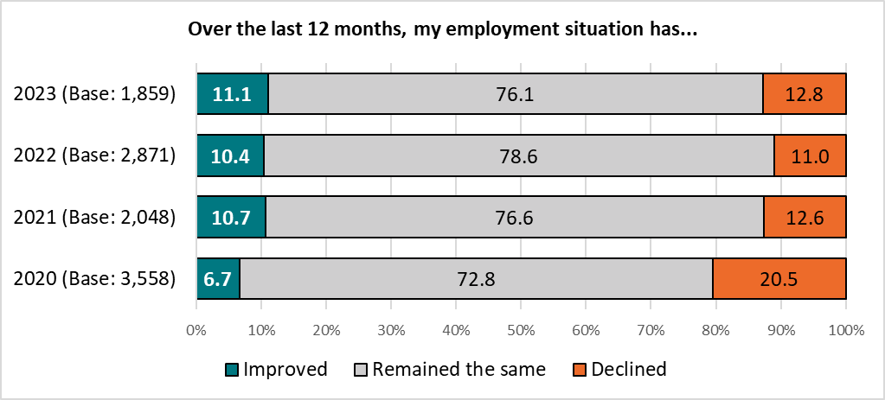Base sizes shown in brackets; excludes ‘Don’t Know’ responses.*

There was a correlation between level of deprivation and the proportion of respondents reporting an improvement in their employment situation, with those living in the most deprived areas most likely to report an improvement:

*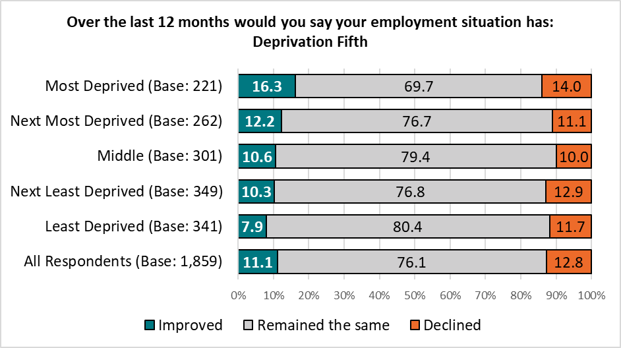Base sizes shown in brackets; excludes ‘Don’t Know’ responses.*

As seen in 2022, a quarter of respondents aged under 35 (27.2%) reported their employment situation had improved over the past year, more than ten percentage points higher than any other demographic group analysed.

Also reflecting the previous year’s findings, respondents who identify as disabled were most likely to report a decline in their employment situation (22.3%, up from 18.8% in 2022).

*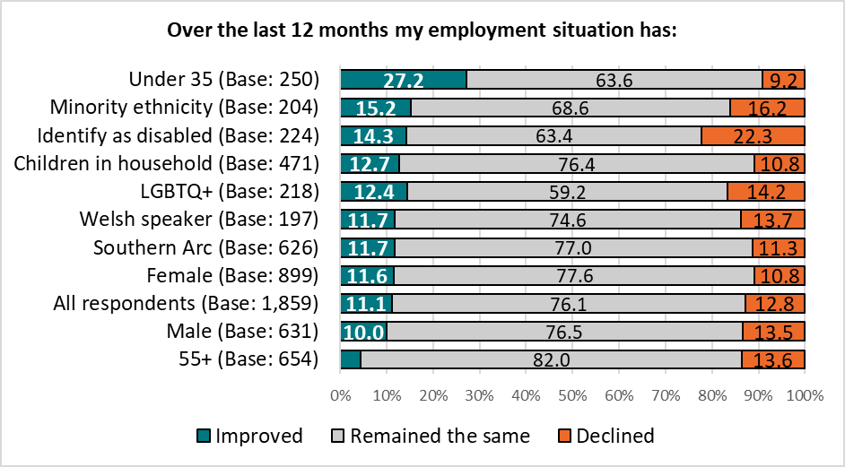Base sizes shown in brackets; excludes ‘Don’t Know’ responses.*

**How confident are you about your future job/career prospects in Cardiff?**

Overall, 58.8% of respondents felt confident about future job or career prospects in Cardiff, broadly unchanged from the previous two surveys.

*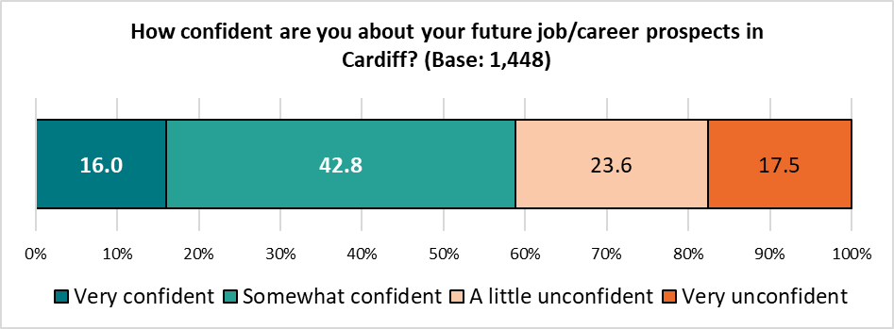Base sizes shown in brackets; excludes ‘Don’t Know’ and ‘Not applicable’ responses*

Confidence in future job/career prospects was highest amongst Welsh speakers (65.4%), women (65.2%) and under 35s (64.5%); it was lowest amongst those identifying as disabled (45.9%), with three in ten of this group (30.4%) feeling ‘very unconfident’ about their future prospects. 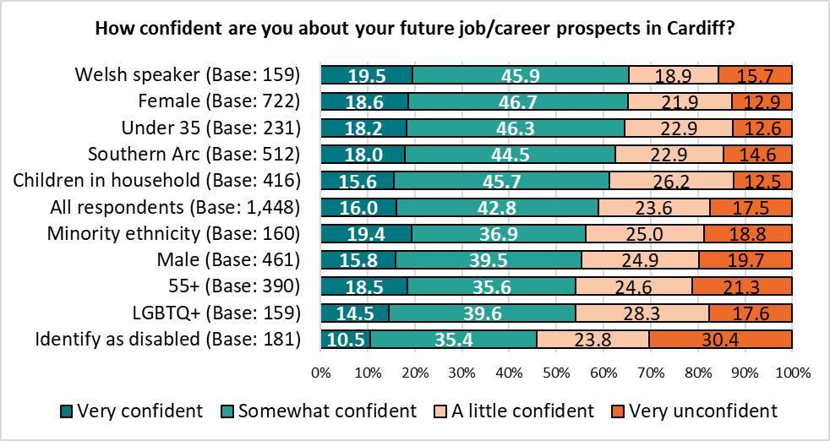*Base sizes shown in brackets; excludes ‘Don’t Know’ and ‘Not applicable’ responses.*

Whilst there was no correlation with level of deprivation, those living in the least deprived areas were twice as likely as those in the most deprived areas to feel ‘very unconfident’ about future job/career prospects (21.7% compared with 14.1%), the opposite of that seen in 2022 (10.2% compared with 21.4% respectively).

*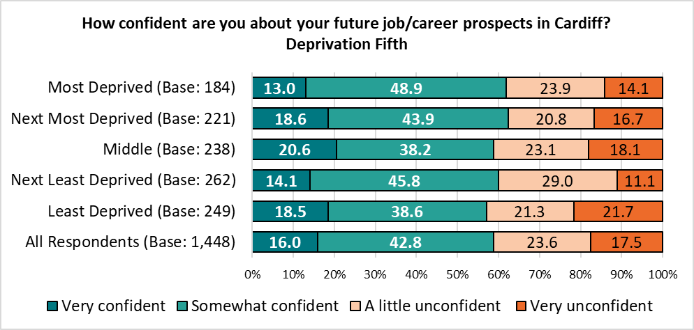Base sizes shown in brackets; excludes ‘Don’t Know’ and ‘Not applicable’ responses.*

**20. Over the last 12 months would you say your personal financial situation has:**

Just over a third of respondents (36.5%) reported a decline in their personal financial situation, down from 44.1% in 2022, but higher than before the ‘cost of living crisis’ in 2021.

*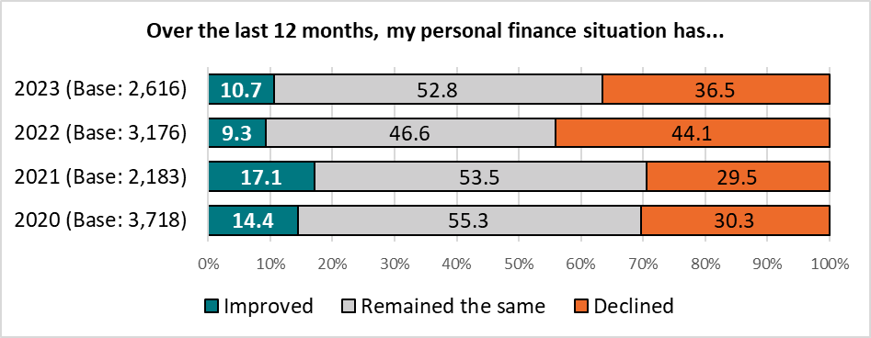Base sizes shown in brackets; excludes ‘Don’t Know’ responses*

All groups analysed were more likely to report a decline in their personal financial situation than an improvement, although this decline was smaller than that seen in the 2022 survey.

As in 2022, those under the age of 35 were most likely to report an improvement in their financial situation (27.1%).

Respondents identifying as disabled were again most likely to report a decline in their financial situation (45.1%, down from 52.0% in 2022).

*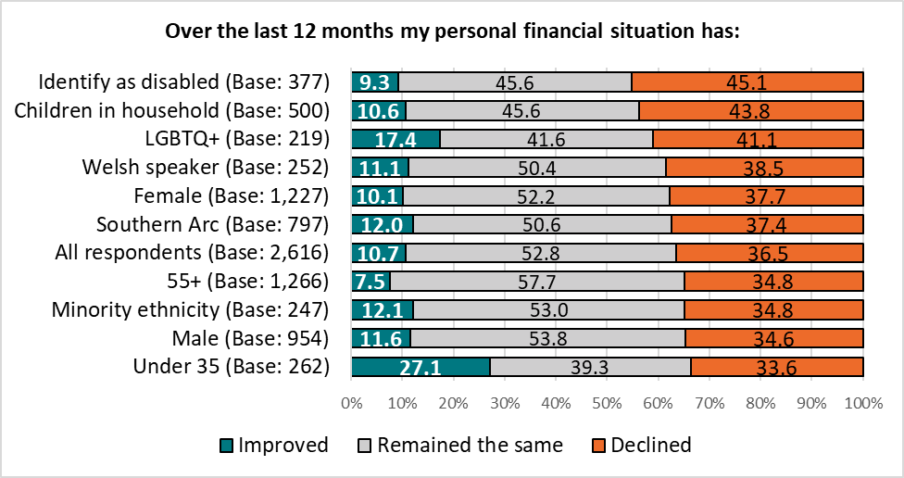Base sizes shown in brackets; excludes ‘Don’t Know’ responses.*

Those living in the most deprived areas of the city were most likely to report an improvement in their financial situation over the last 12 months. However, at least a third of respondents in each of the quintiles reported a decline.

*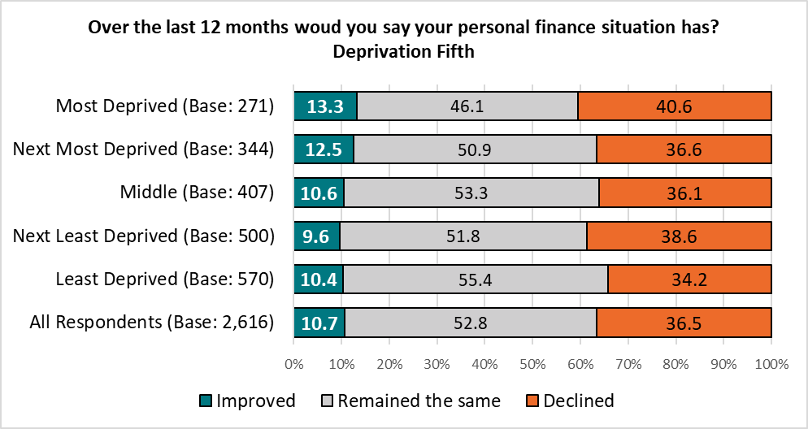Base sizes shown in brackets; excludes ‘Don’t Know’ responses.*

**Section 6:**

# **Health & Well-being**

**21. How would you describe your...?**

Two-thirds of respondents (66.7%) described their physical health as ‘good’ or ‘very good’, continuing a downward trend for the fifth year in a row.

*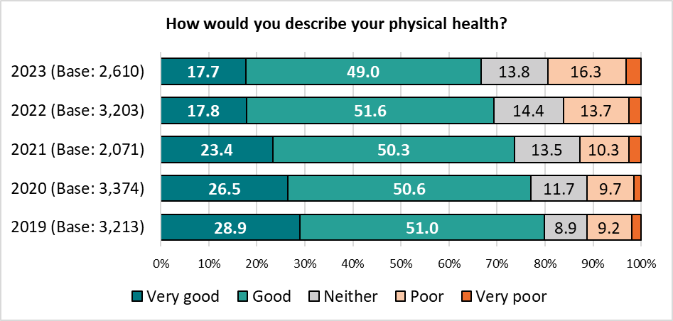Base sizes shown in brackets; excludes ‘Don’t Know’ responses.*

Analysis of the different demographic groups showed a broad consistency of those describing themselves as being in good physical health, with the exception of those identifying as disabled – just 23.1% of this group described their physical health as ‘good’ or ‘very good’ (down slightly from 27.4% in 2022); one in seven (15.2%) described their physical health as ‘very poor’, replicating the 2022 survey.

*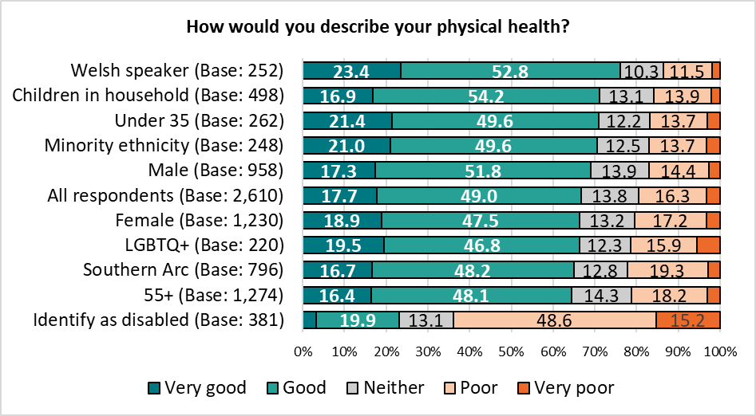Base sizes shown in brackets; excludes ‘Don’t Know’ responses.*

Respondents living in the most deprived areas were least likely to describe their physical health as ‘good’ or ‘very good’.

*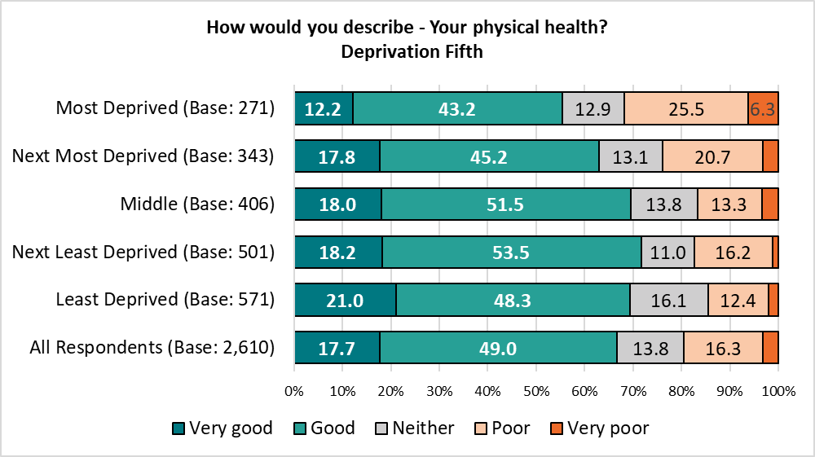Base sizes shown in brackets; excludes ‘Don’t Know’ responses.*

The proportion of respondents describing their mental health as ‘good’ or ‘very good’, remained broadly unchanged from the previous year, at 66.4%.

*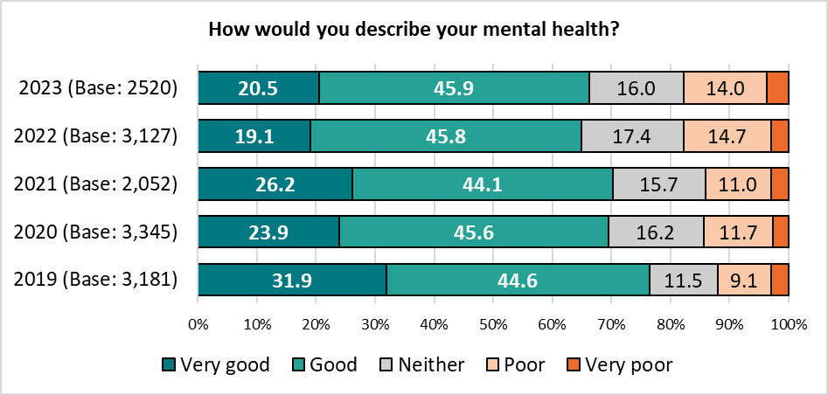Base sizes shown in brackets; excludes ‘Don’t Know’ responses.*

Respondents identifying as disabled reported the lowest levels of mental health, repeating the findings of previous surveys, with fewer than two in five (38.9%) describing their mental health as ‘good’ or ‘very good’.

Older respondents were notably more likely than their younger counterparts to describe their mental health as good (72.9% compared with 52.9% respectively). *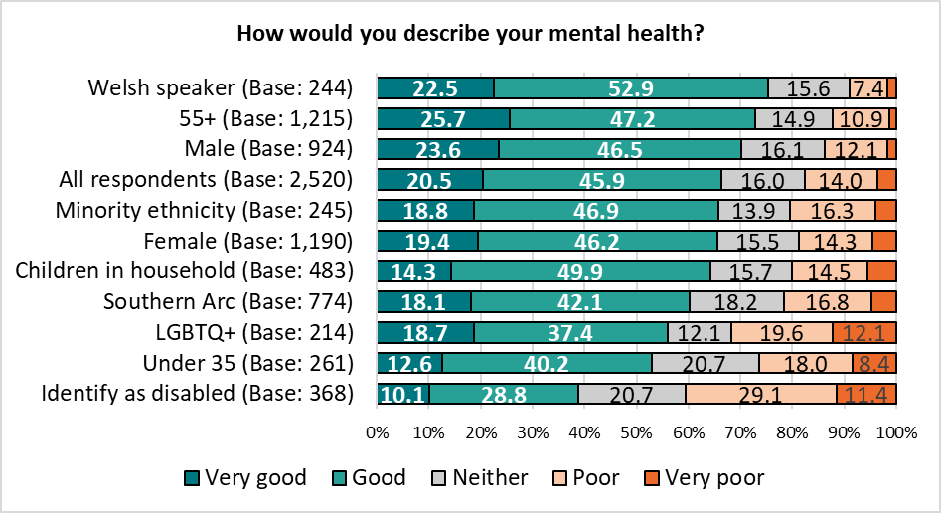Base sizes shown in brackets; excludes ‘Don’t Know’ responses.*

As in 2022, there was a correlation between mental health and level of deprivation, with those living in the most deprived areas of the city reporting the lowest proportion of ‘good’ mental health (50.8%, compared with 77.5% amongst those living in the least deprived areas).

*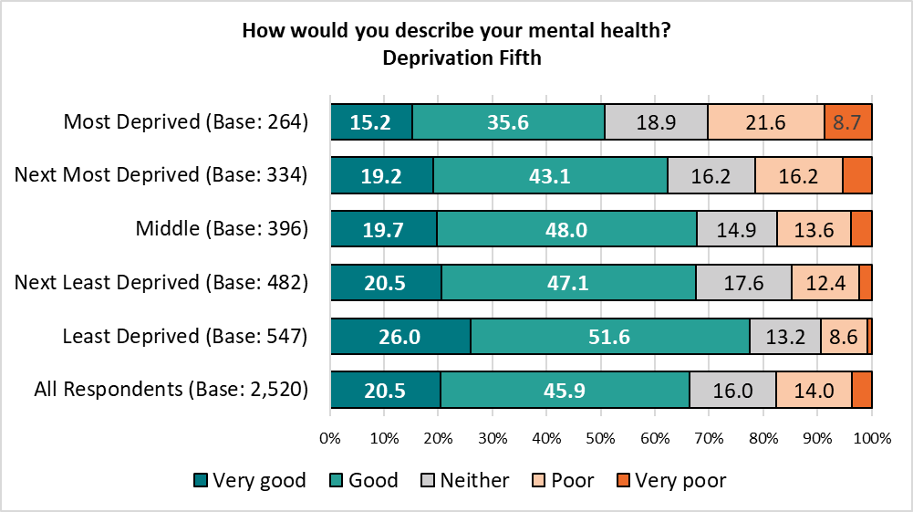Base sizes shown in brackets; excludes ‘Don’t Know’ responses.*

The difference in the proportion of respondents from the most and least deprived areas of the city with good mental health was 26.8 percentage points, the biggest gap seen in the last five years.

|  |  |  |  |
| --- | --- | --- | --- |
|  | Most Deprived | Least Deprived | Difference |
| 2023 | *50.8* | *77.5* | *26.8* |
| 2022 | *54.0* | *75.3* | *21.2* |
| 2021 | *64.2* | *74.5* | *10.3* |
| 2020 | *53.4* | *79.3* | *26.0* |
| 2019 | *62.0* | *84.0* | *21.9* |

**Thinking about your health compared to a year ago, which of the following applies?**

Despite the decline in physical health reported above, there was little change in respondents’ perception of their health compared with that of a year ago, with almost half (46.5%) reporting there had been no change. The proportion reporting a change in their health (positive or negative) year-on-year has been consistent over the past four years.

*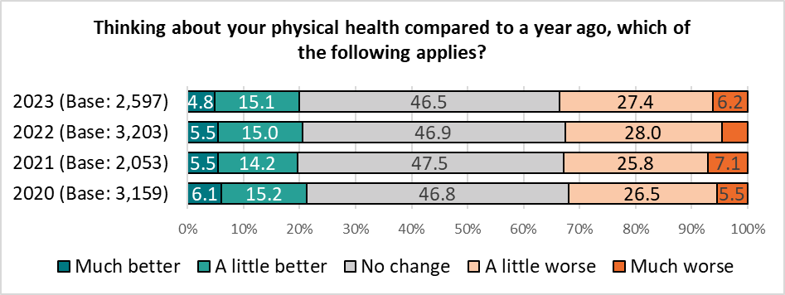Base sizes shown in brackets; excludes ‘Don’t Know’ responses.*

Respondents under the age of 35 (35.9%) and those from a minority ethnicity (28.9%) were most likely to report an improvement in physical health over the past year.

Half of those aged 55 or older (50.5%) reported no change in their physical health.

Over three in five of those identifying as disabled reported a decline in their physical health compared with a year before (62.2%, up from 58.4% in 2022).

*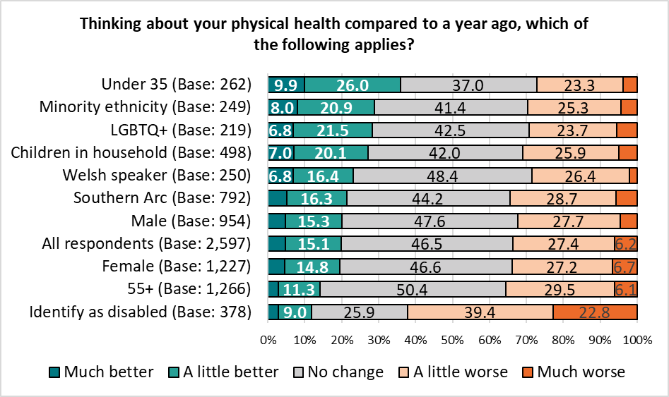Base sizes shown in brackets; excludes ‘Don’t Know’ responses.*

Whilst results did not directly correlate with level of deprivation, respondents living in the most deprived areas of the city were most likely to report a change in their physical health over the last year, with a quarter (26.6%) reporting their physical health was better, but two in five (39.1%) stating it was worse.

*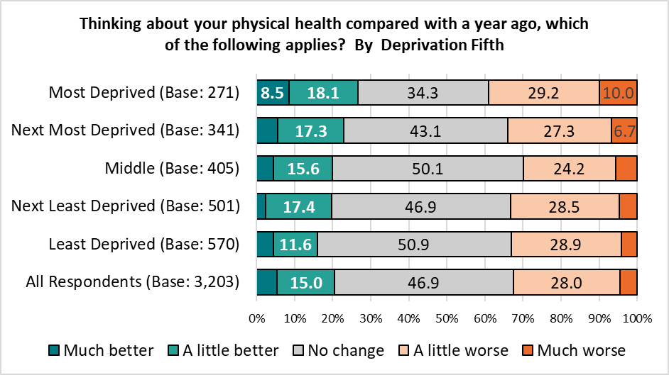Base sizes shown in brackets; excludes ‘Don’t Know’ responses.*

Most respondents (57.0%) reported there had been ‘no change’ in their mental health compared to a year ago, continuing a year-on-year trend.

*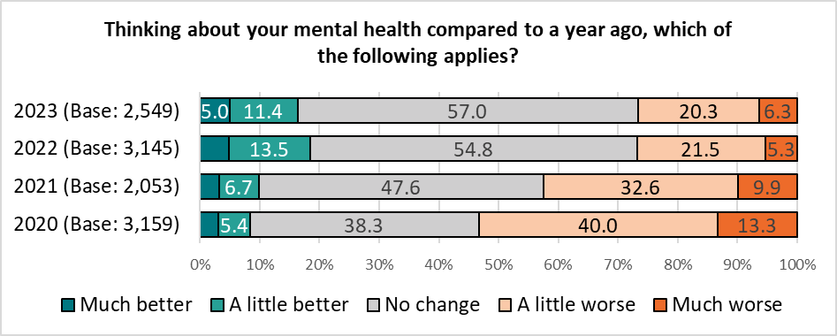Base sizes shown in brackets; excludes ‘Don’t Know’ responses.*

Under 35s were most likely to report a change in their mental health, with 31.0% saying their mental health was better, contrasting with 36.8% who reported a decline.

Seven in ten respondents aged 55 or older (70.5%) felt there had been no change in their mental health over the past year.

Two in five respondents identifying as disabled (41.9%) reported their mental health was worse than it had been a year ago, with more than one in seven (15.7%) stating it was ‘much worse’.

*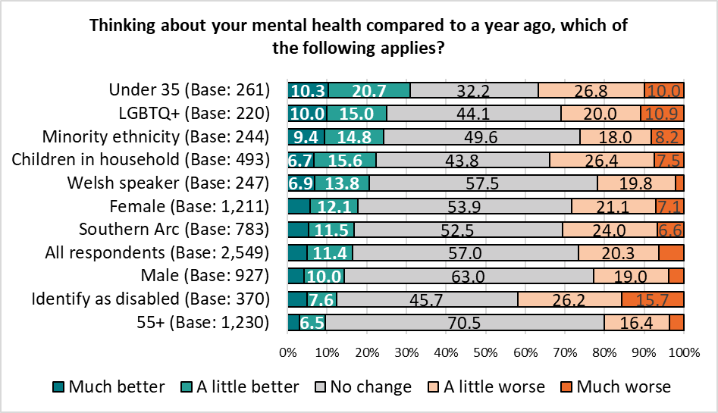Base sizes shown in brackets; excludes ‘Don’t Know’ responses.*

Whilst not a direct correlation, those living in the most deprived areas were most likely to report a change in their mental health, with almost twice as many stating it had got worse compared to those feeling it had got better (37.8% compared with 19.6%).

Those in the least deprived areas were around half as likely as those in the most deprived areas to state their mental health had got worse over the last year (19.9% compared with 37.8% respectively).

*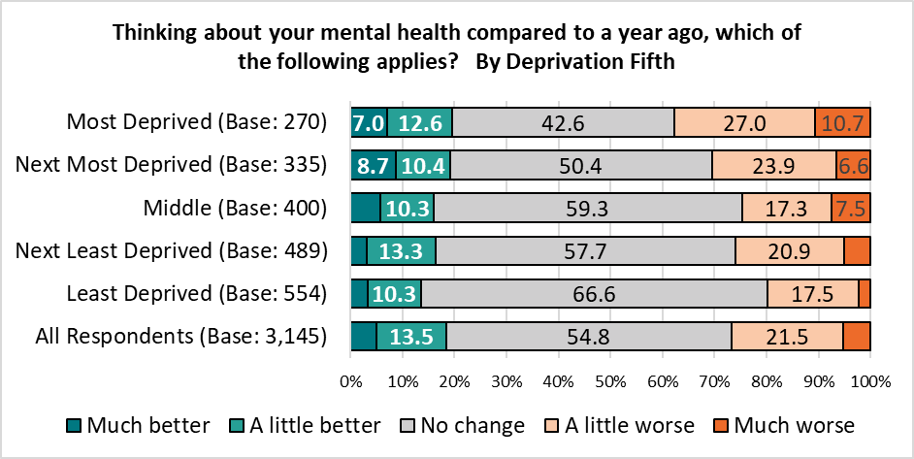Base sizes shown in brackets; excludes ‘Don’t Know’ responses.*

**22. How many portions of fruit and vegetables do you typically eat each day?**

Just over a quarter of respondents (25.9%) reported they typically ate at least five portions of fruit and vegetables each day; just under one in twenty (4.7%) said they didn’t eat any fruit or vegetables in a typical day. Both of these findings reflect the results of the 2022 survey.

The average respondent ate 3.1 portions of fruit and vegetables each day.



Welsh speakers and those aged 55 or over reported the highest consumption of fruit and vegetables, each with an average of 3.3 portions per day.

Respondents identifying as disabled and those under 35 ate the fewest, with an average of 2.6 and 2.7 portions per day.

These findings reflect those seen in 2022.

|  |  |  |  |  |  |  |  |  |
| --- | --- | --- | --- | --- | --- | --- | --- | --- |
|  | Base | 0 | 1 | 2 | 3 | 4 | 5 + | Average |
| Identify as disabled | **377** | 9.3 | 17.0 | 21.2 | 24.4 | 10.6 | 17.5 | **2.6** |
| Under 35 | **261** | 5.7 | 18.8 | 23.4 | 25.3 | 10.3 | 16.5 | **2.7** |
| LGBTQ+ | **221** | 4.1 | 15.8 | 21.7 | 24.9 | 10.4 | 23.1 | **2.9** |
| Southern Arc | **799** | 6.5 | 13.1 | 21.0 | 23.8 | 11.6 | 23.9 | **2.9** |
| Children in household | **500** | 4.8 | 13.6 | 20.0 | 24.4 | 16.2 | 21.0 | **3.0** |
| Male | **955** | 4.3 | 14.8 | 18.1 | 24.6 | 14.8 | 23.5 | **3.0** |
| Minority ethnicity | **246** | 4.9 | 16.7 | 16.7 | 21.5 | 13.4 | 26.8 | **3.0** |
| All respondents | **2600** | 4.7 | 12.0 | 19.5 | 23.6 | 14.3 | 25.9 | **3.1** |
| Female | **1226** | 4.6 | 9.2 | 18.7 | 24.2 | 14.2 | 29.1 | **3.2** |
| Welsh speaker | **251** | 1.6 | 9.6 | 16.7 | 29.1 | 15.9 | 27.1 | **3.3** |
| 55+ | **1269** | 3.8 | 9.0 | 17.7 | 23.2 | 15.1 | 31.3 | **3.3** |

There was a correlation between the amount of fruit and vegetables eaten each day and the level of deprivation, with those in the least deprived areas typically eating an extra portion per day than those in the most deprived areas.

One in eight (12.5%) of those in the most deprived areas stated they did not typically eat any fruit or vegetables, compared with 1.1% of those in the least deprived areas.

|  |  |  |  |  |  |  |  |  |
| --- | --- | --- | --- | --- | --- | --- | --- | --- |
|  | Base | 0 | 1 | 2 | 3 | 4 | 5 + | Average |
| Most Deprived | **272** | 12.5 | 17.3 | 22.4 | 20.2 | 9.2 | 18.4 | **2.5** |
| Next Most Deprived | **342** | 4.4 | 15.8 | 23.4 | 21.9 | 12.9 | 21.6 | **2.9** |
| Middle | **402** | 3.5 | 12.9 | 18.7 | 23.4 | 12.7 | 28.9 | **3.2** |
| Next Least Deprived | **499** | 3.8 | 8.0 | 18.0 | 27.7 | 14.8 | 27.7 | **3.2** |
| Least Deprived | **571** | 1.1 | 9.1 | 14.9 | 24.5 | 18.0 | 32.4 | **3.5** |
| All Respondents | **2600** | 4.7 | 12.0 | 19.5 | 23.6 | 14.3 | 25.9 | **3.1** |

**23. And in a typical week, for how many​ minutes do you exercise or do physical activity (such as walking or gardening)?**

A third of those (32.5%) surveyed reported undertaking at least 150 minutes of exercise or physical activity in a typical week. Just 4.1% said they didn’t do any exercise or physical activity, up slightly from 3.4% in 2022.

The average respondent did a minimum of 87.7 minutes of exercise per week.



Men and those aged 55 or older reported the highest levels of physical activity, with a minimum of 92.3 and 92.0 minutes per week respectively. Those identifying as disabled had the lowest levels of activity, with an average of a minimum 62.3 minutes per week.

|  |  |  |  |  |  |  |  |  |  |
| --- | --- | --- | --- | --- | --- | --- | --- | --- | --- |
|  | Base | 0 | 1-29 | 30-59 | 60-89 | 90-119 | 120-149 | 150 + | Average |
| Male | **951** | 4.1 | 9.7 | 13.0 | 10.9 | 13.8 | 11.4 | 37.1 | **92.3** |
| 55+ | **1260** | 4.0 | 9.8 | 11.9 | 12.4 | 13.0 | 14.2 | 34.8 | **92.0** |
| Welsh speaker | **252** | 3.2 | 8.3 | 13.9 | 15.1 | 12.7 | 13.5 | 33.3 | **90.9** |
| All respondents | **2584** | 4.1 | 11.0 | 13.2 | 13.7 | 13.0 | 12.5 | 32.5 | **87.7** |
| LGBTQ+ | **219** | 4.6 | 11.0 | 12.8 | 15.5 | 13.2 | 10.5 | 32.4 | **86.4** |
| Female | **1215** | 4.4 | 10.9 | 13.8 | 13.8 | 13.3 | 13.3 | 30.5 | **86.1** |
| Under 35 | **261** | 5.0 | 10.0 | 14.9 | 17.6 | 11.1 | 8.8 | 32.6 | **84.6** |
| Children in household | **495** | 3.0 | 13.5 | 15.4 | 12.1 | 14.5 | 9.5 | 31.9 | **84.4** |
| Southern Arc | **793** | 4.4 | 12.4 | 14.8 | 14.0 | 12.5 | 12.4 | 29.6 | **83.5** |
| Minority ethnicity | **241** | 7.5 | 14.1 | 14.5 | 11.6 | 13.7 | 10.8 | 27.8 | **78.4** |
| Identify as disabled | **373** | 13.4 | 17.4 | 15.8 | 13.7 | 11.8 | 10.7 | 17.2 | **62.3** |

Again, there was a correlation with level of deprivation, with those living in the most deprived areas doing less exercise per week than those in the least deprived areas (a minimum of 72.3 minutes compared with a minimum of 98.5 minutes, on average).

|  |  |  |  |  |  |  |  |  |  |
| --- | --- | --- | --- | --- | --- | --- | --- | --- | --- |
|  | Base | 0 | 1-29 | 30-59 | 60-89 | 90-119 | 120-149 | 150 + | Average |
| Most Deprived | **270** | 6.3 | 18.1 | 14.4 | 16.3 | 11.5 | 7.8 | 25.6 | **72.3** |
| Next Most Deprived | **338** | 2.7 | 10.4 | 16.9 | 14.8 | 14.5 | 14.8 | 26.0 | **83.9** |
| Middle | **399** | 4.5 | 8.8 | 15.3 | 12.0 | 12.8 | 12.0 | 34.6 | **89.7** |
| Next Least Deprived | **500** | 3.6 | 10.0 | 10.8 | 12.4 | 15.8 | 12.2 | 35.2 | **92.4** |
| Least Deprived | **572** | 3.0 | 8.2 | 11.4 | 10.7 | 12.4 | 13.8 | 40.6 | **98.5** |
| All Respondents | **2,584** | 4.1 | 11.0 | 13.2 | 13.7 | 13.0 | 12.5 | 32.5 | **87.7** |

**The NHS invites people for screening to identify those at higher risk of some diseases, such as bowel, breast or cervical cancers, and for vaccinations to protect against infectious diseases such as measles, flu, Covid-19 and meningitis.**

**24. Have you taken up invitations for screening?**

Overall, 57.5% of those responding to this question had taken up invitations for screening, up slightly from 53.7% in 2022.

Older respondents (73.8%) and women (65.7%) were most likely to take up their invitations.

Respondents under the age of 35 (66.8%) and those with children in their household (52.0%) were most likely to report they had not been invited for screening.

One in ten of those from a minority ethnicity or identifying as LGBTQ+ reported they had declined invitations for screening (10.1% each).

*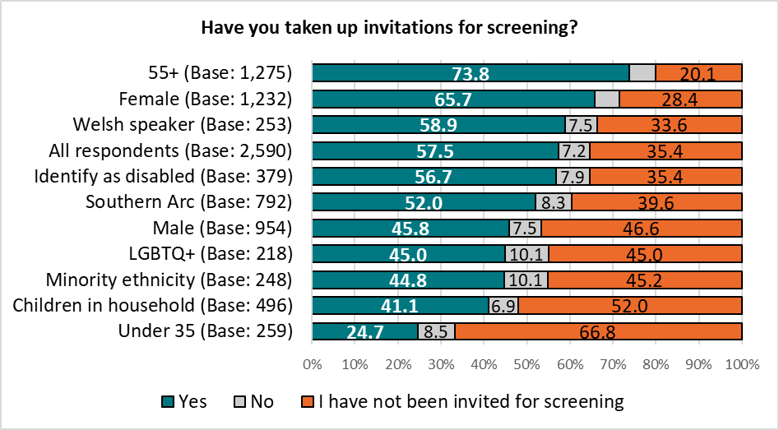Base sizes shown in brackets; excludes ‘Don’t Know’ responses.*

Respondents living in the least deprived areas of the city were most likely to take up their invitations for screening, with just 4.0% reporting they had declined any such invitations.

Those living in the most deprived areas were more likely to report they had not been invited for screening (45.2%).

*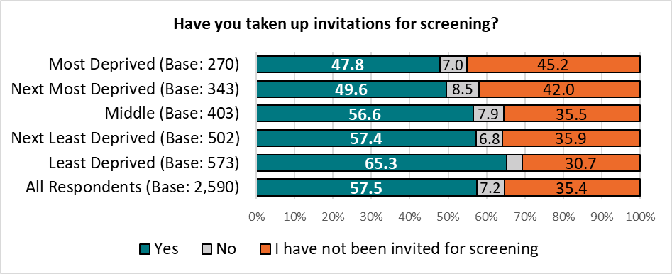Base sizes shown in brackets; excludes ‘Don’t Know’ responses.*

**Please tell us what stopped you taking up the invitation for screening.**

Those stating they had not taken up the invitation for screening were asked what had stopped them from doing so. A total of 76 responses were received and grouped into themes; the top three themes are shown below with a full list in Appendix K.

|  |  |  |  |
| --- | --- | --- | --- |
| Theme | No. | % | Example Comments |
| Haven't received invitation | 13 | *17.1* | * *Never been invited* * *Haven't had one* * *Not offered?* |
| Trust issues | 13 | *17.1* | * *The pandemic killed my trust in the NHS. Glad I didn’t take the vax as I might be dead or seriously injured.* * *The Covid-19 vaccination did not work and is killing and causing serious injury and the government should be held accountable. The govt want people to be sick for pharmaceutical companies to profit* * *unquantifiable risk and cover-ups* |
| Anxiety | 11 | *14.5* | * *Scared of the results* * *Anxious* * *Fear due to negative experiences with the NHS* |

**And have you taken up invitations for vaccinations?**

Overall, 73.7% of respondents reported taking up their invitation for vaccination (down from 88.4% in 2022), with 8.9% declining this offer, and more than one in six (17.3%) not receiving an invitation.

Nine in ten of those aged 55 or over accepted this invitation (87.9%, down from 95.3% in 2022), with just 5.6% of this group declining to do so.

Almost half of those under the age of 35 (48.7%) had not been invited for vaccination.

*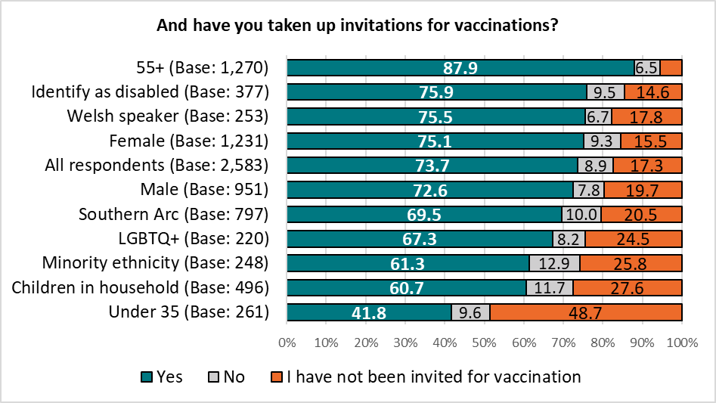Base sizes shown in brackets; excludes ‘Don’t Know’ responses.*

Take up of invitations for vaccination were correlated with level of deprivation, with those living in the least deprived areas most likely to accept.

*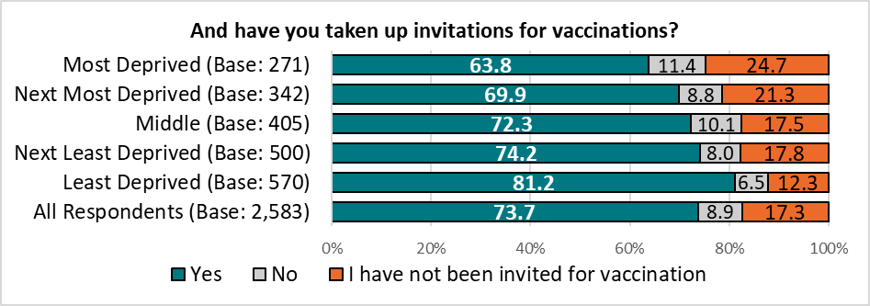Base sizes shown in brackets; excludes ‘Don’t Know’ responses.*

**Please tell us what stopped you taking up the invitation for vaccination.**

Those stating they had not taken up the invitation for vaccination were asked what had stopped them from doing so. A total of 150 responses were received and grouped into themes; the top three themes are shown below with a full list in Appendix L.

|  |  |  |  |
| --- | --- | --- | --- |
| Theme | No. | % | Example Comments |
| Trust issues | 73 | *48.7* | * *Don’t trust advice or evidence* * *Too many lies and side effects* * *not interested and don't feel safe having any of the covid jabs* * *I would rather build up my own immunity than weaken my immune system with poison* |
| Previous negative experience / COVID | 73 | *48.7* | * *problems with heart after covid injection* * *I don’t want any more vaccines* * *It made me ill last time* * *Bad reaction to 3rd covid jab.* |
| Don't need it / My choice | 42 | *28.0* | * *Trust my immune system to handle it.* * *I don’t feel I need them* * *Natural exposure to Covid when my partner recently had it.* |

**25. Are your day-to-day activities limited because of a health problem or disability which has lasted, or is expected to last, at least 12 months? (This includes problems related to old age).**

Overall, 12.9% of respondents reported their day-to-day activities were limited a lot because of a health problem or disability, with a further 26.3% saying their activities were limited a little.

Perhaps unsurprisingly, those identifying as disabled were most likely to report a limit to their activities (92.1%).

*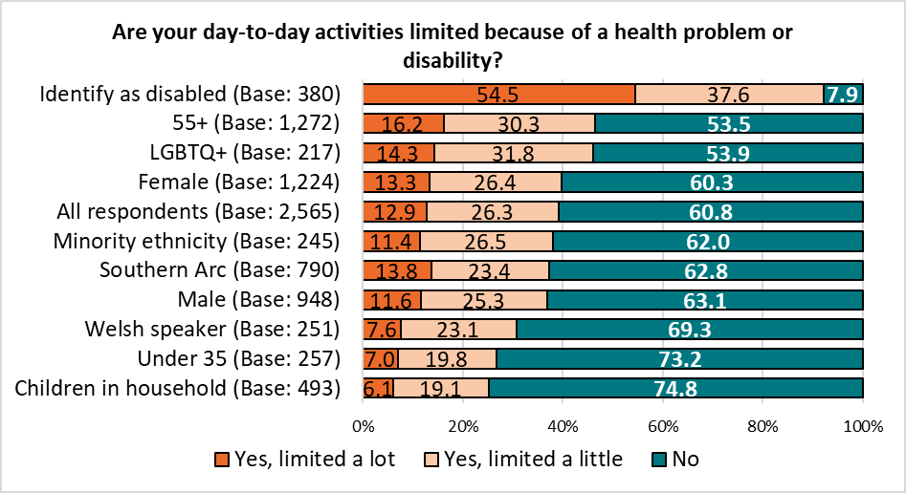Base sizes shown in brackets; excludes ‘Don’t Know’ responses.*

There was no correlation with level of deprivation.

**26. How Do You Feel About Yourself?**

Respondents were given four statements, and asked to indicate how they felt in relation to each, using a 0 to 10 scale:

* *Overall, how satisfied are you with your life nowadays?*
* *Overall, how happy did you feel yesterday?*
* *Overall, how anxious did you feel yesterday?*
* *Overall, to what extent do you feel like the things you do in your life are worthwhile?*

Mean scores were calculated for each of the questions posed.

The table below shows the scores, both overall, and for the different demographic groups analysed. Where scores are better than the overall mean by 0.2 (higher for satisfaction, happiness and feeling worthwhile, and lower for anxiety), cells are highlighted in teal; those worse by 0.2 are highlighted in orange. Those within +/- 0.2 of the overall mean are not highlighted.

As in previous years, respondents identifying as disabled reported the lowest scores for satisfaction with their life, happiness and feeling the things they do are worthwhile.

Respondents under the age of 35 were less satisfied, less happy, more anxious, and less likely to feel the things they do in their life are worthwhile, contrasting with those aged 55 or over.

Those identifying as LGBTQ+ were also less satisfied with their life, happy, feel the things they do are worthwhile and feel more anxious than the average respondent.

There was a correlation with level of deprivation and levels of satisfaction, happiness and feeling the things done in life are worthwhile, with those in the least deprived areas of the city showing the highest levels for these attributes.

Whilst there was no clear correlation, those living in the most deprived areas of the city were the most anxious, scoring a full point higher than those in the least deprived areas.

|  |  |  |  |  |
| --- | --- | --- | --- | --- |
| *Group* | Satisfied | Happy | Anxious | Worthwhile |
| All respondents | 6.4 | *6.3* | *4.0* | *6.6* |
|  |  |  |  |  |
| Under 35 | **6.2** | **5.9** | **4.9** | **6.2** |
| 55+ | **6.7** | 6.7 | **3.6** | **6.8** |
| Female | 6.5 | **6.4** | 4.1 | 6.7 |
| Male | 6.6 | 6.5 | **3.7** | 6.6 |
| Minority Ethnicity | **6.2** | **5.9** | 4.3 | 6.5 |
| Southern Arc | **6.3** | **6.1** | 4.2 | 6.4 |
| Identify as Disabled | **5.2** | **5.2** | **4.7** | **5.3** |
| Welsh Speaker | **6.8** | **6.7** | **3.8** | **6.7** |
| LGBTQ+ | **5.8** | **5.7** | **4.7** | **5.9** |
| Children in household | **6.4** | **6.1** | 4.3 | 6.7 |
|  |  |  |  |  |
| Most Deprived | **5.6** | **5.4** | **4.6** | **5.9** |
| Next Most Deprived | 6.4 | 6.3 | **4.3** | 6.5 |
| Middle | 6.5 | 6.4 | **3.8** | 6.6 |
| Next Least Deprived | 6.6 | **6.5** | 3.9 | 6.7 |
| Least Deprived | **6.9** | **6.8** | **3.6** | **7.0** |

*If an apparent difference of +/- 0.2 is not highlighted, this is due to figures being rounded up/down.*

Overall, figures against each of the measures showed a similar sense of wellbeing than in previous years, lower than that of pre-pandemic levels.

|  |  |  |  |  |
| --- | --- | --- | --- | --- |
|  | Satisfied | Happy | Anxious | Worthwhile |
| All respondents 2023 | 6.4 | 6.3 | 4.0 | 6.6 |
| All respondents 2022 | 6.6 | 6.5 | 4.1 | 6.6 |
| All respondents 2021 | 6.7 | 6.6 | 4.0 | 6.7 |
| All respondents 2020 | 6.7 | 6.5 | 4.2 | 6.8 |
| All respondents 2019 | *7.1* | *7.0* | *3.8* | *7.0* |
| All respondents 2018 | *7.1* | *7.0* | *3.6* | *7.0* |

**27. Over the specified period, would you describe your sense of well-being as having:**

Levels of wellbeing looking back over the past seven days were broadly consistent with those seen in previous years, although the proportion stating it had improved dropped from 5.6% to 3.5%.

*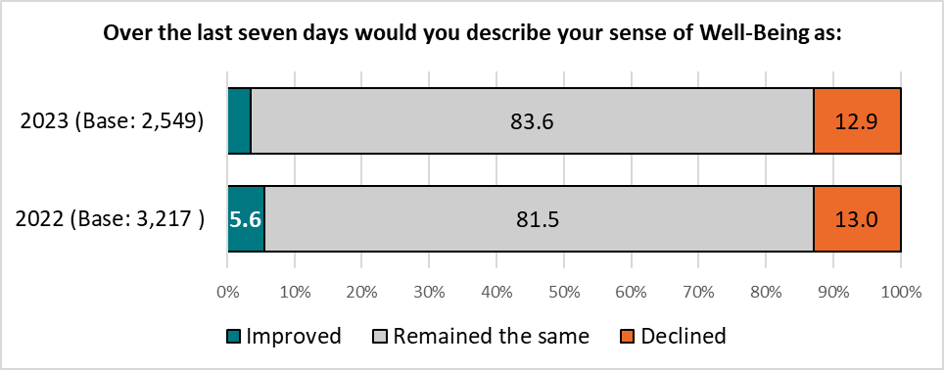Base sizes shown in brackets; excludes ‘Don’t Know’ responses.*

Respondents’ sense of well-being over the past seven days was broadly consistent across the demographic and geographic groups analysed, although at least a fifth of respondents identifying as disabled or living in the most deprived quintile reported a decline in their wellbeing over the last seven days (25.3% and 19.6% respectively).

*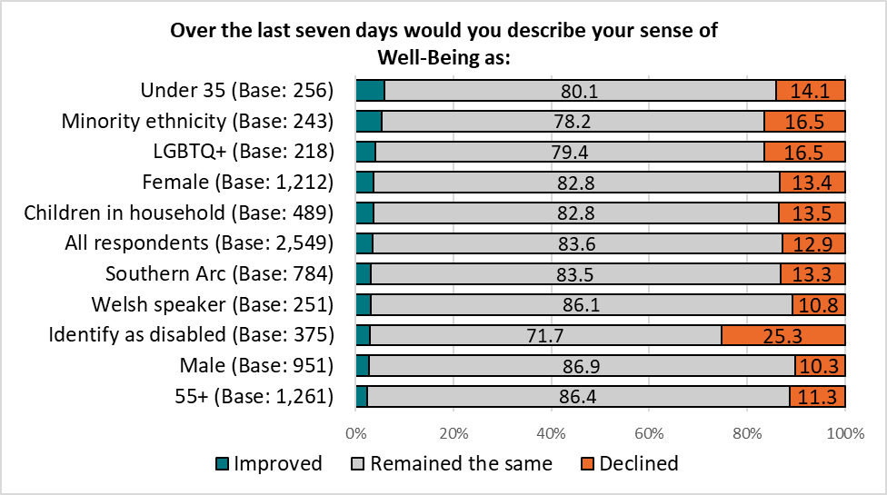Base sizes shown in brackets; excludes ‘Don’t Know’ responses.*

*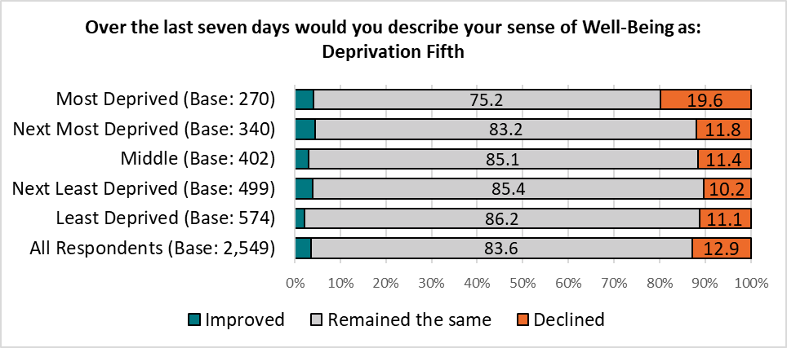Base sizes shown in brackets; excludes ‘Don’t Know’ responses.*

Respondents were more likely to report a decline in their well-being over a 12-month period, with 33.6% reporting a decline over this time, compared with 13.2% over the last week.

The sense of well-being was broadly unchanged compared with the findings of the 2022 survey.

*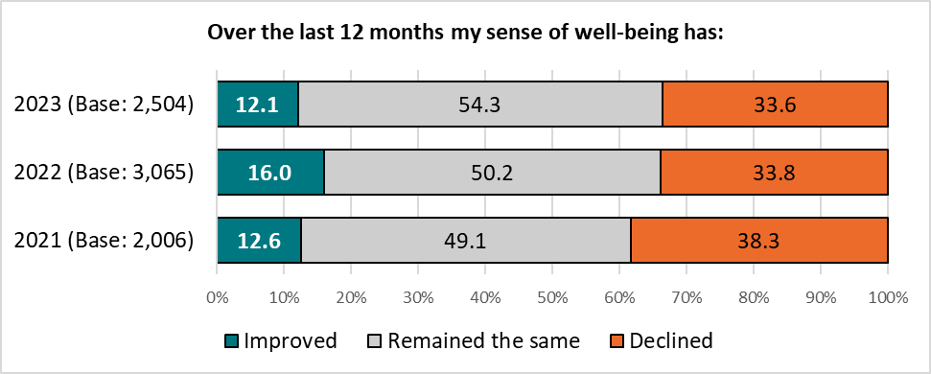Base sizes shown in brackets; excludes ‘Don’t Know’ responses.*

Three in five of those identifying as disabled (60.5%) reported a decline in their sense of well-being over the past 12 months, up ten percentage points from 2022 (50.0%).

Younger respondents were more than twice as likely as those aged 55 or over to report an improved sense of wellbeing over this period of time (22.5% compared with 8.9%).

*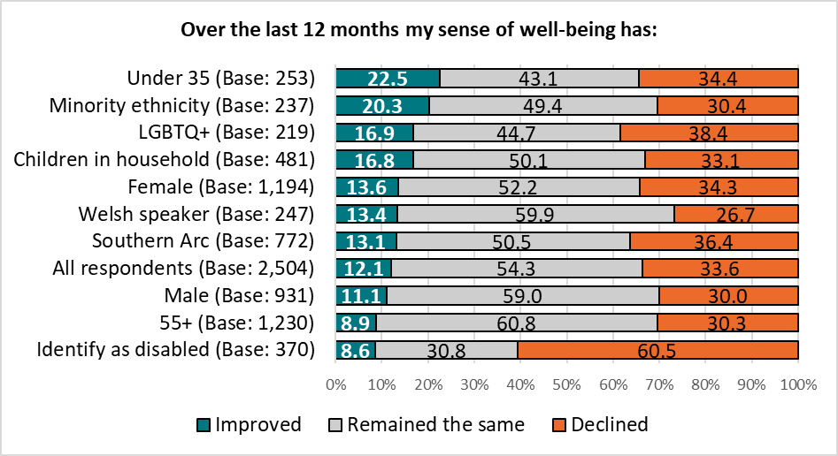Base sizes shown in brackets; excludes ‘Don’t Know’ responses.*

A decline in well-being over the last 12 months correlated with level of deprivation, with respondents living in the most deprived areas most likely to report a decline.

*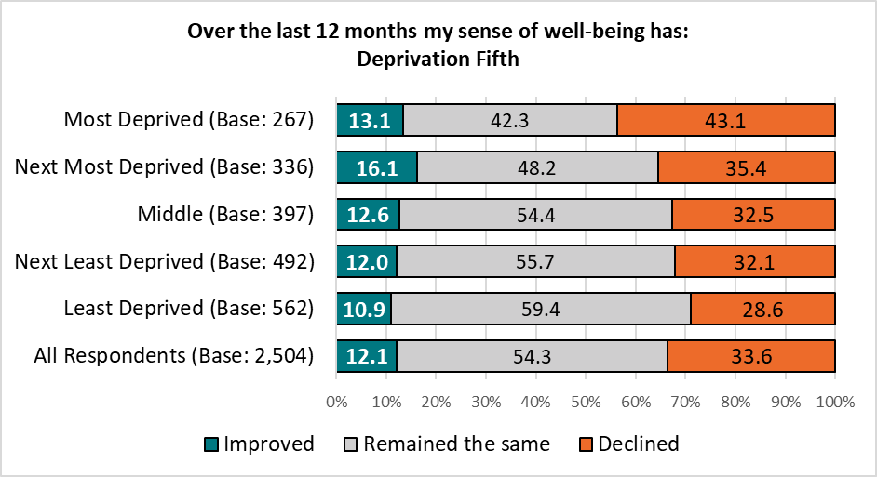Base sizes shown in brackets; excludes ‘Don’t Know’ responses.*

**28. In the last 12 months, have you been to any of the following in Cardiff?**

As seen in previous surveys, respondents were most likely to have been to the cinema, with 57.6% having been at least once in the previous year:

*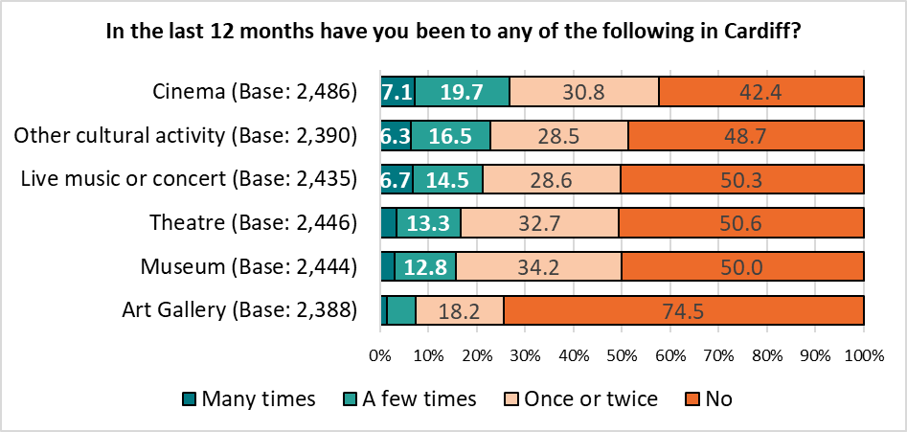 Base sizes shown in brackets; excludes ‘Don’t Know’ responses.*

The proportion of respondents attending at least one cultural activity over the last 12 months rose to 84.7%, but this was still below pre-pandemic levels.

|  |  |  |  |  |  |
| --- | --- | --- | --- | --- | --- |
|  | 2023 | 2022 | 2021 | 2020 | 2019 |
| At least one activity | *84.7* | *81.9* | *64.4* | *68.8* | *92.1* |
| Cinema | *57.6* | *53.9* | *37.7* | *59.7* | *74.0* |
| Other cultural activity | *51.3* | *50.3* | *28.1* | *47.3* | *66.0* |
| Live music or concert | *49.7* | *46.2* | *24.2* | *43.1* | *60.1* |
| Theatre | *49.4* | *43.7* | *21.0* | *43.3* | *57.1* |
| Museum | *50.0* | *42.6* | *25.0* | *50.9* | *64.0* |
| Art Gallery | *25.5* | *22.7* | *12.0* | *25.9* | *36.3* |

Respondents who identified as disabled and those living in the most deprived areas of the city were less likely to attend an event than the average respondent.

*Base sizes shown in brackets.*

*Base sizes shown in brackets.*

**Section 7:**

# **Community Safety**

**29. To what extent would you agree or disagree that the police and other local public services are successfully dealing with anti-social behaviour and crime in your local area?**

A quarter (26.1%) of respondents agreed that enough was being done to tackle anti-social behaviour and crime in their local area; half (50.4%) disagreed, 22.8% disagreeing strongly.

*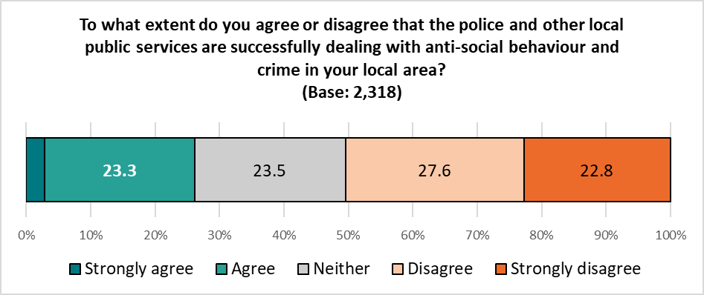Excludes ‘Don’t Know’ responses.*

The proportion agreeing with this statement shows a year-on-year increase since 2021, but still below pre-pandemic levels:

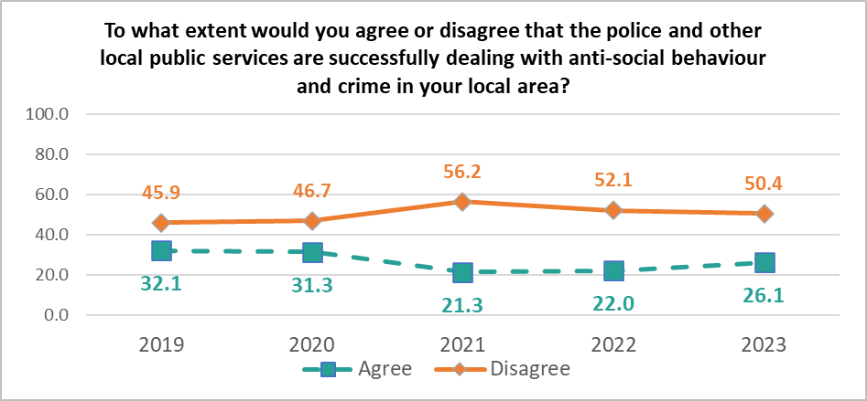

Younger respondents and Welsh speakers were most likely to agree with this statement (33.8% and 33.6% respectively); those identifying as disabled or residing in the Southern Arc of the city were most likely to disagree (58.7% and 57.6% respectively).

*Base sizes shown in brackets; excludes ‘Don’t Know’ responses.*

As in previous years, there was a clear correlation between disagreement with this statement and level of deprivation, with those in the most deprived areas most likely to disagree.

*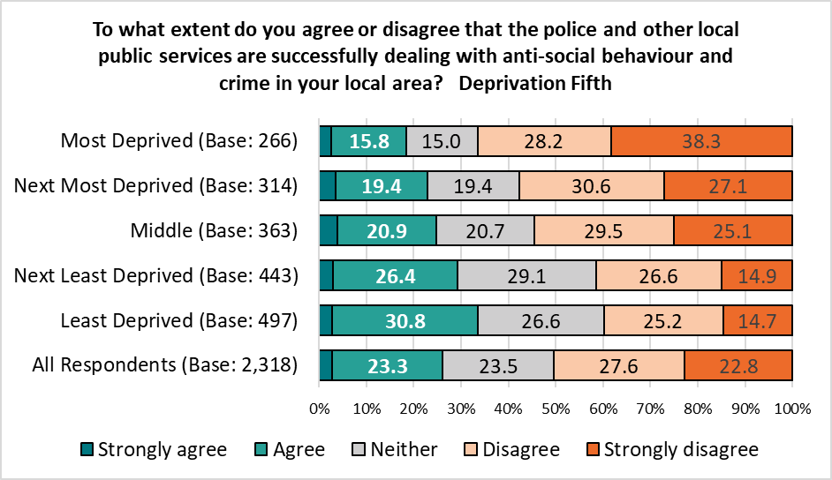Base sizes shown in brackets; excludes ‘Don’t Know’ responses.*

The gap in agreement between the most and least deprived areas narrowed slightly compared with 2022, but is still more than double that seen in 2021:

|  |  |  |  |
| --- | --- | --- | --- |
| % Disagree | Most Deprived | Least Deprived | Difference |
| 2023 | *66.5* | *39.8* | *26.7* |
| 2022 | *67.9* | *39.8* | *28.1* |
| 2021 | *61.6* | *49.7* | *11.9* |

**30. How safe or unsafe do you feel in the following situations?**

Overall, Cardiff residents felt most safe when:

* At home in the daylight (96.7%)
* Walking in their neighbourhood in the daylight (92.9%)
* Travelling by bus in daylight (93.4%)

They felt least safe when:

* Cycling in Cardiff after dark (25.1%)
* Walking in the city centre after dark (31.4%)
* Travelling by bus after dark (54.8%)

*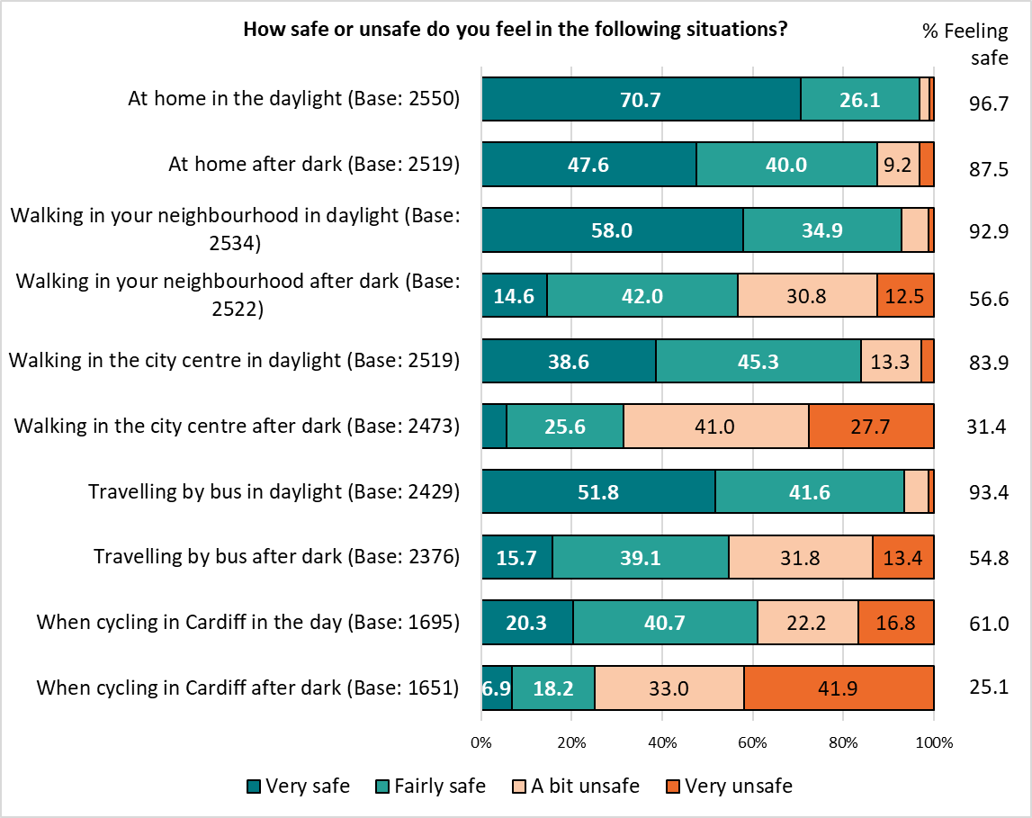Base sizes shown in brackets; excludes ‘Don’t Know’ responses.*

Respondents felt a little safer when at home after dark, when walking in their neighbourhood after dark, when walking in the city centre, both in the daylight and after dark, and when cycling after dark than in the 2022 Ask Cardiff survey.

They felt less safe when travelling by bus in daylight than in the previous year.

|  |  |  |  |
| --- | --- | --- | --- |
| % Feeling Safe | 2022 | 2021 | Difference |
| At home in the daylight | *96.7* | *96.3* | 0.4 |
| At home after dark | *87.5* | *85.9* | **1.6** |
| Walking in your neighbourhood in daylight | *92.9* | *92.8* | 0.1 |
| Walking in your neighbourhood after dark | *56.6* | *53.1* | **3.5** |
| Walking in the city centre in daylight | *83.9* | *82.8* | **1.1** |
| Walking in the city centre after dark | *31.4* | *30.3* | **1.1** |
| Travelling by bus in daylight | *93.4* | *94.3* | **-0.9** |
| Travelling by bus after dark | *54.8* | *54.4* | 0.4 |
| When cycling in Cardiff in the day | *61.0* | *60.9* | 0.1 |
| When cycling in Cardiff after dark | *25.1* | *24.5* | **0.6** |

As seen in previous surveys, women felt less safe than men in all situations, with the exception of when they were at home during the day.

Younger respondents felt less safe than their older counterparts, particularly after dark, when at home, or when walking in their local neighbourhood; they felt safer when walking in the city centre, both during the day and after dark, and when traveling by bus or cycling after dark.

|  |  |  |  |  |  |  |  |  |  |  |  |
| --- | --- | --- | --- | --- | --- | --- | --- | --- | --- | --- | --- |
| % Feeling Safe | At home | | | Walking in your neighbourhood | | Walking in the city centre | | Travelling by bus | | When cycling in Cardiff | |
|  | ***Daylight*** | ***After Dark*** | ***Daylight*** | | ***After Dark*** | ***Daylight*** | ***After Dark*** | ***Daylight*** | ***After Dark*** | ***Daylight*** | ***After Dark*** |
| Overall | *96.7* | *87.5* | *92.9* | | *56.6* | *83.9* | *31.4* | *93.4* | *54.8* | *61.0* | *25.1* |
| Under 35 | *96.6* | *86.9* | *91.6* | | *54.4* | *87.4* | *40.2* | *92.5* | *62.1* | *74.5* | *36.4* |
| 55+ | *97.3* | *90.6* | *94.2* | | *61.9* | *85.2* | *32.8* | *94.8* | *58.6* | *57.6* | *23.9* |
| Female | *97.2* | *86.8* | *92.9* | | *50.1* | *84.6* | *25.9* | *93.8* | *48.2* | *59.7* | *20.6* |
| Male | *96.7* | *90.6* | *94.4* | | *70.4* | *85.3* | *42.3* | *94.8* | *68.1* | *66.1* | *34.0* |
| ME | *95.2* | *88.7* | *91.5* | | *58.1* | *87.9* | *41.7* | *94.5* | *58.2* | *69.3* | *33.5* |
| Southern Arc | *95.6* | *84.6* | *89.5* | | *47.5* | *83.6* | *34.2* | *91.2* | *52.7* | *61.9* | *26.8* |
| Disability | *91.5* | *78.3* | *86.7* | | *44.0* | *76.1* | *20.6* | *86.6* | *43.7* | *48.6* | *21.7* |
| Welsh speaker | *98.4* | *89.9* | *94.8* | | *64.3* | *85.2* | *38.1* | *96.7* | *60.7* | *64.3* | *26.7* |
| Children in household | *97.2* | *85.5* | *92.7* | | *54.4* | *82.2* | *32.6* | *92.0* | *53.3* | *67.5* | *27.5* |
| LGBTQ+ | *95.0* | *83.9* | *89.4* | | *57.3* | *82.1* | *34.0* | *93.8* | *57.7* | *59.8* | *26.2* |

Those living in the more deprived areas of the city felt less safe than those in the least deprived areas when:

* at home, both during the day and particularly after dark
* walking in their neighbourhood, both during the day and particularly after dark (respondents living in the least deprived areas felt twice as safe when walking in their neighbourhood after dark as those living in the most deprived areas)

|  |  |  |  |  |  |  |  |  |  |  |
| --- | --- | --- | --- | --- | --- | --- | --- | --- | --- | --- |
| % Feeling Safe | At home | | Walking in your neighbourhood | | Walking in the city centre | | Travelling by bus | | When cycling in Cardiff | |
|  | ***Daylight*** | ***After Dark*** | ***Daylight*** | ***After***  ***Dark*** | ***Daylight*** | ***After Dark*** | ***Daylight*** | ***After Dark*** | ***Daylight*** | ***After Dark*** |
| Most Deprived | *93.0* | *74.8* | *82.5* | *34.0* | *82.6* | *31.8* | *90.0* | *48.4* | *65.2* | *30.6* |
| Next Most Deprived | *94.2* | *80.8* | *89.4* | *45.9* | *81.3* | *30.1* | *92.4* | *51.8* | *59.9* | *25.9* |
| Middle | *97.8* | *89.7* | *93.3* | *55.4* | *86.4* | *37.8* | *94.5* | *59.8* | *61.6* | *27.1* |
| Next Least Deprived | *99.2* | *94.0* | *97.0* | *62.9* | *83.9* | *31.9* | *95.0* | *59.6* | *64.3* | *25.8* |
| Least Deprived | *98.1* | *94.2* | *98.4* | *69.4* | *85.6* | *30.5* | *95.6* | *58.9* | *62.5* | *24.6* |
| Overall | *96.7* | *87.5* | *92.9* | *56.6* | *83.9* | *31.4* | *93.4* | *54.8* | *61.0* | *25.1* |

There was a correlation between levels of deprivation and feeling safe, with residents in the least deprived areas feeling safer when:

* At home after dark
* When walking in their neighbourhood, both during the day and after dark
* When travelling by bus in the daylight

Trend data shows levels of safety in these situations are largely unchanged since 2019. Trend data by situation is available in Appendix M.

Respondents who felt unsafe in these situations were asked to explain why they felt this way; responses for each situation were grouped into themes, with the top three reasons shown below, with full lists of themes provided in Appendix N.

|  |  |  |  |  |  |  |  |
| --- | --- | --- | --- | --- | --- | --- | --- |
| Walking in your neighbourhood | | |  | | Walking in the city centre | | |
| Gangs / Intimidating Youths | *30.3%* |  | | **Intoxicated People Drunk / On Drugs** | | *42.2%* |
| Anti-social behaviour | *23.2%* |  | | **Homelessness / Beggars** | | *32.1%* |
| Drug use / Dealing | *19.2%* |  | | **Cyclists / E-scooters** | | *12.8%* |
|  |  |  | |  | |  |
| Travelling by bus | | |  | | **Cycling** | | |
| Anti-social behaviour | *29.0%* |  | | **Poor Cycling Infrastructure** | | *25.7%* |
| Lack of security / safety measures | *23.2%* |  | | **Too many cars / Dangerous driving** | | *24.1%* |
| Intoxicated People Drunk / On Drugs | *18.2%* |  | | **Safety concerns** | | *21.7%* |

Respondents who reported feeling unsafe in any of the above situations were also asked what would make them feel safer. Again, responses were grouped into themes, with the top three for each scenario shown below, and a full breakdown for each available in Appendix O.

**When at Home**

|  |  |  |  |
| --- | --- | --- | --- |
| Theme | No. | *%* | Example Comments |
| Concerns over the local areas | 64 | *26.0* | * *The area I live has a lot of young people hanging around, taking/ dealing drugs* * *Because of the type of idiots you bring to the area* * *I live in a rough area* * *Locality is such and being a family of colour, you are always apprehensive, police cannot react as they have better things to do* |
| Anti-social behaviour | 61 | *24.8* | * *Anti social people in the area* * *Anti social neighbours* * *Because we have many antisocial behaviour activities going on in our area.* * *Level of noise and disruption in the area* |
| Burglary / theft | 58 | *23.6* | * *Worried about break-ins* * *Because people have been trying doors* * *Neighbouring properties have been burgled before in broad daylight* * *There has been multiple break ins to the shop right by our door and nothing has been done, no support offered* |

**When Walking in my Neighbourhood**

|  |  |  |  |
| --- | --- | --- | --- |
| Theme | No. | *%* | Example Comments |
| Gangs / Intimidating Youths | 273 | *30.3* | * *Groups of youngsters. I tend to avoid going out at night unless someone is picking me up* * *lot of youngsters hanging around shops* * *Youth gathering* * *It’s dark, there are lots of men around.* * *Groups are allowed to congregate in random places, outside shops, gulleys, etc.* |
| Anti-social behaviour | 209 | *23.2* | * *A lot of anti social behaviour by teenagers* * *Too many people around with covered faces* * *Bad behaviour by others* * *Dodgy people. Antisocial behaviour.* * *I don’t know all my neighbours and there are many young kids that are very rude. they even walked into my garden, messing about, lot of rubbish from them in my garden, scratched my car, etc told their parents, they are as rude as their kids.* |
| Drug use / Dealing | 173 | *19.2* | * *Lot of drug users about* * *Substance abusers in abundance.* * *Too many drinkers/druggies about* * *Drug addicts and dealers* * *Drugged up kids in local area* |

**When Walking in the City Centre**

|  |  |  |  |
| --- | --- | --- | --- |
| Theme | No. | *%* | Example Comments |
| Intoxicated People Drunk / On Drugs | 598 | *42.2* | * *Unsavoury persons, drunken persons, rowdy behaviour, especially by students. Too many bars, and cafes, too few shops* * *Lots of drunk men around* * *Lots of drug takers in the centre* * *Drunks and hooligans from nearby pubs. Drug dealing and people smoking weed in hoodies everywhere.* * *Too many drunks and drug addicts* |
| Homelessness / Beggars | 455 | *32.1* | * *Homeless population* * *Aggressive begging* * *The city has degraded quite a lot over the last decade with more homelessness and just has more of an edge to it than there was in the early 2000's* * *Lots of homeless people are addicts and are always approaching us for money* * *There are lots of desperate people with personal issues (homeless) who I’m a bit scared of.* |
| Cyclists / E-scooters | 181 | *12.8* | * *Bike and scooter riding in the pedestrian areas* * *People whizzing around on bikes - might get knocked over.* * *Cyclists in no cycle areas.* * *Too many illegal mopeds flying about the pedestrianised areas at speed* * *e scooters and cycle delivery staff speeding on pedestrianised streets after 10am.* |

**When Travelling by Bus**

|  |  |  |  |
| --- | --- | --- | --- |
| Theme | No. | % | Example Comments |
| Anti-social behaviour | 223 | *29.0* | * *Antisocial behaviour* * *Public transport is terrible. I’ve witnessed people urinating and fighting on buses.* * *Too many antisocial people about* * *Antisocial behaviour on bus by kids and teenagers* * *No respect anymore* |
| Lack of security / safety measures | 178 | *23.2* | * *Number of people carrying knives* * *I was verbally attacked on a Cardiff Bus by a drunk. It was traumatic and Cardiff Bus did not respond in any helpful manner. They should be ashamed of themselves.* * *Driver is totally on their own buses often not very crowded. No help if attacked.* * *Lack of security* * *I'm a driver. No immediate police support or inspection.* |
| Intoxicated People Drunk / On Drugs | 140 | *18.2* | * *Concerned about people who have been drinking.* * *Drunk passengers can be very intimidating.* * *At night people can be drunk and I've had unwanted advances on a bus* * *Excess drug and alcohol use evident.* * *Get rid of the drunks* |

**When Cycling**

|  |  |  |  |
| --- | --- | --- | --- |
| Theme | No. | *%* | Example comments |
| Poor Cycling Infrastructure | 235 | *25.7* | * *the cycle routes aren't joined up* * *Chaotic cycle lanes* * *The cycle routes don't join up, leave you stranded on the wrong side of the street often, and generally are poorly organised!* * *Cycling infrastructure is still poor, except in the very centre* * *Because the cycling lanes in Cardiff are a joke* |
| Too many cars / Dangerous driving | 221 | *24.1* | * *Too many idiot drivers on the roads* * *Dangerous drivers* * *Poor driving* * *Appalling road surfaces and appalling driving standards.* * *Some car drivers don't give a damn* |
| Safety concerns | 199 | *21.7* | * *The bike paths are poorly lit, as a female on a bike there are occasion’s whereby I feel a bit worried to travel alone at night.* * *In the dark - visibility and people driving under the influence of drugs. Also drug dealers hanging about make me feel unsafe.* * *not enough separation from motor transport* * *travelling on a road with large vehicles is by its very definition dangerous* * *Roads are unsafe* |

**Section 6:**

# **Environment**

**31. To what extent do you agree with the following statements?**

More than two-fifths of respondents rated air quality in Cardiff as good (44.7%), the highest proportion in the last five years (including in 2020 when lockdowns during the pandemic restricted the use of vehicles).

*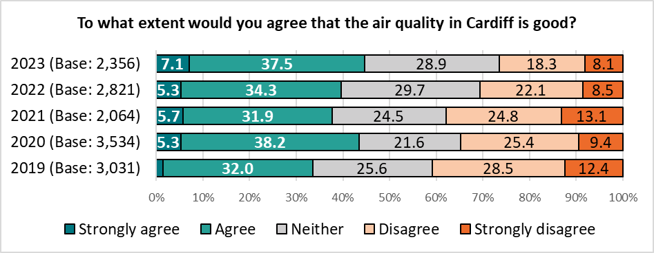Base sizes shown in brackets; excludes ‘Don’t Know’ responses.*

More than half of respondents from a minority ethnicity (52.9%), men (51.3%) and those under 35 (50.6%) rated air quality as good, contrasting with those identifying as disabled (36.6%) and women (40.9%).

*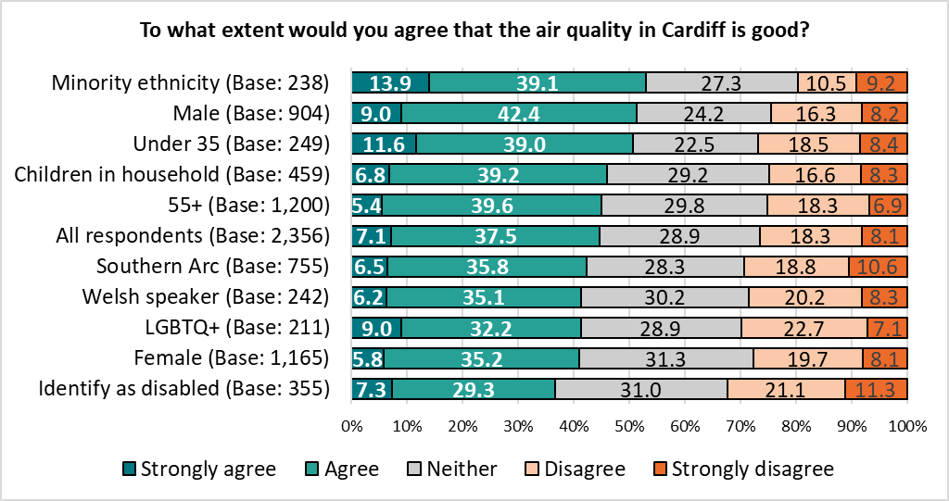Base sizes shown in brackets; excludes ‘Don’t Know’ responses.*

There was no clear correlation between rating of air quality in the city and the level of deprivation.

Just over a quarter of respondents (27.9%) agreed that Cardiff has a clean environment, reflecting the findings of the 2022 and 2021 surveys, but below levels seen during and before the pandemic.

*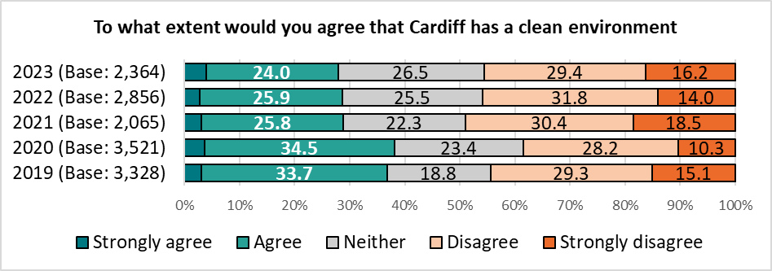Base sizes shown in brackets; excludes ‘Don’t Know’ responses.*

Younger respondents and those from a minority ethnicity were most likely to agree that ‘Cardiff has a clean environment’ (35.5% and 35.0% respectively, reflecting the findings of the 2022 survey, albeit at a slightly lower level). Those identifying as disabled, or living in the Southern Arc were least likely to agree (23.0% and 24.9% respectively).

*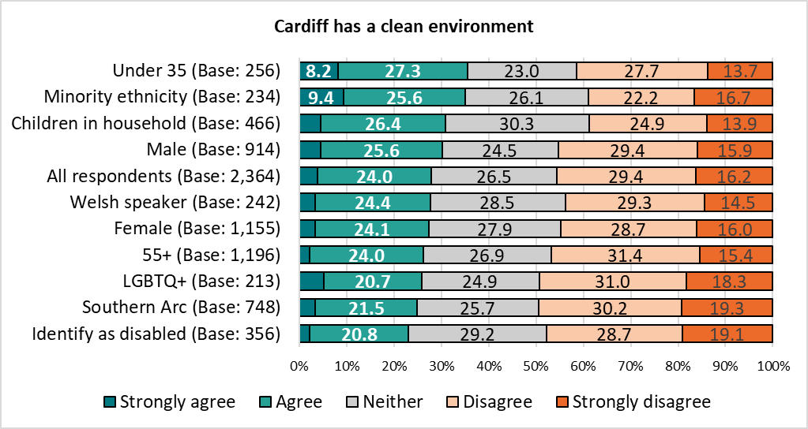Base sizes shown in brackets; excludes ‘Don’t Know’ responses.*

There was not a clear correlation with level of deprivation, although respondents living in the least deprived areas were most likely to agree with the statement (32.8%, compared with 24.4% of those in the most deprived areas).

*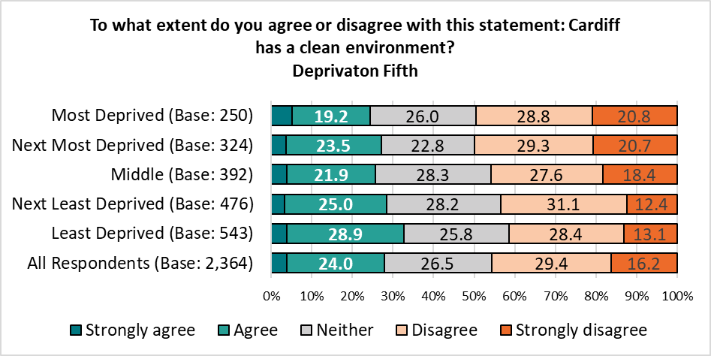Base sizes shown in brackets; excludes ‘Don’t Know’ responses.*

**32. Over the last 12 months, would you say the cleanliness in your local area has:**

Almost half of those answering this question (46.2%) reported the cleanliness in their local area had declined over the last year, the largest proportion in the last five years. Just 2.5% of respondents felt the level of cleanliness in their local area had improved. [*Note: Waste operatives were involved in industrial action whilst the survey was live, potentially impacting these results.*]

*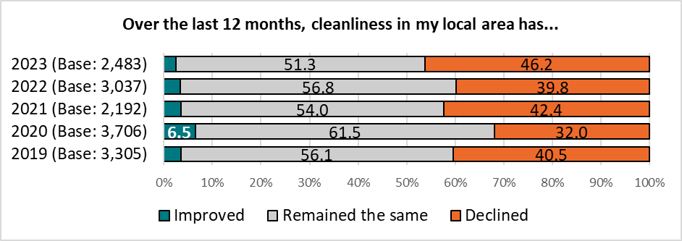Base sizes shown in brackets; excludes ‘Don’t Know’ responses.*

The proportion of those stating cleanliness in their local area had declined ranged from 36.3% of those aged under 35 to 53.2% of respondents living in the Southern Arc.

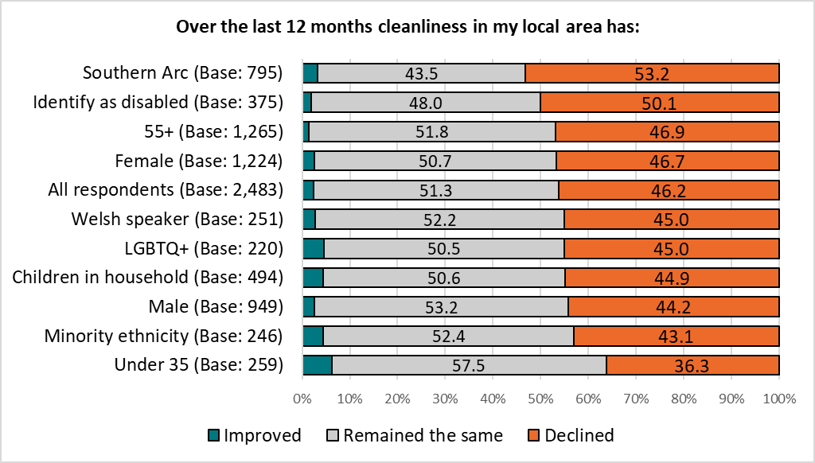*Base sizes shown in brackets; excludes ‘Don’t Know’ responses.*

There was a clear correlation between level of deprivation and the proportion of respondents reporting a decline in the cleanliness, with almost two-thirds of those in the most deprived areas reporting a decline in cleanliness compared with 36.9% of those in the least deprived areas.

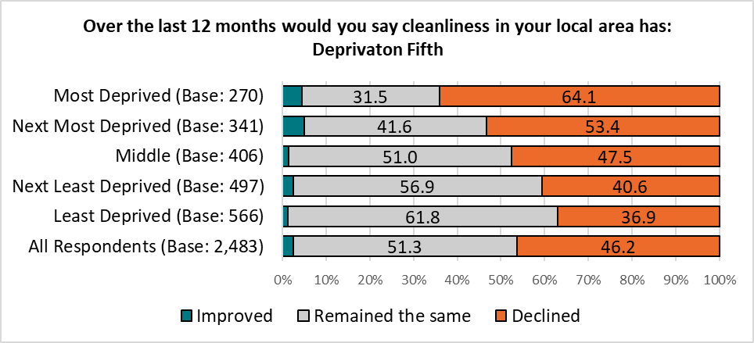*Base sizes shown in brackets; excludes ‘Don’t Know’ responses.*

**33. How concerned are you about Climate Emergency?**

The majority of respondents expressed concern about Climate Emergency, reflecting the findings of previous surveys, although the number reporting concern fell from 84.1% in 2022 to 76.5%.

Levels of concern ranged from 86.6% amongst those identifying as LGBTQ+ to 69.8% amongst men, with more than half of the former group, and under 35s stating they were ‘very concerned’.

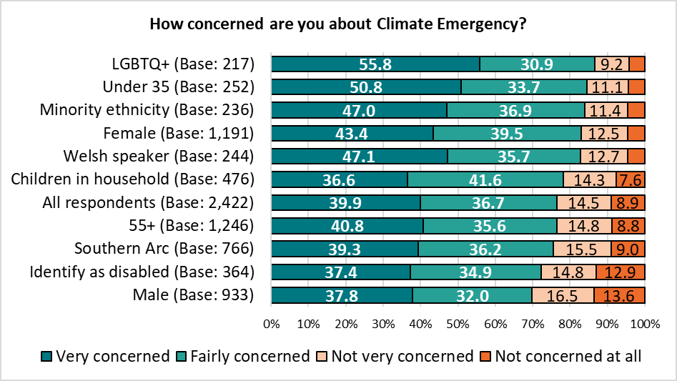*Base sizes shown in brackets; excludes ‘Don’t Know’ responses.*

There was no correlation with level of deprivation.

**Do you feel the Council is doing enough to respond to the challenge of Climate Emergency?**

Looking at all responses, around two in five (41.5%) were unsure if the Council was doing enough to respond to the challenges of Climate Emergency. When excluding those answering, ‘Don’t know’, almost two-thirds (62.6%) felt the Council was not doing enough to respond to the Climate Emergency, reflecting the findings of the 2022 Ask Cardiff survey.

*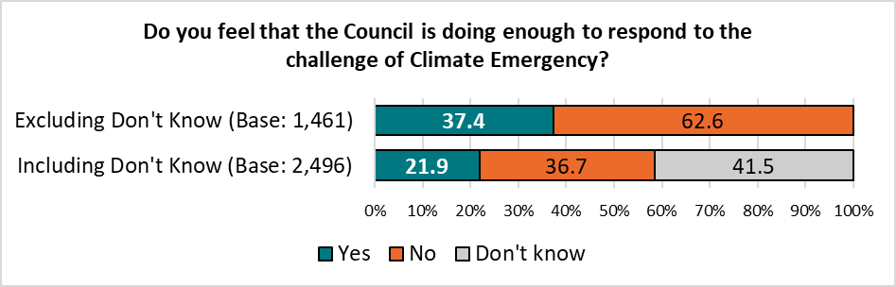 Base sizes shown in brackets.*

Perhaps reflecting the pattern of concern about the Climate Emergency, those identifying as LGBTQ+ were least likely to feel the Council was doing enough, contrasting with men (26.2% compared with 40.5% respectively).

*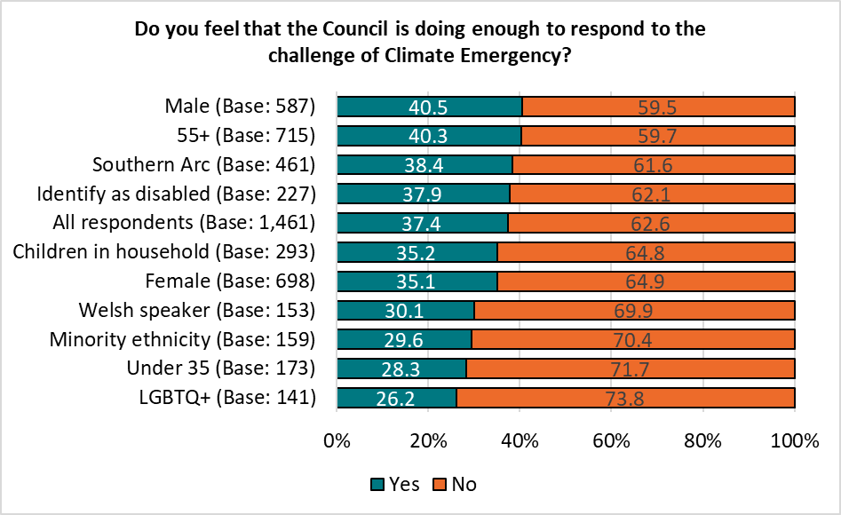Base sizes shown in brackets; excludes ‘Don’t Know’ responses.*

There was no correlation with level of deprivation.

**Section 9:**

# **Budget Priorities**

**34. The inflationary pressures that are affecting organisations and households nationwide are placing the Council’s budget under pressure. Faced with rising costs and demand, there will be a need to prioritise scarce resources when setting the 2024/25 Budget.**

Respondents were given a list of services provided by the Council, and asked to prioritise the Council’s available resources both for the next financial year, and in the longer term.

Scores were generated based on the number of votes for first place, second place and so on, giving each service a total score out of 12 – the higher the score, the more important the service.

**Priorities for 2024/25**

Schools and Education, including Youth Services, was seen as the most important service, with a score of 9.3 out of 12. Over a third of respondents (36.2%) ranked this as their most important priority, with three-fifths (58.5%) putting this in their top three priorities.

This was followed by supporting vulnerable children and families (scoring 8.7, with 12.9% placing this as their most important priority) and supporting vulnerable adults and older people (scoring 8.4, with 8.0% of first place votes).

These findings reflect the priorities highlighted in the 2022 and 2021 Ask Cardiff surveys.

Possibly due to the industrial action on-going whilst the survey was live, Recycling and Waste Services moved up to fourth place, with its score increasing from 7.6 to 7.9; Neighbourhood Services, including Street Cleansing, also saw its score increase from 6.5 to 6.7.

‘Culture, Venues and Events’ was seen as the lowest priority, gaining a score of 4.0, with 0.8% of first place votes.

**Priorities for the Longer Term**

The pattern of priorities for the longer term broadly matched those for the next financial year; ‘Delivery of the One Planet Cardiff Strategy’ and ‘Major projects including infrastructure to support businesses, local economy, city centre and local community centres’ were given a higher priority in the longer term, with at least one in six respondents ranking each in their top three priorities.

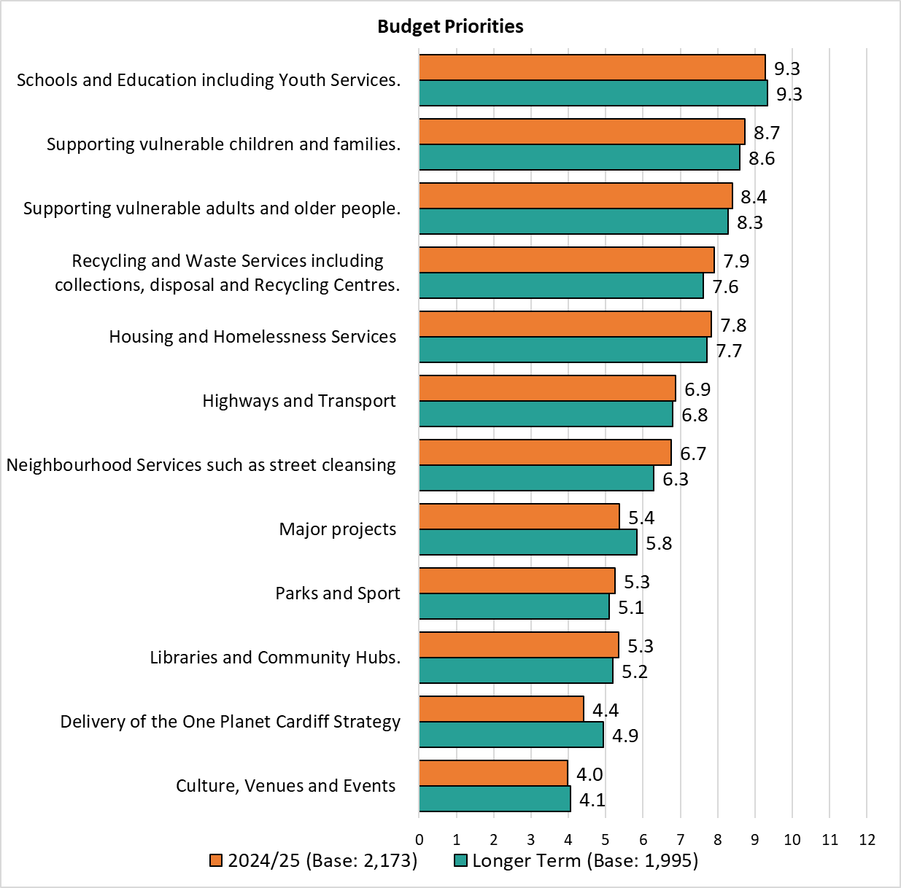

Priorities were broadly consistent across the different demographic and geographic groups analysed. A full breakdown is available in Appendix P.

**Section 10:**

# **Family Services & Social Care**

**35. Are you aware of Cardiff Family Advice and Support Service?**

Respondents were asked if they were aware of Cardiff Family Advice & Support Service with a quarter (25.5%) stating they were.



**Have you used Cardiff Family Advice and Support Service within the last 12 months?**

Respondents who were aware of the Cardiff Family Advice and Support Service were then asked if they had used this service in the past 12 months, with one in twelve (8.6%) stating that they had.

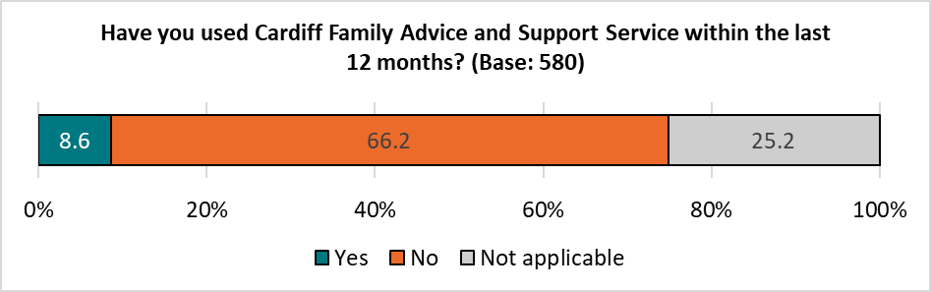

**How satisfied or dissatisfied are you with Cardiff Family Advice and Support Service?**

Respondents who had used the service were asked how satisfied or dissatisfied they were with it. Of the 50 respondents answering this question, two-thirds (66.0%) were satisfied, with a quarter (28.0%) stated they were dissatisfied.

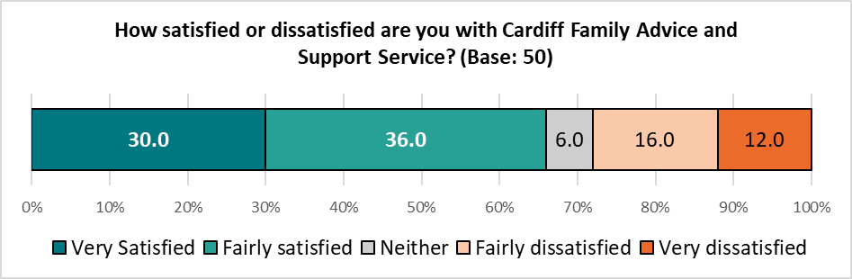  *Caution should be taken with low base sizes.*

**36. Are you a parent of a child under 25 with additional needs?**

Of those responding to this question, 4.8%, or 109 individuals, were identified as a parent of a child aged under 25 with additional needs.

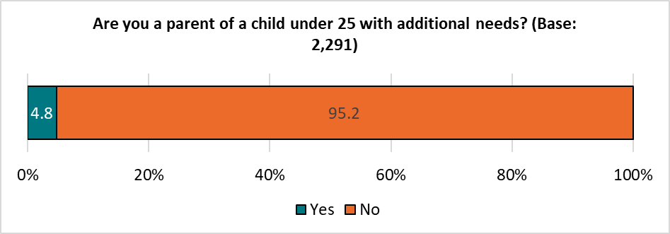

Those answering ‘Yes’ were then asked the following questions:

**Have you accessed support for your child?**

Of those answering this question, just over half (52.4%) had accessed support.

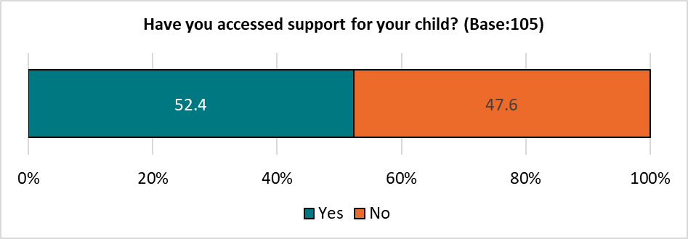

Those accessing support were asked to give further details of the kind of support they had accessed; 41 responses were received, and categorised into themes. The top three themes are shown below, with a full breakdown available in Appendix Q:

|  |  |  |  |
| --- | --- | --- | --- |
| Theme | No. | % | Example Comments |
| Via School | 14 | *34.1* | * *Increased school support* * *Statement of educational need* * *Via local education. Autism base at Llanishen School was fantastic.* |
| Mental Health | 5 | *12.2* | * *CAMHS, neuro developmental team at St David’s* * *Community Mental health* |
| ALN Support | 5 | *12.2* | * *Undergoing ALN assessment with ED Psych in school* * *A school for children with ALN* |

*Respondents could select multiple options so the total will exceed 100%.*

**How satisfied or dissatisfied are you with the services you received?**

Just over half (52.7%) of those accessing support were satisfied with the services they had received, with two in five (40.0%) stating they were dissatisfied.

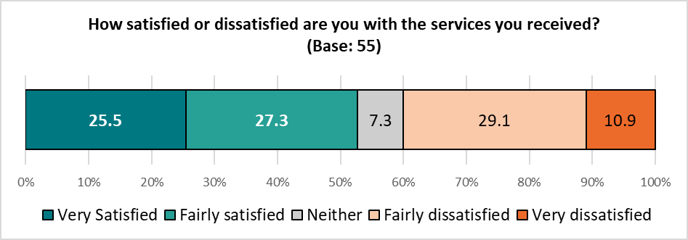 *Caution should be taken with low base sizes.*

**Please tell us why you have not accessed support:**

Those who did not access support were asked why they did not; 39 comments were received, and grouped into themes. The top three are shown below, with a full breakdown in Appendix R

|  |  |  |  |
| --- | --- | --- | --- |
| Theme | No. | % | Example Comments |
| Unaware | 9 | *23.1* | * *Don't know what's available* * *not sure how to get accessed support* |
| Cannot get support I need | 9 | *23.1* | * *Support I need isn’t available* * *I have tried countless times never given help or support.* |
| Not needed | 8 | *20.5* | * *We don't need it currently.* * *Not required at this time* |

**Are you aware of the Disability Index?**

Respondents with a child aged under 25 with additional needs were asked if they were aware of the Disability Index – three in ten (31.8%) said they were.

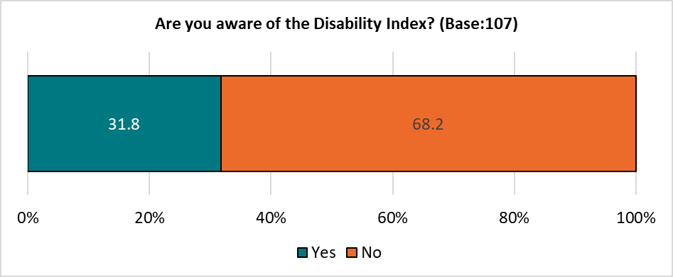

**37. Has anyone in your household accessed social care from the Council?**

Amongst those responding to this question, 7.3% reported that someone in their household had accessed social care from the Council; 5.9% of these had accessed care for an adult, and 1.8% for a child, reflecting the results of previous Ask Cardiff surveys.

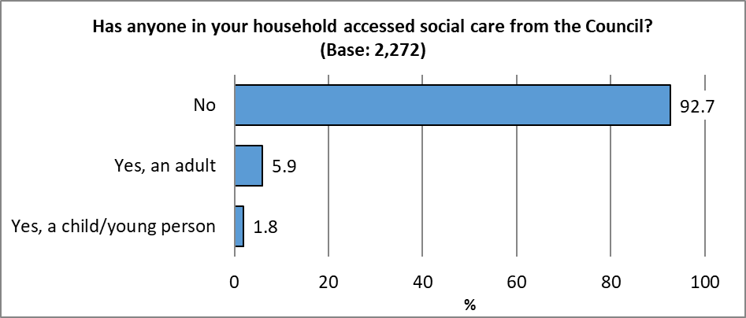  *Respondents could select multiple options so the total will exceed 100%.*

**How satisfied were they with the service they received?**

Just over half of those who had accessed social care for an adult were satisfied with this service (55.8%, reflecting the findings of the 2022 survey); 32.5% of those accessing this service for a child were satisfied, down from 49.0% in 2022.

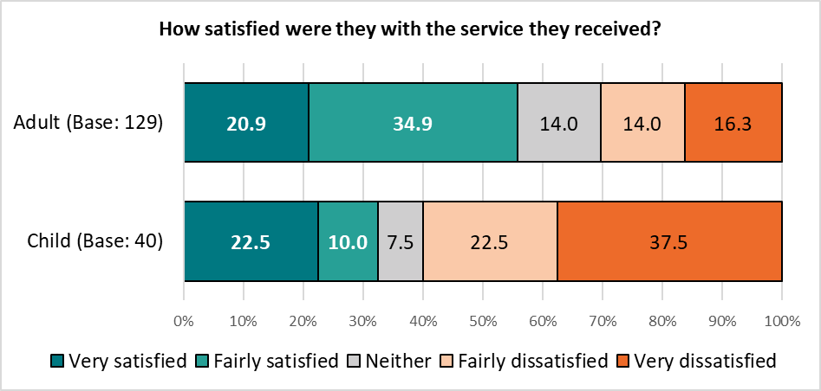 *Base sizes shown in brackets; excludes ‘Don’t Know’ responses. Caution should be taken with low base sizes.*

**Section 12:**

# **Any Other Comments**

**38. Do you have any other feedback for us? This could include comments about your experiences of Council services, what the Council does well, what we could do better, or what you’d like to see in the future.**

Respondents were asked for any other comments they wished the Council to be made aware of; 1,138 comments were received, which have been grouped into themes. The top three themes are shown below, with a full breakdown in Appendix S.

|  |  |  |  |
| --- | --- | --- | --- |
| Theme | No. | % | Example Comments |
| Recycling & Waste / Street Cleaning / Refuse Issues / Pollution | 342 | *30.1* | * *Cleanliness of streets has decline rapidly since pandemic. On a positive note, the recycling centres in Cardiff are great and the staff are a credit to you.* * *Refuse collection needs improvement. Timing of Garden waste cut off over winter is poor* * *Cardiff is so dirty. Many more bins required and more street cleaning.* * *Waste awareness, education and enforcement. The council spends so much on clearing flytipping from the same hotspots in my community every week. Surely it would make more sense to tackle it at source and deter those who do it?* * *Used to have someone picking up litter every week in this area, haven't seen anyone for months* * *Please sort out the issues re rubbish collection* |
| Highways / Roads / Pavements / Walkways / Cycle lanes | 288 | *25.3* | * *The roads for a capital city is shocking. Every time it rains many roads flood making it dangerous to cycle and wet for pedestrians. Nothing has changed in the 36 years of living here.* * *Drains at side of the roads need cleaning of debris* * *Streets are so narrow, parking facilities to houses essential* * *Stop messing with the roads and invest in schools, homes and care* * *Get rid of cycle lanes and replace with bus lanes - busses carry more people; increase speeds to 30 mph on more routes into city centre to speed the bus journey times* * *Look after the walkways and pavements around the city.* |
| Improve Public Transport | 241 | *21.2* | * *Cardiff forgets outlying villages. You are making it difficult to drive into the centre but we have no reliable public transport.* * *The Council needs to force TfW to run train services on the City line on a Sunday* * *A central bus station is needed to link with the central train station as it used to be. This could be out at the back of the train station. Also, an underground system like the tube in London would be a good option to link the city centre to all areas of the city and help take the strain off the roads. This could then make it safer for cyclists.* * *Public transport needs to increased massively and made more reliable* * *Bus services in Cardiff are not good enough. Unreliable and after 6pm not frequent enough. Until this is resolved car use will remain too high.* * *you want people out of their cars, then please support bus services* |

**Section 13:**

# **About You**

**What is your home postcode?**

**What was your age on your last birthday?**

|  |  |  |  |  |  |  |
| --- | --- | --- | --- | --- | --- | --- |
|  | No. | % |  | % | Ask Cardiff 2023 | 2022 Mid-Year Estimate |
| Under 16 | 2 | *0.1* |  | 16-34 | *11.7* | *40.0* |
| 16-24 | 34 | *1.1* |  | 35-54 | *31.3* | *29.5* |
| 25-34 | 229 | *7.2* |  | 55+ | *57.0* | *30.4* |
| 35-44 | 355 | *11.1* |  |  |  |  |
| 45-54 | 351 | *11.0* |  |  |  |  |
| 55-64 | 535 | *16.8* |  |  |  |  |
| 65-74 | 518 | *16.3* |  |  |  |  |
| 75+ | 234 | *7.3* |  |  |  |  |
| Prefer not to say | 64 | *2.0* |  |  |  |  |
| Total | 2,322 | *100.0* |  |  |  |  |

*Note: Figures comparing against the Mid-Year estimates excludes ‘Prefer not to say’ and under 16s*

**Are you…?**

|  |  |  |  |
| --- | --- | --- | --- |
|  | No. | % | 2022 Mid-Year Estimate |
| Female | 1243 | *53.9* | *48.6* |
| Male | 965 | *41.9* | *51.4* |
| Non-binary | 16 | *0.7* | *-* |
| Prefer not to say | 81 | *3.5* | *-* |
| Total | 2,305 | *100.0* | *100.0* |

**Do you identify as Trans?**

|  |  |  |
| --- | --- | --- |
|  | No. | % |
| Yes | 12 | *0.5* |
| No | 2149 | *94.5* |
| Prefer to self-describe | 8 | *0.4* |
| Prefer not to say | 106 | *4.7* |
| Total | 2,275 | *100.0* |

**Do any children live in your household?**

|  |  |  |
| --- | --- | --- |
|  | No. | % |
| No children | 1754 | *77.7* |
| Yes, under 5 years old (pre-school) | 133 | *5.9* |
| Yes, aged 5 - 11 (primary school) | 217 | *9.6* |
| Yes, aged 11 - 16 (secondary school) | 197 | *8.7* |
| Yes, aged 16 - 18 in full-time education, or working | 101 | *4.5* |
| Yes, aged 16 - 18 but not in full time education or working | 10 | *0.4* |
| Total | 2,257 | *-* |

*Respondents could select multiple options so the total will exceed 100%.*

**Are you pregnant, or have you given birth within the last 26 weeks?**

|  |  |  |
| --- | --- | --- |
|  | No. | *%* |
| Yes, I’m pregnant | 16 | *0.7* |
| Yes, I’ve given birth | 11 | *0.5* |
| No | 2146 | *96.1* |
| Prefer not to say | 59 | *2.6* |
| Not specified | 16 | *0.7* |
| Total | 2,232 | *100.0* |

**Do you care unpaid, for a friend or family member who due to illness, disability, a mental health problem or an addiction cannot cope without your support?**

|  |  |  |
| --- | --- | --- |
|  | No. | % |
| Yes | 441 | *19.5* |
| No | 1710 | *75.7* |
| Prefer not to say | 107 | *4.7* |
| Total | 2,258 | *100.0* |

**Which of the following best describes what you are doing at present?**

|  |  |  |
| --- | --- | --- |
|  | No. | *%* |
| Working full-time (30+ hours per week) | 952 | *41.4* |
| Working part-time (less than 30 hours per week) | 267 | *11.6* |
| On a government training scheme | 0 | *0.0* |
| In full time education | 23 | *1.0* |
| Unemployed - Registered Job Seeker | 20 | *0.9* |
| On a zero-hour contract | 15 | *0.7* |
| Permanently sick or disabled person | 111 | *4.8* |
| Wholly retired from work | 717 | *31.2* |
| Looking after home | 22 | *1.0* |
| Caring for a child or adult | 64 | *2.8* |
| Unemployed - Unregistered but seeking work | 24 | *1.0* |
| Other | 83 | *3.6* |
| Total | 2,298 | *100.0* |

**Which of the following best describes your housing tenure?**

|  |  |  |
| --- | --- | --- |
|  | No. | *%* |
| Owned outright | 1120 | 49.2 |
| Owned with a mortgage | 721 | 31.7 |
| Rented from Local Authority | 74 | 3.3 |
| Rented from a Housing Association | 87 | 3.8 |
| Private rented | 207 | 9.1 |
| Other | 66 | 2.9 |
| Total | 2,275 | *100.0* |

**Are you or a member of your household:**

|  |  |  |  |  |
| --- | --- | --- | --- | --- |
|  | You | | A member of your household | |
|  | No. | *%* | No. | *%* |
| Currently serving | 6 | *0.3* | 4 | *0.2* |
| An armed forces service leaver (Veteran) | 60 | *2.8* | 39 | *2.1* |
| Not applicable | 2073 | *96.9* | 1845 | *97.7* |
| Total | 2,139 | *-* | 1,888 | *-* |

**Do you identify as a disabled person?**

|  |  |  |
| --- | --- | --- |
|  | No. | % |
| Yes | 383 | *17.0* |
| No | 1760 | *78.0* |
| Prefer not to say | 114 | *5.1* |
| Total | 2,257 | *100.0* |

**Please tick any of the following that apply to you:**

|  |  |  |
| --- | --- | --- |
|  | No. | % |
| Deaf/Deafened/Hard of Hearing | 242 | *11.6* |
| Learning impairment/difficulties | 29 | *1.4* |
| Wheelchair user | 21 | *1.0* |
| Long-standing illness or health condition (e.g. cancer, HIV, diabetes or asthma) | 488 | *23.3* |
| Mental health difficulties | 275 | *13.1* |
| Visual impairment | 96 | *4.6* |
| Mobility impairment | 283 | *13.5* |
| Neurodivergent (e.g. Attention Deficit Disorders, Autism, Dyslexia, Dyspraxia, Dyscalculia and Dysgraphia) | 115 | *5.5* |
| Prefer not to say | 103 | *4.9* |
| Other | 60 | *2.9* |
| None of these | 1013 | *48.4* |
| Total | 2,094 | *-* |

**Do you regard yourself as belonging to any particular religion?**

|  |  |  |
| --- | --- | --- |
|  | No. | % |
| No, no religion | 1082 | *47.2* |
| Christian (Including Church in Wales, Catholic, Protestant and all other Christian denominations) | 925 | *40.4* |
| Muslim | 53 | *2.3* |
| Hindu | 33 | *1.4* |
| Buddhist | 15 | *0.7* |
| Jewish | 6 | *0.3* |
| Sikh | 1 | *0.0* |
| Other | 42 | *1.8* |
| Prefer not to answer | 135 | *5.9* |
| Total | 2,292 | *100.0* |

**How would you describe your sexual orientation?**

|  |  |  |
| --- | --- | --- |
|  | No. | % |
| Bisexual | 82 | *3.6* |
| Gay Woman/Lesbian | 30 | *1.3* |
| Gay Man | 67 | *3.0* |
| Heterosexual/Straight | 1833 | *81.1* |
| Other | 32 | *1.4* |
| Prefer not to answer | 216 | *9.6* |
| Total | 2,260 | *100.0* |

**Are you:**

|  |  |  |
| --- | --- | --- |
|  | No. | % |
| Single | 427 | *18.9* |
| In a same-sex Civil Partnership | 16 | *0.7* |
| Married | 1220 | *53.9* |
| Living together / Cohabiting | 297 | *13.1* |
| Separated/divorced or legally separated if formerly in a same-sex Civil Partnership | 130 | *5.7* |
| Widowed | 114 | *5.0* |
| Other | 61 | *2.7* |
| Total | 2,265 | *100.0* |

**How would you describe your Welsh language skills?**

|  |  |  |
| --- | --- | --- |
|  | No. | % |
| None | 126 | *5.6* |
| Learner | 129 | *5.7* |
| Basic | 448 | *19.8* |
| Moderate | 403 | *17.8* |
| Fluent | 1161 | *51.2* |
| Total | 2,267 | *100.0* |

**Do you consider yourself to be Welsh?**

|  |  |  |
| --- | --- | --- |
|  | No. | % |
| Yes | 1507 | *66.6* |
| No | 755 | *33.4* |
| Total | 2,262 | *100.0* |

**What is your ethnic group?**

|  |  |  |  |
| --- | --- | --- | --- |
|  | No. | % | 2021 Census |
| White - Welsh/English/Scottish/Northern Irish/British | 1888 | *82.7* | *73.6* |
| White - Irish | 23 | *1.0* | *0.6* |
| White - Gypsy or Irish Traveller | 3 | *0.1* | *0.2* |
| White - Any other white background | 107 | *4.7* | *4.6* |
| Mixed/Multiple Ethnic Groups - White & Asian Welsh / British / Other | 13 | *0.6* | *1.2* |
| Mixed/Multiple Ethnic Groups - White and Black African Welsh / British / Other | 5 | *0.2* | *0.7* |
| Mixed/Multiple Ethnic Groups - White and Black Caribbean Welsh / British / Other | 10 | *0.4* | *1.0* |
| Mixed/Multiple Ethnic Groups - Any other | 11 | *0.5* | *1.1* |
| Asian/Asian Welsh/British - Bangladeshi | 7 | *0.3* | *2.4* |
| Asian/Asian Welsh/British - Chinese | 9 | *0.4* | *2.4* |
| Asian/Asian Welsh/British - Indian | 37 | *1.6* | *1.9* |
| Asian/Asian Welsh/British – Pakistani | 9 | *0.4* | *1.4* |
| Asian/Asian Welsh/British - Any other | 16 | *0.7* | *1.6* |
| Black/African/Caribbean/Black Welsh/British - African | 11 | *0.5* | *0.4* |
| Black/African/Caribbean/Black Welsh/British – Caribbean | 4 | *0.2* | *2.9* |
| Black/African/Caribbean/Black Welsh/British - Any other | 1 | *0.0* | *0.5* |
| Arab | 16 | *0.7* | *1.8* |
| Any other ethnic group (please specify) | 23 | *1.0* | *1.5* |
| Prefer not to say | 90 | *3.9* | *-* |
| Total | 2,283 | *100.0* | *100.0* |

# **Appendix A – Attitudes to Activities & Events in Your Community by Demographic**

# **Appendix B - How do you prefer to access information about services, events, etc?**

|  |  |  |  |  |  |  |
| --- | --- | --- | --- | --- | --- | --- |
|  | All respondents | Under 35 | 55+ | Female | Male | Minority ethnicity |
| Base | **2837** | **263** | **1280** | **1236** | **960** | **250** |
| Websites | 73.1 | 69.6 | 73.5 | 72.4 | 75.7 | 69.6 |
| Social Media | 54.4 | 73.0 | 44.4 | 61.2 | 42.6 | 56.8 |
| Email | 55.8 | 47.5 | 62.7 | 54.9 | 62.3 | 56.0 |
| Messaging platforms (e.g. WhatsApp groups) | 18.0 | 13.7 | 19.3 | 18.7 | 17.7 | 22.4 |
| Other digital format | 4.4 | 3.4 | 4.0 | 3.7 | 4.9 | 4.0 |
| I don't want to / can't access information digitally | 3.9 | 2.3 | 4.6 | 3.5 | 3.4 | 3.2 |
| Posters/flyers/leaflets in community buildings | 49.8 | 55.9 | 49.1 | 58.1 | 40.4 | 55.2 |
| Newsletters | 34.2 | 24.7 | 39.9 | 35.8 | 34.9 | 32.4 |
| Radio | 14.7 | 12.2 | 16.0 | 14.5 | 13.6 | 14.4 |
| Billboards/bus stops/screens | 28.7 | 38.8 | 26.3 | 33.5 | 25.0 | 32.4 |
| Letters | 25.6 | 31.6 | 25.1 | 24.2 | 27.8 | 28.0 |
| Telephone/text | 8.8 | 9.1 | 9.5 | 8.6 | 9.2 | 11.2 |
| Other non-digital format | 1.8 | 0.4 | 2.0 | 1.6 | 1.5 | 0.4 |
| I prefer to access information digitally | 18.3 | 17.9 | 16.8 | 15.7 | 20.9 | 16.0 |

|  |  |  |  |  |  |  |
| --- | --- | --- | --- | --- | --- | --- |
|  | All respondents | Identify as disabled | Welsh speaker | Southern Arc | Children in household | LGBTQ+ |
| Base | **2837** | **380** | **252** | **799** | **499** | **223** |
| Websites | 73.1 | 71.1 | 74.6 | 72.7 | 73.5 | 73.5 |
| Social Media | 54.4 | 51.6 | 59.5 | 58.8 | 66.1 | 62.3 |
| Email | 55.8 | 61.8 | 58.7 | 53.3 | 53.3 | 59.6 |
| Messaging platforms (e.g. WhatsApp groups) | 18.0 | 16.8 | 20.2 | 18.1 | 18.8 | 17.5 |
| Other digital format | 4.4 | 5.8 | 4.8 | 3.6 | 4.8 | 6.3 |
| I don't want to / can't access information digitally | 3.9 | 6.1 | 2.8 | 3.3 | 1.8 | 2.2 |
| Posters/flyers/leaflets in community buildings | 49.8 | 48.9 | 54.4 | 51.9 | 52.5 | 47.5 |
| Newsletters | 34.2 | 38.7 | 35.7 | 53.3 | 30.5 | 33.6 |
| Radio | 14.7 | 12.9 | 17.1 | 15.4 | 12.6 | 14.8 |
| Billboards/bus stops/screens | 28.7 | 27.6 | 34.9 | 34.0 | 31.7 | 37.7 |
| Letters | 25.6 | 33.9 | 20.2 | 28.2 | 27.5 | 25.6 |
| Telephone/text | 8.8 | 13.9 | 9.5 | 9.6 | 7.2 | 9.9 |
| Other non-digital format | 1.8 | 1.8 | 1.2 | 1.1 | 1.2 | 3.1 |
| I prefer to access information digitally | 18.3 | 17.4 | 13.5 | 16.3 | 17.4 | 22.0 |

|  |  |  |  |  |  |  |
| --- | --- | --- | --- | --- | --- | --- |
|  | All Respondents | Least Deprived | Next Least Deprived | Middle | Next Most | Most Deprived |
| Base | **2837** | **527** | **501** | **410** | **344** | **272** |
| Websites | 73.1 | 78.8 | 77.8 | 71.5 | 74.1 | 70.2 |
| Social Media | 54.4 | 48.3 | 51.1 | 53.9 | 54.7 | 68.0 |
| Email | 55.8 | 61.4 | 58.5 | 55.4 | 53.2 | 59.2 |
| Messaging platforms (e.g. WhatsApp groups) | 18.0 | 19.2 | 18.6 | 17.1 | 17.4 | 19.5 |
| Other digital format | 4.4 | 3.7 | 5.0 | 4.4 | 3.5 | 3.7 |
| I don't want to / can't access information digitally | 3.9 | 2.1 | 5.0 | 4.1 | 2.9 | 2.9 |
| Posters/flyers/leaflets in community buildings | 49.8 | 51.4 | 47.3 | 54.4 | 50.9 | 54.4 |
| Newsletters | 34.2 | 39.7 | 35.9 | 32.0 | 31.1 | 32.7 |
| Radio | 14.7 | 12.6 | 16.0 | 15.6 | 12.2 | 14.3 |
| Billboards/bus stops/screens | 28.7 | 24.1 | 28.9 | 34.1 | 31.1 | 35.3 |
| Letters | 25.6 | 20.6 | 21.8 | 27.8 | 30.8 | 33.5 |
| Telephone/text | 8.8 | 7.0 | 8.0 | 7.6 | 9.6 | 13.6 |
| Other non-digital format | 1.8 | 1.0 | 2.2 | 2.2 | 0.6 | 0.7 |
| I prefer to access information digitally | 18.3 | 19.4 | 20.8 | 16.6 | 18.0 | 12.9 |

# **Appendix C – What Services Delivered Within Your Local Hub / Library Do You Find Most Helpful To You?**

|  |  |  |  |  |  |  |
| --- | --- | --- | --- | --- | --- | --- |
|  | All respondents | Under 35 | 55+ | Female | Male | Minority ethnicity |
| Base | *3143* | *259* | *1268* | *1225* | *950* | *249* |
| Money Advice | *5.5* | *10.8* | *5.0* | *6.7* | *5.8* | *14.5* |
| Housing & Benefit Advice | *7.3* | *12.4* | *7.3* | *8.7* | *8.2* | *16.1* |
| Into Work Services | *3.3* | *11.6* | *2.0* | *4.2* | *3.1* | *12.9* |
| Job clubs | *2.3* | *6.6* | *1.5* | *2.6* | *2.5* | *7.6* |
| Adult Learning | *7.1* | *9.7* | *7.9* | *9.1* | *6.6* | *14.9* |
| Coffee mornings | *5.1* | *6.2* | *5.8* | *6.7* | *4.7* | *8.4* |
| Volunteer opportunities | *5.7* | *6.9* | *7.0* | *7.8* | *5.4* | *9.2* |
| Community events | *10.8* | *8.9* | *13.2* | *15.3* | *9.1* | *15.7* |
| Café provision | *8.0* | *10.8* | *8.0* | *10.3* | *7.2* | *8.8* |
| Friends & neighbours groups | *5.7* | *4.6* | *6.6* | *7.3* | *4.9* | *8.4* |
| Author talks | *4.2* | *4.6* | *5.3* | *6.2* | *2.6* | *5.6* |
| Reading Groups | *4.3* | *7.3* | *4.7* | *6.4* | *3.2* | *7.2* |
| Book loan | *32.1* | *40.5* | *38.5* | *43.2* | *32.0* | *41.0* |
| Health & wellbeing materials (including books on Prescription / information leaflets) | *4.5* | *7.7* | *5.0* | *7.1* | *3.6* | *8.8* |
| Exercise classes | *6.8* | *9.7* | *7.3* | *10.4* | *5.1* | *10.4* |
| ESOL classes | *1.3* | *4.2* | *0.9* | *1.8* | *1.1* | *5.2* |
| PC use & digital assistance | *7.7* | *11.6* | *9.5* | *9.1* | *9.5* | *11.2* |
| E Reader loan | *2.7* | *3.1* | *3.3* | *3.8* | *2.2* | *6.8* |
| Childrens activities including story & rhyme time | *8.9* | *13.9* | *5.8* | *12.9* | *7.2* | *15.3* |
| Age Friendly advice, including help in your home, wellbeing services | *4.9* | *3.9* | *7.3* | *7.3* | *4.2* | *8.0* |
| None of these | *28.1* | *21.6* | *30.9* | *25.8* | *34.1* | *15.3* |

|  |  |  |  |  |  |  |
| --- | --- | --- | --- | --- | --- | --- |
|  | All respondents | Identify as disabled | Welsh speaker | Southern Arc | Children in household | LGBTQ+ |
| Base | *3143* | *375* | *253* | *787* | *496* | *218* |
| Money Advice | *5.5* | *9.3* | *7.1* | *8.6* | *6.5* | *9.6* |
| Housing & Benefit Advice | *7.3* | *16.3* | *9.5* | *10.8* | *9.1* | *11.9* |
| Into Work Services | *3.3* | *4.3* | *5.5* | *6.5* | *5.2* | *7.3* |
| Job clubs | *2.3* | *2.9* | *3.2* | *3.8* | *2.4* | *5.0* |
| Adult Learning | *7.1* | *8.3* | *14.2* | *8.1* | *7.1* | *10.1* |
| Coffee mornings | *5.1* | *7.2* | *7.9* | *6.2* | *6.5* | *7.3* |
| Volunteer opportunities | *5.7* | *7.2* | *13.8* | *7.2* | *4.2* | *8.3* |
| Community events | *10.8* | *11.7* | *18.6* | *11.2* | *13.5* | *10.6* |
| Café provision | *8.0* | *8.3* | *13.0* | *9.4* | *11.7* | *11.0* |
| Friends & neighbours groups | *5.7* | *8.8* | *9.9* | *5.1* | *5.2* | *6.9* |
| Author talks | *4.2* | *5.3* | *10.7* | *3.8* | *2.8* | *9.2* |
| Reading Groups | *4.3* | *5.9* | *7.5* | *6.4* | *5.2* | *8.3* |
| Book loan | *32.1* | *34.7* | *43.9* | *36.5* | *44.2* | *33.0* |
| Health & wellbeing materials (including books on Prescription/information leaflets) | *4.5* | *7.5* | *7.1* | *6.6* | *5.0* | *10.1* |
| Exercise classes | *6.8* | *7.7* | *7.5* | *8.0* | *7.9* | *6.4* |
| ESOL classes | *1.3* | *1.3* | *3.6* | *2.4* | *1.6* | *3.2* |
| PC use & digital assistance | *7.7* | *12.3* | *13.8* | *10.4* | *7.7* | *11.9* |
| E Reader loan | *2.7* | *3.5* | *5.5* | *3.4* | *2.4* | *5.0* |
| Childrens activities including story & rhyme time | *8.9* | *8.0* | *14.6* | *10.9* | *29.0* | *10.6* |
| Age Friendly advice, including help in your home, wellbeing services | *4.9* | *11.2* | *11.1* | *5.8* | *4.6* | *6.9* |
| None of these | *28.1* | *32.0* | *24.5* | *30.4* | *24.0* | *25.2* |

# **Appendix D – Is there anything that is not available to you in your local Hub/Library that you think would be beneficial to you and your community?**

|  |  |  |  |
| --- | --- | --- | --- |
| Theme | No. | % | Example Comments |
| Better Variety for  Young / Old / Vulnerable | 79 | *18.0* | * *More activities and groups for pensioners* * *Local groups using it like U3A.* * *Youth Club* * *More mum and baby groups, that don't require booking (drop in)* |
| There is no local Hub/Library - No access | 66 | *15.0* | * *The library is closed and has been for some time, and I am not aware of any hub.* * *No local Hub* * *It would be useful to actually have one in the area.* * *I don't know where the local hub is* |
| Community Activities / Groups | 48 | *10.9* | * *Cultural activities and space for cultural communities to meet* * *More social groups also libraries are so sparse within the city there needs to be more centres* * *Organise walking groups and confidence building / using a bike* |
| Recycling / Green Bags | 41 | *9.3* | * *picking up recycling bags* * *A recycling hub in my local library (Cardiff Central)* * *Wider range of items collected for recycling in Rhiwbina Hub, as they are in Whitchurch Hub.* |
| Health & Well-being | 35 | *8.0* | * *Well-being and age friendly services* * *Support for people with mental health problems like coffee mornings for them to meet* * *Access to basic health services / nurses etc to avoid having to go surgery or wait weeks for appointments* |
| Better Facilities: Seating; Café; Toilets; meeting / Quiet / Safe space | 34 | *7.7* | * *Central library lacks seating! It needs to be a more welcoming place to come and dwell* * *I would love more rentable meeting space - our local community centre is always booked out.* * *A cafe with information boards* |
| Don't Know What is available | 31 | *7.1* | * *don't know what's available. Went for green bags.* * *Goodness - didn't know that there was all this* * *When entering the hub it is difficult to find out what is available* |
| More Books / Printed media | 29 | *6.6* | * *more books to borrow and for reference* * *Sheet Music and copies of music scores have vanished and we don’t seem to have qualified librarians* * *More books - they now look really sparse.* |
| Information / Advice - Travel, services, events, housing, Bus passes | 27 | *6.2* | * *Better range of reference library material, local and Welsh tourist and travel information* * *help with renewing concessionary bus passes* * *There are no advice services in my local Hyb, I have to travel to another one* |
| Increase Opening Times | 23 | *5.2* | * *The infirmary hours means I can't visit as I work full time. Better opening hours please.* * *I don't access the hub as I work full time* * *More after work activities* |
| Staff suggestions / concerns – Police / Cllr | 23 | *5.2* | * *Talk to someone who actually cares. Been fobbed off so often* * *Helpful staff who actually took an interest and informed people of what is available.* * *Community policing* |
| Languages | 21 | *4.8* | * *Gwersi Cymraeg a chyfleoedd i bobl ymarfer a defnyddio'u Cymraeg. - Welsh lessons and opportunities for people to practice and use their Welsh.* * *Polish books* * *Language classes (e.g. Spanish)* |
| Don't Use | 20 | *4.6* | * *I rarely visit my local library as it's a long horrible walk or an awkward public transport journey.* * *I have never been to the hub. I don’t believe it’s accommodating to people in their late 20s.* |
| Sports | 18 | *4.1* | * *Affordable access to the hub's gym facilities and classes* * *Yoga and Pilates exercise would be good but I don't know of any hub near me that does these?* |
| Accessibility | 15 | *3.4* | * *Activities for neurologically challenged individuals* * *Disabled child support* * *A local bus that will get me to the library* |
| Finance / Legal | 14 | *3.2* | * *Legal advice* * *Banking hub* |
| ICT | 12 | *2.7* | * *Printing and photocopying* * *I would like to see staff give instructions on using ICT - mobile phones and computers* |
| Negative Comments | 11 | *2.5* | * *About as much use as a chocolate teapot* * *My hub provides very few of the above* |
| Arts & Crafts | 10 | *2.3* | * *Weekend craft or messy play for young children* * *More things of interest to retired ....art classes ....pottery classes ......adult learning classes* |
| All/Many of those listed | 8 | *1.8* | * *Pretty much all of the above!* * *all mentioned are there and it's amazing* |
| Misc. | 33 | *7.5* | * *Yes notice telling people . Not to use mobile phone . Not to eat or drink. Not to talk loudly* * *Parking Department very difficult to contact* * *Comments box to send complaints/queries to council.* * *Parking spaces* |
|  | 439 |  |  |

*Respondents could select multiple options so the total will exceed 100%*

# **Appendix E – Volunteering**

|  |  |  |  |
| --- | --- | --- | --- |
| Theme | No. | % | Example Comments |
| Too busy / old / poorly to volunteer | 36 | *19.9* | * *Too busy at work to be able to volunteer* * *I’m the one that needs some help, I’m in my 70’s* * *I can't get involved until the NHS get around to replacing my knees!* |
| Community / Culturally focused | 22 | *12.2* | * *You've failed to mention Local History groups or Family history Societies* * *Urban gardening in Splott and creating activities to encourage a garden festival i.e. Splott in Bloom* |
| Education / Training | 17 | *9.4* | * *Teaching music and art* * *Education volunteering* |
| Helping Vulnerable / Homeless / Asylum seekers | 16 | *8.8* | * *Helping with homelessness* * *Help refugees integrate* |
| Already Involved | 14 | *7.7* | * *I already volunteer as a Samaritan* * *Already very involved in local Church* |
| Environmental | 11 | *6.1* | * *Tree planting* * *I am already involved with Cardiff Rivers Group. I think you should add conservation groups to your list.* |
| Animal related | *5.5* | 10 | * *Animal welfare* * *already volunteer in cardiff dogs rescue home* |
| Council should do these | 7 | *3.9* | * *Volunteering is lovely, but volunteer services shouldn't be relied upon to pick up the slack the council and other services are unable to provide.* * *All that is your job that we pay for* |
| Negative comments | 7 | *3.9* | * *What and do the job of the police, no thanks* * *I am against all or most types of volunteering its cheap labour and de- skilling* |
| Would like to help in some way | 8 | *4.4* | * *I’m disabled but would love to help in some way* * *I am unsure of volunteering needs locally, I would like to find out* |
| Foodbank | 6 | *3.3* | * *would love to work in food banks* |
| Litter Picker | 4 | *2.2* | * *I am a registered litter picker* |
| Sport | 3 | *1.7* | * *Sporting activities* |
| Misc | 34 | *18.8* | * *I have completed the form several times regarding volunteering but heard nothing back* * *I wish we had a Chapter arts centre in Birchgrove and I would volunteer* * *Create better social media accounts of events to let people know* * *Tourist information* |
|  | 181 |  |  |

*Respondents could mention multiple options so the total will exceed 100%*

# **Appendix F – Other Options for Social Clauses**

|  |  |  |  |
| --- | --- | --- | --- |
| Theme | No. | % | Example Comments |
| More Localised Support / Community Activities / Groups | 15 | *16.9* | * *Community wealth building and supporting a strong local supply chain* * *There is nothing in our local community Pontprennau. No cafes no little shops just massive supermarkets. No community.* * *Supporting community through a local church* |
| Greater Support / Services for the Elderly / disabled / vulnerable | 13 | *14.6* | * *Providing appropriate care and support for disabled people* * *Help for veterans* * *Day centre for lonely OAPs* |
| Health / Well-being | 12 | *13.5* | * *NHS and GP services* * *Providing private health services e.g. physiotherapy* |
| Recycling & Waste / Street Cleaning | 10 | *11.2* | * *Cleanliness of the city* * *Tackling fly tipping and general littering* |
| Improve Public Transport | 10 | *11.2* | * *Better public transport* * *Improve transport links* |
| Art / Cultural | 8 | *9.0* | * *Funding public artworks by local artists in the area* * *Support Cardiff's under-funded provision for culture and heritage so that our communities have opportunities to understand their rich and diverse history.* |
| More Needed for Young Adults / Children | 8 | *9.0* | * *Youth clubs* * *Anything for the youth, young children* |
| Highways / Roads / Pavements / Walkways / Cycle lanes | 8 | *9.0* | * *Highways improvements. Pavement resurfacing.* * *Footpaths and eco transport options. There is no way out of Pentyrch without a car apart from one very unreliable bus.* |
| Protection of Green / Open Spaces / Tackle Climate Change | 7 | *7.9* | * *Protecting our green spaces* * *Prioritise low carbon projects or donate to decarbonisation projects EG solar panels on roofs / roof top gardens/ district heating* |
| 20 mph Speed limit | 4 | *4.5* | * *Stop the 20mph* |
| Safer Streets / Tackle ASB Issues | 4 | *4.5* | * *Reduction of crime, vandalism and drug dealing in my area* |
| Planning concerns | 2 | *2.2* | * *student accommodation built 24 years ago everything promised by council and building companies did not materialize* |
| Economy / Regeneration | 2 | *2.2* | * *Ensure opportunities/ jobs for women in non-traditional occupations* |
| Misc. | 19 | *21.3* | * *This seems like a backhander incentive which rarely trickle down to the tax paying people.* * *improve public spaces. less traffic, more green spaces, less litter, better pavements and general look of the area. Junctions made people friendly. colourful additions to roads. more planters and baskets.* * *buying Welsh/UK products / services. e.g. not Chinese electric buses* |
|  | 89 |  |  |

*Respondents could mention multiple options so the total will exceed 100%*

# **Appendix G – Prioritising Social Clauses by Demographic & Deprivation Fifth**

|  |  |  |  |  |  |  |
| --- | --- | --- | --- | --- | --- | --- |
|  | All respondents | Under 35 | 55+ | Female | Male | Minority ethnicity |
| Base | **2650** | **258** | **1269** | **1227** | **949** | **242** |
| Training opportunities, Apprenticeships, Job Opportunities and Work Placements | *53.6* | *46.1* | *55.1* | *51.8* | *57.4* | *61.2* |
| Increasing opportunities for disadvantaged groups | *24.6* | *33.7* | *21.8* | *27.4* | *21.9* | *30.2* |
| Supporting One Planet Cardiff priorities including promoting sustainability projects and safeguarding the natural environment | *30.8* | *41.1* | *29.7* | *34.1* | *30.7* | *37.2* |
| Supporting communities i.e. community safety, tackling homelessness and health & wellbeing initiatives | *48.5* | *60.9* | *46.3* | *53.2* | *45.3* | *51.7* |
| Providing support to local voluntary, community or social enterprises, including donations and grant funding | *24.2* | *24.8* | *25.5* | *26.5* | *23.2* | *24.4* |
| Providing support to schools and young people | *33.6* | *34.5* | *29.4* | *34.0* | *34.0* | *31.4* |
| Providing support to initiatives that support an Age Friendly City | *23.4* | *8.1* | *31.4* | *24.7* | *22.0* | *12.8* |
| Promoting Welsh culture and language | *10.8* | *15.5* | *9.9* | *10.1* | *11.4* | *7.0* |
| Something else | *3.9* | *2.3* | *2.6* | *2.9* | *4.1* | *3.7* |
| No opinion / Don’t know | *8.3* | *5.0* | *9.5* | *5.9* | *9.2* | *7.4* |

|  |  |  |  |  |  |  |
| --- | --- | --- | --- | --- | --- | --- |
|  | All respondents | Identify as disabled | Welsh speaker | Southern Arc | Children in household | LGBTQ+ |
| Base | **2650** | **374** | **255** | **794** | **493** | **219** |
| Training opportunities, Apprenticeships, Job Opportunities and Work Placements | *53.6* | *46.5* | *47.1* | *53.9* | *55.8* | *46.6* |
| Increasing opportunities for disadvantaged groups | *24.6* | *32.9* | *23.5* | *24.1* | *26.4* | *32.4* |
| Supporting One Planet Cardiff priorities including promoting sustainability projects and safeguarding the natural environment | *30.8* | *29.1* | *34.1* | *31.5* | *30.4* | *40.6* |
| Supporting communities i.e. community safety, tackling homelessness and health & wellbeing initiatives | *48.5* | *49.7* | *44.7* | *52.3* | *49.5* | *58.0* |
| Providing support to local voluntary, community or social enterprises, including donations and grant funding | *24.2* | *22.5* | *17.3* | *25.7* | *22.7* | *24.7* |
| Providing support to schools and young people | *33.6* | *28.1* | *37.3* | *32.9* | *55.4* | *26.5* |
| Providing support to initiatives that support an Age Friendly City | *23.4* | *27.8* | *17.6* | *21.7* | *11.0* | *17.4* |
| Promoting Welsh culture and language | *10.8* | *11.5* | *43.9* | *13.0* | *9.5* | *20.5* |
| Something else | *3.9* | *2.9* | *2.4* | *4.5* | *5.3* | *2.7* |
| No opinion / Don’t know | *8.3* | *9.4* | *4.7* | *7.2* | *4.9* | *4.1* |

|  |  |  |  |  |  |  |
| --- | --- | --- | --- | --- | --- | --- |
|  | All Respondents | Least Deprived | Next Least Deprived | Middle | Next Most Deprived | Most Deprived |
| Base | **2650** | **571** | **498** | **405** | **343** | **271** |
| Training opportunities, Apprenticeships, Job Opportunities and Work Placements | 53.6 | 58.8 | 55.8 | 54.6 | 46.9 | 53.5 |
| Increasing opportunities for disadvantaged groups | 24.6 | 24.5 | 25.3 | 23.0 | 23.0 | 24.7 |
| Supporting One Planet Cardiff priorities including promoting sustainability projects and safeguarding the natural environment | 30.8 | 33.3 | 34.3 | 32.6 | 34.1 | 29.2 |
| Supporting communities i.e. community safety, tackling homelessness and health & wellbeing initiatives | 48.5 | 46.9 | 48.6 | 48.6 | 52.8 | 58.3 |
| Providing support to local voluntary, community or social enterprises, including donations and grant funding | 24.2 | 26.1 | 22.3 | 25.9 | 27.4 | 24.7 |
| Providing support to schools and young people | 33.6 | 36.3 | 33.3 | 30.9 | 34.7 | 35.8 |
| Providing support to initiatives that support an Age Friendly City | 23.4 | 27.0 | 23.5 | 24.0 | 19.8 | 20.3 |
| Promoting Welsh culture and language | 10.8 | 8.8 | 11.2 | 13.3 | 11.7 | 10.3 |
| Something else | 3.9 | 3.2 | 3.6 | 3.5 | 4.1 | 5.2 |
| No opinion / Don’t know | 8.3 | 5.3 | 7.2 | 8.9 | 9.0 | 5.9 |

# **Appendix H - In the last 6 months, have you or anyone else in your household done any of the following because you couldn't AFFORD food by Demographic & Level of Deprivation**

# **Appendix I – Impact of Increase in Energy Costs by Demographic & Level of Deprivation**

# **Appendix J – How Do You Plan to Cope With The Increase in Energy Costs: Other Comments**

|  |  |  |  |
| --- | --- | --- | --- |
| Theme | No. | % | Example Comments |
| Make Savings - use less energy - reduce outgoings | 22 | *52.4* | * *Socialise less and eat cheaper food* * *Saving but costs are largely for standing charges not gas for heating (£100-ish)* * *Reduce the time my heating is on. switch off radiators not in use. Keep the thermostat around 20 or below. Wrap -up warm.* * *heat 1 room and then the children's room when they go to bed.* |
| Doesn't affect me | 6 | *14.3* | * *We have a log burner* * *Anticipated increase in pension* * *I'm on a fixed rate - set before the increases - for another year. After then, who knows?* |
| I cannot afford increase | 6 | *14.3* | * *We need to insulate our house, but can’t afford that yet - so cardboard on the floors in the kitchen, thick curtains and blankets for now and hot water bottles* * *not sure how to cope* |
| Negative Comments | 2 | *4.8* | * *Become increasingly angry + read at the inequality of the CEO’s of big energy corporations taking in massive profit and stealing from working class* |
| Heat myself not the house | 2 | *4.8* | * *I try to wear extra layers* |
| Misc. | 4 | *9.5* | * *We have installed an air source heat pump, solar panels and a storage battery so that we use minimal amounts of electricity and use no gas* * *Shoplift* |
|  | 42 |  |  |

*Respondents could select multiple options so the total will exceed 100%*

# **Appendix K - Reasons for declining invitations for screening**

|  |  |  |  |
| --- | --- | --- | --- |
| Theme | No. | % | Example Comments |
| Haven't received invitation | 13 | *17.1* | * *Never been invited* * *Haven't had one* * *Not offered?* |
| Trust issues | 13 | *17.1* | * *The pandemic killed my trust in the NHS. Glad I didn’t take the vax as I might be dead or seriously injured.* * *The Covid-19 vaccination did not work and is killing and causing serious injury and the government should be held accountable. The govt want people to be sick for pharmaceutical companies to profit* * *unquantifiable risk and cover-ups* |
| Anxiety | 11 | *14.5* | * *Scared of the results* * *Anxious* * *Fear due to negative experiences with the NHS* |
| Clash of commitments / Time | 11 | *14.5* | * *Time given coincided with school pick up* * *Work commitments* * *limited time* |
| Difficulty accessing GP | 7 | *9.2* | * *Booking an appointment in my GP surgery is a real struggle.* * *Difficult to get to an appointment* |
| Forget | 5 | *6.6* | * *I was pregnant then just forgot to follow it up.* * *Remembering to organise an appointment* |
| Negative Comments | 5 | *6.6* | * *I dislike accessing healthcare. I have had my health concerns dismissed by various medical professionals and therefore, I find it difficult to find the desire to interact with them. Also, I am not spending 30 minutes on hold to fight with a receptionist to get an appointment. The whole system is complete BS.* * *I lost all faith in the NHS during the plandemic* |
| Misc | 20 | *26.3* | * *No reason. I just don't.* * *a mixture of revulsion (bowel cancer screening) and feeling that the NHS has more important things to do than look after an apparently reasonably healthy 75year old* * *What about support/ help blind people* * *some things not to be discussed* |
|  | 76 | *-* |  |

*Respondents could select multiple options so the total will exceed 100%*

# **Appendix L - Reasons for declining invitations for vaccinations**

|  |  |  |  |
| --- | --- | --- | --- |
| Theme | No. | % | Example Comments |
| Trust issues | 73 | *48.7* | * *Don’t trust advice or evidence* * *Too many lies and side effects* * *not interested and don't feel safe having any of the covid jabs* * *I would rather build up my own immunity than weaken my immune system with poison* |
| Previous negative experience / COVID | 73 | *48.7* | * *problems with heart after covid injection* * *I don’t want any more vaccines* * *It made me ill last time* * *Bad reaction to 3rd covid jab.* |
| Don't need it / My choice | 42 | *28.0* | * *Trust my immune system to handle it.* * *I don’t feel I need them* * *Natural exposure to Covid when my partner recently had it.* |
| Anxiety | 6 | *4.0* | * *Anxiety and scared to leave the house... Isolation and nobody to accompany, physical and mental health.* * *I'm not at risk, plus I get really anxious going there and having it, I often have panic attacks while having it.* |
| Haven't received invitation | 5 | *3.3* | * *Not told about it.* * *I haven’t been invited* |
| Clash of commitments / Time | 5 | *3.3* | * *Too busy* * *Inconvenient days* |
| Forget | 3 | *2.0* | * *Forgot* * *didn't get around to it* |
| Misc | 9 | *6.0* | * *none of your business to be honest* * *personal reasons* * *I have only not taken up flu and Covid vaccinations. I have taken up others and up to date on immunisations.* |
|  | 150 | *-* |  |

*Respondents could select multiple options so the total will exceed 100%*

# **Appendix M - Community Safety: Trends**

# **Appendix N – Community Safety: Reasons for Feeling Unsafe**

**When at Home**

|  |  |  |  |
| --- | --- | --- | --- |
| Theme | No. | *%* | Example Comments |
| Concerns over the local areas | 64 | *26.0* | * *The area I live has a lot of young people hanging around, taking/ dealing drugs* * *Because of the type of idiots you bring to the area* * *I live in a rough area* * *Locality is such and being a family of colour, you are always apprehensive, police cannot react as they have better things to do* |
| Anti-social behaviour | 61 | *24.8* | * *Anti social people in the area* * *Anti social neighbours* * *Because we have many antisocial behaviour activities going on in our area.* * *Level of noise and disruption in the area* |
| Burglary / theft | 58 | *23.6* | * *Worried about break-ins* * *Because people have been trying doors* * *Neighbouring properties have been burgled before in broad daylight* * *There has been multiple break ins to the shop right by our door and nothing has been done, no support offered* |
| Unsavoury people / groups | 55 | *22.4* | * *The neighbours and lack of community* * *too many homeless/refugees/foreigners wandering the streets* * *Number of people hanging around and walking past trying car door etc* * *In case someone knocks the door at night* |
| Level of crime / criminal activity | 54 | *22.0* | * *Only after dark - people are most likely to burgled at this time* * *Increased crime in this area* * *High crime rate* * *Criminal activity* |
| Drunk people/ Drugs | 37 | *15.0* | * *People injecting drugs outside my residence* * *Drug dealing and drugged people walking and dealing in broad daylight* * *Near a pub, drunkards regularly walking by* |
| Previous experience | 32 | *13.0* | * *Previous arson attack* * *We've had people come into our garden (back) and wander around and vandalise a couple of times at least. We're surrounded by people, yet no-one (apparently) knew nor cared.* * *Because i was burglarised and the police didn't care* |
| Lack of Police / police response | 22 | *8.9* | * *Locality is such and being a family of colour, you are always apprehensive, police cannot react as they have better things to do* * *No beat policemen* * *Police won’t help if you need them* |
| Need better home / Neighbourhood security | 20 | *8.1* | * *Need to keep door locked* * *Home not wholly secure* * *Windows not secure, and Council have ignored* |
| Concerns with youth | 19 | *7.7* | * *Continuous kids on bikes* * *youngsters fooling around outside property* |
| My age / Live alone | 15 | *6.1* | * *I am aged 82 and live alone. I feel lonely. I could do with someone calling on me or to get some shopping for me.* * *I suffer anxiety, I live alone, I've had one theft from my property by deception, I don't feel able to trust anyone.* |
| Cold Callers | 13 | *5.3* | * *People selling at door* * *Don't know who's coming to my door.* |
| After Dark | 9 | *3.7* | * *I don't like being at home in the dark* * *In the nights ? You never know who is around* |
| Misc | 28 | *11.4* | * *I have good neighbours who look out for me* * *Just the position of our house- right on the pavement* * *Been living in car and sofa surfing* |
|  | 246 |  |  |

*Respondents could select multiple options so the total will exceed 100%*

**When Walking in my Neighbourhood**

|  |  |  |  |
| --- | --- | --- | --- |
| Theme | No. | *%* | Example Comments |
| Gangs / Intimidating Youths | 273 | *30.3* | * *Groups of youngsters. I tend to avoid going out at night unless someone is picking me up* * *lot of youngsters hanging around shops* * *Youth gathering* * *It’s dark, there are lots of men around.* * *Groups are allowed to congregate in random places, outside shops, gulleys, etc.* |
| Anti-social behaviour | 209 | *23.2* | * *A lot of anti social behaviour by teenagers* * *Too many people around with covered faces* * *Bad behaviour by others* * *Dodgy people. Antisocial behaviour.* * *I don’t know all my neighbours and there are many young kids that are very rude. they even walked into my garden, messing about, lot of rubbish from them in my garden, scratched my car, etc told their parents, they are as rude as their kids.* |
| Drug use / Dealing | 173 | *19.2* | * *Lot of drug users about* * *Substance abusers in abundance.* * *Too many drinkers/druggies about* * *Drug addicts and dealers* * *Drugged up kids in local area* |
| Worry / Anxious / being alone / very quiet | 162 | *18.0* | * *I am a pensioner with walking difficulties, I’m nervous of drunk youths who get too abusive.* * *Quiet and alone too many unknowns* * *Feel vulnerable* * *idiot boys around I’m a young girl so just basic fears of a girl and where i live i do not see as a safe place* |
| After dark | 153 | *17.0* | * *Dark and lots of alleys and hidden areas previous reports of attacks etc* * *Only in the dark.* * *I just feel unsafe after dark on my own.* * *I do not go out after dark. It's an age thing. When I have walked locally I am more vigilant.* |
| Need better security - lighting etc. | 114 | *12.6* | * *Lighting is relatively poor in some areas and youths are sometimes loitering around.* * *Not enough street lights* * *Street lights broken and not fixed for some time. Not able to see who is around* * *Lack of CCTV and police patrols as a preventative.* |
| Inconsiderate Bikes / E-scooters | 102 | *11.3* | * *Bikes on pavements. Cyclists regularly cycle on the pavement and at great speed.* * *Teenage boys on e-cooters and bikes in balaclavas.* * *People whizzing around at high speeds on off road motorbikes or electric scooters.* * *drug runners on electric bikes/scooters* |
| Unsafe area | 70 | *7.8* | * *After dark, because of the general area, drug couriers on their electric bikes* * *Dangerous* * *I live in quite a run down area. There is a lot of litter and fly tipping so it feels more rough.* |
| Due to age / disability / Gender | 69 | *7.6* | * *Being Registered Blind I feel vulnerable from the traffic and people* * *I am old and infirm and would be unable to help myself* * *As I'm disabled I just feel vulnerable.* |
| Fear of Sexual Harassment / Assault / Racism | 69 | *7.6* | * *Nowhere is safe for women whilst there are men who want to cause us harm.* * *I'm a woman, there is a student halls opposite my house so lots of jeering* * *I feel unsafe walking alone in the dark - as an older female I feel a little vulnerable e.g. to mugging* |
| Poorly Maintained / Unsteady Pavements | 62 | *6.9* | * *The state of the pavements is appalling. I sometimes have to walk in the road which is clearly unsafe* * *Lots of main streets without proper pavements. Subways or pathways going thru take you off the main route. Need to walk on roads to avoid* * *Bad pavements* |
| No police presence | 55 | *6.1* | * *No police* * *Never see community police* * *Never any police, local station closed* |
| Crime / Theft | 54 | *6.0* | * *There has been crime* * *Beggars, stealing from supermarkets* * *Increase in crime due to cost of living crisis* |
| Drunk & Disorderly | 47 | *5.2* | * *Drunks, drug taking and general anti-social behaviour.* * *Drug dealing drunken people* * *I feel there a few drug dealers and people drinking alcohol.* |
| Parking concerns / inconsiderate drivers | 42 | *4.7* | * *Illegal parking on busy road outside school, nursery, church on main road during school hours.* * *Fast cars at night sometimes* * *Cars mostly! Speeding, ignoring pedestrian crossings, not stopping to let you cross side street* |
| Homeless / Beggers | 37 | *4.1* | * *Homeless, alcoholics* * *Aggressive begging* * *too many homeless/refugees/foreigners wandering the streets* |
| Misc. | 28 | *3.1* | * *Not necessarily the local community that makes me feel unsafe just things like Sarah Everard's calamity* * *Ely riots* * *Dogs and just feel uncomfortable* |
|  | 902 |  |  |

*Respondents could select multiple options so the total will exceed 100%*

**When Walking in the City Centre**

|  |  |  |  |
| --- | --- | --- | --- |
| Theme | No. | *%* | Example Comments |
| Intoxicated People Drunk / On Drugs | 598 | *42.2* | * *Unsavoury persons, drunken persons, rowdy behaviour, especially by students. Too many bars, and cafes, too few shops* * *Lots of drunk men around* * *Lots of drug takers in the centre* * *Drunks and hooligans from nearby pubs. Drug dealing and people smoking weed in hoodies everywhere.* * *Too many drunks and drug addicts* |
| Homelessness / Beggars | 455 | *32.1* | * *Homeless population* * *Aggressive begging* * *The city has degraded quite a lot over the last decade with more homelessness and just has more of an edge to it than there was in the early 2000's* * *Lots of homeless people are addicts and are always approaching us for money* * *There are lots of desperate people with personal issues (homeless) who I’m a bit scared of.* |
| Cyclists / E-scooters | 181 | *12.8* | * *Bike and scooter riding in the pedestrian areas* * *People whizzing around on bikes - might get knocked over.* * *Cyclists in no cycle areas.* * *Too many illegal mopeds flying about the pedestrianised areas at speed* * *e scooters and cycle delivery staff speeding on pedestrianised streets after 10am.* |
| Anti-Social Behaviour | 168 | *11.8* | * *Far too much anti-social behaviour, criminal elements, drunkenness, begging, drug taking, sexual harassment, stealing.* * *Reports of anti-social behaviour* * *We would be most reluctant to visit the City Centre late at night, especially on a weekend when anti-social behaviour is at its height, something that has plagued Cardiff - and other cities - for years.* * *Actions of others at times.* |
| Gangs / Large Crowds | 143 | *10.1* | * *It's busy - I feel I have to be hypervigilant* * *Too many people I don't know* * *Because of groups of individuals that hang about.* * *Very busy. I get anxious* |
| Lack of police resource & presence | 110 | *7.8* | * *Yobs everywhere and Police in their offices drinking tea and watching TV.* * *No visible police present, have walked the city center for hours and never seen a police officer.* * *Total lack of police on many occasions.* |
| Feel unsafe at night | 67 | *4.7* | * *Feel unsafe when dark* * *In the night, there are drunks etc and on occasion have accosted me and made me feel vulnerable* * *At night - less people around, darker. Can be frightening as a lone female.* |
| Crime | 61 | *4.3* | * *Perceived increase in crime* * *High crime rate* * *Mugging and stabbings* |
| Violence, Attacking, Fights | 59 | *4.2* | * *Drunken, people - fights - intimidated* * *I know some serious attacks have occurred* * *I was Violently assaulted in Bute Park* |
| General Public | 56 | *3.9* | * *There are one or two characters that give a sense of unease.* * *Place is run down and full of shouty people getting in your face.* * *Too many dodgy looking people about* |
| Disruptive / Intimidating Youths | 56 | *3.9* | * *Groups of young people* * *Gangs of youths standing around* * *A lot of gangs of young people around* |
| Unsafe area | 48 | *3.4* | * *I don't generally walk in the city centre after dark unless I'm with someone else. I just don't feel safe on my own.* * *There is a feeling that you must always be on your guard* * *i am always looking over my shoulder and wondering if someone is going to try to steal my bag/phone.* |
| More vulnerable as a female | 41 | *2.9* | * *I’m female* * *because I am a woman, and men are predators* * *As a women i think it is natural to feel unsafe.* |
| Age / Heath Reasons | 33 | *2.3* | * *feel vulnerable as older* * *poor eyesight* * *as I am older feel a lot weaker* |
| Don't visit city centre | 21 | *1.5* | * *Just had an oppressive feel about it sometimes, rarely go in as don’t like atmosphere* * *I used to go into town in the past but haven't in a long while, I just feel it's my perception* * *Not been there for years but I read about things that happen there and it's awful* |
| Poorly Maintained / Unsteady Pavements | 19 | *1.3* | * *Too many uneven pavements* * *the pavements are very poorly maintained with the chance of tripping very high* * *Poor street lighting, damaged pavements, wet leaves not cleared, bikes ridden recklessly* |
| Don't know | 4 | *0.3* | * *Not sure* * *Do not really know why! Never actually had any problems!* |
| Sexual Harassment / Assault | 4 | *0.3* | * *The fear of being assaulted or sexually assaulted* * *A night there are more men who have had alcohol or are just generally misogynistic or inappropriate with girls, women, LGBTQIA people* |
| Misc | 142 | *10.0* | * *Unexpected situations happening* * *Stories of reported incidents on news/press* * *At night it gets very rowdy, I avoid town at night* * *cannot walk very far without problems* * *Victim Anxiety from previous crimes* |
|  | 598 |  |  |

*Respondents could select multiple options so the total will exceed 100%*

**When Travelling by Bus**

|  |  |  |  |
| --- | --- | --- | --- |
| Theme | No. | % | Example Comments |
| Anti-social behaviour | 223 | *29.0* | * *Antisocial behaviour* * *Public transport is terrible. I’ve witnessed people urinating and fighting on buses* * *Too many antisocial people about* * *Antisocial behaviour on bus by kids and teenagers* * *No respect anymore* |
| Lack of security / safety measures | 178 | *23.2* | * *Number of people carrying knives* * *I was verbally attacked on a Cardiff Bus by a drunk. It was traumatic and Cardiff Bus did not respond in any helpful manner . They should be ashamed of themselves.* * *Driver is totally on their own buses often not very crowded. No help if attacked.* * *Lack of security* * *I'm a driver. No immediate police support or inspection.* |
| Intoxicated People Drunk / On Drugs | 140 | *18.2* | * *Concerned about people who have been drinking* * *Drunk passengers can be very intimidating* * *At night people can be drunk and I've had unwanted advances on a bus* * *Excess drug and alcohol use evident* * *Get rid of the drunks* |
| At night | 135 | *17.6* | * *At night. No public transport is safe at night.* * *Only at night* * *Can be rowdy late* * *After dark, drunk/rowdy people on the bus* * *Often at night the bus lights are not on. Due to people parking on the pavement it means the bus can't always get right to the edge, the drop from the bus can be high and am scared I will fall* |
| Unsavoury characters / People | 123 | *16.0* | * *People.* * *Weirdos around* * *Because of people on bus carrying weapons* * *There’s always some mentalist on the bus* * *Because of the people around me* |
| Poor Bus Service - Unreliable / Lack of Services / Overcrowding / Dirty | 117 | *15.2* | * *There are so few busses and public transport finishes so early* * *the busses don’t turn up - end up having to walk. appalling and unreliable service* * *Unreliable bus service, buses don't turn up when advertised, have to wait a long time at poorly illuminated bus stops in the dark with dodgy characters* * *Buses often don’t turn up* |
| Concerns waiting at bus stop / travelling to bus stops | 83 | *10.8* | * *Walking to dodgy areas to catch bus* * *It’s waiting for the bus in unsafe areas and bus doesn’t turn up* * *My local bus service has been removed and I don’t feel safe walking to the next bus route* * *A night its scary, waiting by the bus stop on my own* |
| Youth concerns | 52 | *6.8* | * *Youths on buses can be anti-social* * *My area is full of young thugs* * *Youths in my area attack buses* |
| Harassment / Sexual Harassment / Assault | 33 | *4.3* | * *I had a man expose himself to me.* * *Drunken/abusive people on buses at night. My wife and daughter have been threatened.* * *numerous instances of aggressive behaviour* |
| More vulnerable as a female | 29 | *3.8* | * *Being a lone woman always feels slightly unsafe* * *Difficult for women travelling alone. Men can appear threatening* * *Seen incidents online of young girls being sexually harassed on cardiff bus and a women with a baby being assaulted* |
| Lack of Passengers / Travelling Alone | 25 | *3.3* | * *Low occupancy with strangers, no conductors to intervene if anyone with mental health problems interacts* * *because I travel alone* * *So few passengers would be very isolated if something happened* |
| Poor Street Lighting / Travelling in the dark | 17 | *2.2* | * *Street lighting for when you get off at the bus stop* * *Buses don't run frequently enough at night, so you're waiting at a stop in the dark far too long* |
| Age / Heath Reasons | 17 | *2.2* | * *my age* * *Nothing against the drivers or Cardiff bus, but people seem to think they can be unpleasant and get away with it. I'm disabled. You think I could defend myself?* * *My own physical condition* |
| The Bus Drivers | 14 | *1.8* | * *Poor standard of drivers on Cardiff Bus* * *Mostly because the standard of driving by the bus drivers is erratic!* |
| COVID | 6 | *0.8* | * *Covid still exists* * *No masking therefore infection risk if crowded* |
| Crime | 6 | *0.8* | * *Crime and antisocial behaviour* * *crime* |
| Misc. | 70 | *9.1* | * *Because it rumbles around a lot* * *Too cramped* * *Have you ever travelled by bus? If you did you'd know.* * *Which clown thought that putting a 2 way cycle lane between the bus stops on Kingsway & the point of getting on the bus would be safe. On several occasions I have narrowly avoided being injured by speeding bikes . Bikes do not want to stop for people trying to get on buses despite the highway code saying pedestrians have priority* |
|  | 768 |  |  |

*Respondents could select multiple options so the total will exceed 100%*

**When Cycling**

|  |  |  |  |
| --- | --- | --- | --- |
| Theme | No. | *%* | Example comments |
| Poor Cycling Infrastructure | 235 | *25.7* | * *the cycle routes aren't joined up* * *Chaotic cycle lanes* * *The cycle routes don't join up, leave you stranded on the wrong side of the street often, and generally are poorly organised!* * *Cycling infrastructure is still poor, except in the very centre* * *Because the cycling lanes in Cardiff are a joke* |
| Too many cars / Dangerous driving | 221 | *24.1* | * *Too many idiot drivers on the roads* * *Dangerous drivers* * *Poor driving* * *Appalling road surfaces and appalling driving standards.* * *Some car drivers don't give a damn* |
| Safety concerns | 199 | *21.7* | * *The bike paths are poorly lit, as a female on a bike there are occasion’s whereby I feel a bit worried to travel alone at night.* * *In the dark - visibility and people driving under the influence of drugs. Also drug dealers hanging about make me feel unsafe.* * *not enough separation from motor transport* * *travelling on a road with large vehicles is by its very definition dangerous* * *Roads are unsafe* |
| Traffic / other road users | 169 | *18.4* | * *roads are very busy and congested with lots of heavy vehicles and no cycle paths* * *Too much traffic, many cars are far too big for an urban area, too many drivers go too fast, too many drivers are careless around cyclists* * *Cardiff is so congested* * *Cars (and buses -surprisingly) do not respect cyclists safety* * *Traffic congestion everywhere around city. Getting worse.* |
| I don't / can't cycle | 118 | *12.9* | * *I used to cycle but many other cyclist just do not follow the rules of the road at traffic lights and crossings, so I just don’t bother any more. And the daft layout of many of the new cycle lanes are more dangerous now due to the poor planning of the routes where they have just been added to many road that are just not large enough to have cycle lanes making them death traps* * *Can't cycle due to disabilities* * *I don't cycle but looking at traffic etc. I know I wouldn't be safe* * *I no longer cycle due to heavy traffic* * *I’m getting too doddery to cycle.* |
| Dark / Poor lighting / visibility | 105 | *11.5* | * *After dark, I am always aware that there have been attacks on some of the cycle routes.* * *It’s dark and cars may not always notice you* * *The bike paths are poorly lit, as a female on a bike there are occasion’s whereby I feel a bit worried to travel alone at night.* * *The River Taff cycle route is completely without light so it's not safe cycling there alone at night* * *Not enough lighting on cycle paths and not enough separate cycle lanes outside of the city centre* |
| Anti-Social Behaviour | 87 | *9.5* | * *Thugs other idiot cyclists young tearaways* * *Cardiff drivers don't like cyclists* * *gangs of kids hanging round possibly dealing drugs or taking them. I do not cycle often now* |
| Potholes / Road Surface | 81 | *8.8* | * *Poorly maintained roads.* * *Seriously?? Potholes and the state if the roads!* * *Roads are in a terrible state. Full of potholes* |
| Other cyclist / scooter Users | 77 | *8.4* | * *Too many cyclists and scooters shooting around ignoring lights and other traffic* * *Crazy rules applied by other cyclists* * *The delivery service bike riders pay no attention to the highway code and are a danger to themselves and others. Some drive illegal electric bicycles that can travel at more than 30mph.* |
| Bike theft / Muggings / Crime | 63 | *6.9* | * *Got pushed off my bike and it was stolen in Broad day light police did nothing* * *I fear someone may try to steal my bike* * *High crime rate* |
| 20 MPH limit | 28 | *3.1* | * *Cars are annoyed by 20mph and driving more recklessly out of frustration* * *The ridiculous 20mph has made me a target for road rage* |
| Inconsiderate parking | 26 | *2.8* | * *No dedicated cycle lanes in my area, lots of people parking on the roads so narrow roads, I do not feel confident cycling and see very few cyclists.* * *Cars parked on cycle lanes* |
| Pedestrians | 16 | *1.7* | * *I have been knocked off my bike 3 times in Cardiff by unobservant car drivers, and once by a pedestrian suddenly crossing the road while talking on her phone* * *People walking in front of bike on cycle ways etc* |
| Harassment as a woman | 7 | *0.8* | * *Being a lone woman always feels slightly unsafe* * *Roads are terrible and cars don’t give you any space. I’ve had a lot of abuse from drivers as a female cyclist on my own* |
| Misc. | 46 | *5.0* | * *Cycle lanes are pointless* * *If you have to ask this then then you don’t understand roads at all* * *UK is not built for it* * *Well because I’m not a confident cyclist* |
|  | 916 |  |  |

*Respondents could select multiple options so the total will exceed 100%*

# **Appendix O – Community Safety: What could be done to make you feel safer?**

**When at Home**

|  |  |  |  |
| --- | --- | --- | --- |
| Theme | No. | *%* | Example Comments |
| More Police | 113 | *48.1* | * *Police presence in the community and NOT PCSOs, real police.* * *Increased police patrolling, reduced police response times and an increased number of crimes investigated appropriately.* * *More police in neighbourhood* * *For the police to do their job* * *More & better policing* |
| Improve security | 49 | *20.9* | * *Help with cost for home locks and safety stuff like that* * *better higher secured fencing from the flats and lighting - but this is unaffordable - i do add solar lights* * *Stronger door* * *One of the video door bells.* |
| Better enforcement | 30 | *12.8* | * *Police presence and feeling like if something happened, they would investigate - I have no faith they would* * *Serious penalties and convictions for criminals* * *People should be held accountable for their poor behaviour and be penalised. People will not chamge their behaviour without repercussions. The neighbours suffer every day because of it.* |
| Tackle Crime | 28 | *11.9* | * *Less crime - more people caught and deterred* * *Action against asb… regular drug dealing on park opposite. Better lighting, cctv in Road maybe?* * *Get rid of all the drug dealers* |
| Don't know | 15 | *6.4* | * *I don't know* * *Not sure* |
| Move/Neighbours move | 12 | *5.1* | * *If my neighbour moves somewhere else* * *I will be relieved when my neighbour moves which seems to be on the cards! The police has been v supportive and they are the reason he has stopped coming to my door.* * *what could be done to make me feel safe is find me better accommodation like another hostel better than huggard.* |
| Better opportunities for youth | 3 | *1.3* | * *More youth clubs so teenagers not doing anti-social stuff right outside my front door.* * *do something about the large numbers of teenagers hanging around shops.* |
| Misc | 44 | *18.7* | * *A guard dog* * *Teach boys and men not to rape* * *a partner* * *Reducing interest rates* |
|  | 235 |  |  |

*Respondents could select multiple options so the total will exceed 100%*

**When Walking in my Neighbourhood**

|  |  |  |  |
| --- | --- | --- | --- |
| Theme | No. | *%* | Example Comments |
| Greater police presence | 430 | *49.9* | * *More visible community police officers on the beat* * *Seeing a Police Office occasionally on the streets* * *More police presence/communication* * *Increased police presence and knowledge that any offences are investigated and perpetrators caught.* * *More patrols and punishment* |
| Improve security / Lighting | 219 | *25.4* | * *More lights and systems in place to minimise people having to be in dark, abandoned areas for long* * *Better lighting and security cameras in areas of high anti-social behaviour* * *More police patrols / CCTV* * *Brighter lights* * *More illumination and police patrolling from time to time.* |
| Better enforcement | 134 | *15.5* | * *Enforcement of basic regulations.* * *Uphold the ban on cyclists on pavements.* * *Enforcing the law with car parking* * *Deal with the anti-social behaviour* * *Get rid of the balaclavas* |
| Tackle Crime / Drugs | 104 | *12.1* | * *locking up known repeat local offenders* * *Stronger action on drug addicts* * *Targeting anti-social behaviour especially in relation to the use of motorbikes and public drug and alcohol use. It appears that anti-social behaviour is not given the attention it needs and gives a negative impression to young people who emulate the behaviour thinking it is acceptable. Housing management do not have the resources to act on incidents of anti-social behaviour and the negative impact it is having on the community.* * *Not having drug dealers around.* |
| Better Maintained / Pavements/ Verges | 74 | *8.6* | * *Cut down some trees fix pavements* * *Repair roads and pavements* * *Maintenance* * *Sort out the pavement and improve the lighting* |
| Better support / opportunities for youth / vulnerable | 62 | *7.2* | * *The council should come up with a viable solution for homelessness. A decent shelter with individual locked rooms would stop them roaming the streets, threatening people and taking shelter in our building, which is unacceptable. Effectively we have become their shelter, and it's not acceptable - the council needs to do something* * *More places for youths to go to instead of street corners* * *Better youth facilities reopen our boxing gym and youth centre* |
| Control E bikes / scooters bikes | 44 | *5.1* | * *Ban the electric bike/scooters* * *Cyclists and scooters off pavements* * *Get all the illegal electric scooters off the road and bicycles off pavements* |
| Don't know | 35 | *4.1* | * *Not sure what can be done.* * *I don't know - it's just not a busy road after 7pm and I feel nervous walking alone* * *I have no clue, but i guess when police is called, to come and sort it out, not just take details and leave, then no news from the police anymore* |
| Nothing | 22 | *2.6* | * *Not much, I don't go out once it's dark, better safe than sorry* * *Nothing. Just a personal feeling* * *Nothing. Women will always be at risk* |
| Culture change - more respect / challenge Misogyny | 22 | *2.6* | * *cultural change around a woman's right to be able to live without blame, judgement or harassment* * *Teaching respect!* * *For some groups to have a little more respect* |
| Disperse large groups | 16 | *1.9* | * *Stop the gangs of youths from being so antisocial.* * *Making sure gangs of teenagers are not allowed to gather outside shops as they tend to intimidate elderly people again* |
| Improve public transport | 8 | *0.9* | * *More buses after 6pm including night buses would mean I could walk a safer route* * *A far better bus service so as not to walk so far.* |
| Move / Neighbours move | 4 | *0.5* | * *Relocate either my problem neighbours or myself.* * *Move out of area* |
| Misc | 76 | *8.8* | * *If there was no suggestion, evidence of threat* * *I don't really need to walk in the dark* * *Company* * *Stop rehousing scum in the area.* |
|  | 862 |  |  |

*Respondents could select multiple options so the total will exceed 100%*

**When Walking in the City Centre**

|  |  |  |  |
| --- | --- | --- | --- |
| Theme | No. | *%* | Example Comments |
| More Police / PCSO / Community Wardens Presence | 708 | *53.1* | * *Police presence / street wardens* * *More overt police presence - not sat in vans* * *Increase Police or community Support officers* * *Dedicated foot patrol officers for the city centre by Police officers, community support officers, private security. Organised volunteer groups using mobile Apps to communicate anti-social behaviour and harassment and to call it out and confront it. Posters displayed with contact numbers to call out anti-social behaviour. NAME AND SHAME the individuals.* * *Different culture??? It doesn't happen abroad. That's not realistic so perhaps greater police presence* |
| Greater Support for Homeless / Vulnerable / Youth | 233 | *17.5* | * *There needs to be a concerted effort to engage with single homeless and divert them from the city centre and into support services throughout the city. If they are causing anti-social behaviour due to alcohol and drugs there should be a strict zero tolerance policy and exclusion orders where needed to make our streets safe and prevent the intimidation of law abiding citizens.* * *Remove rough sleepers and house them* * *council supporting people with substance abuse issues.* * *Have places for these people to go so they can be safe* * *Youth clubs for kids that are relevant to today's issues* |
| Greater Enforcement / Punishment / Better Prosecutions / ASBO's | 170 | *12.7* | * *Enforce the existing legislation. Tell the police not to ignore infringements.* * *More police, tackle drug users etc.* * *Greater police presence, clamping down on fighting* * *more police with a better, more inclusive attitude towards every member of the community & a zero tolerance policy to antisocial behaviour. given that the UK is a country with one of the highest CCTV camera numbers per capita, even when CCTV exists of crime perpetrators its useless. do better!* |
| Stop Cyclists / Scooters | 108 | *8.1* | * *Pedestrian only, no bikes* * *More policing of cyclists and ebikes* * *Make people get off their bikes and walk* * *Ban E Scooters , restrict deliveroo to certain areas, clean the city pavements.* |
| Improved security / Lighting / CCTV | 94 | *7.0* | * *Better lighting and improvements to the environment in some areas* * *Advertising of cctv coverage and better management of poor behaviour on the streets* * *Better lighting and better security* * *Better lighting higher police or security presence* |
| Healthier Socialising Culture - Limit Alcohol Sales / Less Pubs / Reduce drinking hours | 80 | *6.0* | * *Nothing unless we are talking a fundamental change for the better in all areas of our society.* * *Change the pub opening times, have quiet areas without the bars, the walk to the train station does not feel safe.* * *Fewer bars and pubs* * *Making it more socially unacceptable to be very drunk. So higher prices of alcohol, more strict rules on who bars will serve. Less cheap deals on drinks.* |
| I don't know | 70 | *5.2* | * *I’m not sure as the fear is now embedded and will only get worse with age* * *Not sure there currently is capacity for taking measures* * *I cannot think of anything that the council can do. Make sure that I am never by myself.* * *Wish I knew* |
| Improve Surroundings - Fix Pavings / Clean Streets | 36 | *2.7* | * *better maintained paving particularly in pedestrian only areas* * *Clean up the streets. Council focusing on essentials not stupid money pit projects* * *Streets cleaned. Rubbish picked up. Weeds taken away.* |
| Nothing | 30 | *2.2* | * *Nothing* * *Probably not much! It's already well-lit and open.* * *Nothing really, it as cultural and social issue.* |
| Disperse Gangs / Intoxicated People | 25 | *1.9* | * *Stop drunks and druggies congregating in city centre* * *Better control over people loitering in the city centre* * *Move out troublemakers* |
| I don't go there at night / go rarely | 19 | *1.4* | * *Don't know I just wouldn't go after dark alone* * *Not been to City since before Covid. Do not know where bus stops or starts are and pain to take car.* * *I minimise my visits. I walk briskly and try to think of how best to take evasive action. Having been on demonstrations in the past I regard the police as a greater threat, so would not seek their help. I have no answer to this question.* |
| Improved Public Transport Infrastructure | 17 | *1.3* | * *a busy central bus station near the train station so I don't have to walk across town* * *more bus stops and buses that arrived when they are due.* * *Having a bus centre where I could catch the right service for my destination* |
| Better Education | 5 | *0.4* | * *Educate society to be civil and polite and not do what they like.* * *I don't think anything can be done about people behaviour and attitude. Perhaps schools should teach pupils about this* |
| Concerns Around Foreign Nationals | 4 | *0.3* | * *Digital id for asylum seekers* * *Stop taking in migrants with nothing to do* |
| Improved Taxi Service | 2 | *0.1* | * *ensure taxis accept fairs no matter how close to city centre it is* |
| Misc | 70 | *5.2* | * *Guess!* * *Get rid of the shops there will be no point in going when you introduce your congestion charge* * *True gender equality* * *don’t like crowds* |
|  | 1,334 |  |  |

*Respondents could select multiple options so the total will exceed 100%*

**When Travelling by Bus**

|  |  |  |  |
| --- | --- | --- | --- |
| Theme | No. | % | Example Comments |
| Security Measures - Police Patrols / CCTV / Improved Lighting | 166 | *24.4* | * *More security* * *Have a code of conduct* * *Bus drivers and security who are interested in public safety* * *better lighting in bus stops* * *Clear camera monitoring* |
| Don’t Know / Not Sure | 121 | *17.8* | * *Honestly don't know. People don't care anymore. No-one cares about anyone but themselves. So selfish, so entitled.* * *I have no idea what the solution would be* * *Goodness knows!* * *Not sure what can be done about this, because drivers are vulnerable enough as it is.* |
| Improved Bus Service - Reliability / Frequency / Bus Shelters / Routes | 125 | *18.4* | * *Make sure the buses actually turn up on time and aren't cancelled* * *Joined up public transport service for Cardiff. It is so disjointed that it doesn’t work. Up to date information and more frequent services would make me feel safer. It’s terrifying waiting at a bus stop for irregular bus services. We are a capital city. We’re filled with cycle lanes that no one uses and no reliable, regular public transport, particularly in the evenings* * *It would help if the electronic screens with information on buses were working and accurate. the times I've felt most unsafe have been while waiting for buses.* * *More stops, being able to ask the bus to stop in between stops if nearer to your house. More women using them* |
| Deal with ASB Issues / restrict passengers | 102 | *15.0* | * *Remove drunk people* * *Remove aggressive individuals* * *Any troublemakers being asked to get off bus. Zero tolerance* * *The same problem is everywhere in Cardiff. Nobody controls antisocial behaviour* |
| More Staff / Bus Conductor | 101 | *14.9* | * *Having someone who is readily available to deal with issues* * *Having an additional person with the driver to report to* * *Give the driver more control to remove people, bring back conductors. Have a public information film about behaviour on public transport.* * *Bring back conductors and refuse travel to folk who don't behave* |
| Avoid / Don't use Bus | 39 | *5.7* | * *don't know - avoid travelling by bus at night* * *I won’t travel on the bus alone.* * *Let me drive rather than rely on your awful public transport* |
| Bus Driver Comments | 33 | *4.9* | * *Give the bus drivers extra driving lessons!* * *Feel sorry for bus drivers as they are left to deal with difficult situations.* * *If bus drivers are trained in dealing with disruptive passengers and for that to be known and advertised to the public. Knowing we can ask for help from the driver and they’ll be able to handle it.* |
| Health & Safety Measures | 25 | *3.7* | * *Having a warning buzzer to alert the driver* * *Bus drivers and security who are interested in public safety* * *Provide proper disabled access at the bus stop. I cannot reach the adapted bus stop* |
| Nothing | 40 | *5.9* | * *Can’t see anything can be done* * *Nothing it’s rubbish. Will never use a bus again* * *Nothing, I no longer intend going on buses in evening because the bus stops are too far away anyway so safety not guaranteed in streets or on non-existent buses* |
| Misc. | 65 | *9.6* | * *Older people allowed to have a seat* * *I'm not an expert in this field, but I'm sure there are examples of best practice elsewhere in the world that Cardiff could learn from.* * *General break down in society* |
|  | 679 |  |  |

*Respondents could select multiple options so the total will exceed 100%*

**When Cycling**

|  |  |  |  |
| --- | --- | --- | --- |
| Theme | No. | *%* | Example comments |
| Improved Cycling Infrastructure | 412 | *48.6* | * *Have to take streetlight streets, can't go in the parks or usual routes. The Cardiff bay trail has some floor lights in the park that work quite well.* * *Joined up cycle lanes. The approach to the City centre is good, North Westerly via the Taff trail, and Easterly via Tyndall Street, but it all stops short* * *Lovely new bike path in Allensbank Road was very slippery tonight due to wet leaves. Poor lighting and leaves makes it hard to see obstacles and putting a bus stop in the middle of the lane doesn't help!* * *Better places to lock bikes.* * *make the cycle paths wider! some of them are just wide enough for a bike to ride in it, and cars think they can drive as close to the line as possible. put up physical barriers wherever possible too. also, fix potholes in St Mellons, they are horrific and make me worry my bike will be damaged.* |
| Enforcement / Policing | 168 | *19.8* | * *Dangerous driving needs to be tackled city wide. More police presence and seeing them actually doing something rather than looking the other way* * *Enforce the law* * *stop parking in cycle lanes* * *More enforcements of the speed limits and cutting out anti-social / dangerous driving* |
| Improved Road Infrastructure | 78 | *9.2* | * *Better cycle lanes...not share with buses... and fewer potholes.* * *Wider roads, better parking facilities so cars don't need to block pavements etc* * *Road maintenance* * *sorting out the potholes! Will save tyre blowouts for cyclists and motorists alike. Sort out blocked drains and broken glass. Allow cycling on pavements at dangerous junctions where there is no alternative.* |
| Nothing | 68 | *8.0* | * *If I'm honest nothing* * *There isn’t anything that can be done.* * *Nothing, I have given it up.* |
| Education / Guidance | 66 | *7.8* | * *have some cycling proficiency courses for people to apply for.* * *more to change anti cycling cultures* * *Undertake a wide ranging education program on the value to society, both ecologically and health wise, of riding a bike.* |
| Don't know | 44 | *5.2* | * *Don't know really - some places have segregated cycling routes, which helps, although it's not practical to have these everywhere. I just try to avoid cycling at night as much as possible.* * *I can not think of anything.* * *I don't know.* |
| Don't Currently Cycle | 42 | *5.0* | * *I've stopped cycling. I don't like the cycle lanes because they're ignored by drivers and pedestrians and are often full of debris. I'd rather cycle on a normal road but I've had too many close calls despite being a defensive rider. For the record I drive too.* * *Don’t cycle now - did a lot before 59* * *Would not consider cycling after dark* |
| Speed Limits | 41 | *4.8* | * *Slower traffic* * *I felt better a few weeks ago when the 20mph limit was introduced but people are tending to ignore it now because it's not being enforced.* * *keep and enforce the 20mph limit* |
| Less Traffic on Roads | 37 | *4.4* | * *Reducing traffic, reducing the size of cars - e.g. Edinburgh is looking at banning SUVs from parts of the city, slowing down drivers, preventing rat running.* * *Ban cars!* * *Less cars and traffic except buses.* |
| Reduce Crime | 31 | *3.7* | * *Target theft and anti-social behaviour* * *Police actually doing job* * *More security, get people to stop nicking and vandalising OVO council bikes* |
| Remove Cycle Lanes / Ban Bikes / Money Should be Spent Elsewhere | 16 | *1.9* | * *Nothing no more cycle lanes please.* * *Keep cyclists in cycle lanes - other road users become annoyed when cyclists are not following designated lanes (even if by law they don't have to) - if this is the case then remove the lane!!* |
| Cyclists to Pay Insurance / Road Tax | 6 | *0.7* | * *Introduce mandatory registration, training, insurance and inspection of equipment for delivery service bike riders.* * *Tax and insure like cars. They are dangerous road users.* |
| More Pedestrianised Areas | 3 | *0.4* | * *Separate paths for pedestrians* |
| Misc. | 62 | *7.3* | * *Too much to list!* * *Thats a tough one as it's down to personal behaviour* * *I think things have improved a lot in Cardiff. However, drivers can still be unpredictable.* * *Return to my youth!* |
|  | 848 |  |  |

*Respondents could select multiple options so the total will exceed 100%*

# **Appendix P – Breakdown of Budget Priorities**

|  |  |  |  |  |  |  |
| --- | --- | --- | --- | --- | --- | --- |
| 2023/2024 Priorities | All respondents | Under 35 | 55+ | Female | Male | Minority ethnicity |
| Base | **2,173** | **238** | **1,133** | **1,120** | **863** | **218** |
| Schools and Education including Youth Services. | 9.3 | 8.8 | 9.4 | 9.4 | 9.3 | 9.5 |
| Supporting vulnerable children and families. | 8.7 | 9.1 | 8.6 | 9.1 | 8.3 | 8.5 |
| Supporting vulnerable adults and older people. | 8.4 | 8.2 | 8.6 | 8.7 | 8.0 | 7.9 |
| Housing and Homelessness Services. | 7.9 | 7.3 | 8.1 | 7.6 | 8.2 | 7.7 |
| Recycling and Waste Services | 6.7 | 5.9 | 7.0 | 6.5 | 7.0 | 6.6 |
| Neighbourhood Services such as street cleansing. | 7.8 | 8.8 | 7.8 | 8.2 | 7.4 | 8.3 |
| Highways and Transport. | 5.3 | 5.3 | 5.4 | 5.4 | 5.3 | 5.4 |
| Parks and Sport. | 6.9 | 6.3 | 7.1 | 6.5 | 7.3 | 6.4 |
| Libraries and Community Hubs. | 4.4 | 5.3 | 4.0 | 4.7 | 4.0 | 5.4 |
| Major projects | 4.0 | 4.1 | 3.9 | 3.9 | 4.0 | 4.2 |
| Delivery of the One Planet Cardiff Strategy | 5.3 | 4.5 | 5.3 | 5.0 | 5.5 | 5.2 |
| Culture, Venues and Events. | 5.4 | 6.5 | 5.2 | 5.1 | 5.7 | 5.8 |

|  |  |  |  |  |  |  |
| --- | --- | --- | --- | --- | --- | --- |
| 2023/2024 Priorities | All respondents | Southern Arc | Identify as disabled | Welsh speaker | Children in household | LGBTQ+ |
| Base | **2,173** | **720** | **331** | **222** | **467** | **201** |
| Schools and Education including Youth Services. | 9.3 | 9.1 | 8.8 | 9.5 | 10.6 | 8.4 |
| Supporting vulnerable children and families. | 8.7 | 9.0 | 8.9 | 8.7 | 9.4 | 8.9 |
| Supporting vulnerable adults and older people. | 8.4 | 8.6 | 9.1 | 8.3 | 8.2 | 8.3 |
| Recycling and Waste Services | 7.9 | 7.9 | 8.1 | 7.5 | 7.8 | 7.6 |
| Neighbourhood Services such as street cleansing. | 6.7 | 7.0 | 7.0 | 6.3 | 6.2 | 6.1 |
| Housing and Homelessness Services. | 7.8 | 8.0 | 8.1 | 7.6 | 7.7 | 8.3 |
| Libraries and Community Hubs. | 5.3 | 5.3 | 5.7 | 5.5 | 5.3 | 5.4 |
| Highways and Transport. | 6.9 | 6.5 | 7.0 | 6.6 | 6.2 | 6.7 |
| Parks and Sport. | 4.4 | 4.3 | 4.1 | 5.1 | 4.3 | 5.5 |
| Major projects | 4.0 | 4.0 | 3.6 | 4.3 | 3.6 | 4.3 |
| Delivery of the One Planet Cardiff Strategy | 5.3 | 5.1 | 4.9 | 4.8 | 5.3 | 4.5 |
| Culture, Venues and Events. | 5.4 | 5.3 | 4.6 | 5.2 | 4.8 | 5.4 |

|  |  |  |  |  |  |  |
| --- | --- | --- | --- | --- | --- | --- |
| Longer term priorities | All respondents | Under 35 | 55+ | Female | Male | Minority ethnicity |
| Base | **1,995** | **223** | **1,072** | **1,054** | **822** | **202** |
| Schools and Education including Youth Services. | 9.3 | 8.9 | 9.4 | 9.5 | 9.2 | 9.8 |
| Supporting vulnerable children and families. | 8.6 | 8.9 | 8.6 | 9.0 | 8.1 | 8.5 |
| Supporting vulnerable adults and older people. | 8.3 | 8.0 | 8.5 | 8.6 | 7.8 | 7.6 |
| Housing and Homelessness Services. | 7.6 | 6.8 | 7.9 | 7.3 | 7.9 | 7.4 |
| Recycling and Waste Services | 6.3 | 5.5 | 6.5 | 6.0 | 6.6 | 6.3 |
| Highways and Transport. | 7.7 | 8.3 | 7.7 | 8.1 | 7.2 | 8.0 |
| Neighbourhood Services such as street cleansing. | 5.2 | 5.0 | 5.2 | 5.3 | 5.1 | 5.4 |
| Major projects | 6.8 | 6.4 | 6.9 | 6.3 | 7.2 | 6.2 |
| Parks and Sport. | 4.9 | 6.1 | 4.5 | 5.2 | 4.6 | 5.8 |
| Delivery of the One Planet Cardiff Strategy | 4.1 | 4.3 | 3.9 | 4.0 | 4.2 | 4.2 |
| Libraries and Community Hubs. | 5.1 | 4.4 | 5.1 | 4.9 | 5.3 | 4.8 |
| Culture, Venues and Events. | 5.8 | 6.0 | 5.9 | 5.6 | 6.2 | 6.1 |

|  |  |  |  |  |  |  |
| --- | --- | --- | --- | --- | --- | --- |
| Longer term priorities | All respondents | Southern Arc | Identify as disabled | Welsh speaker | Children in household | LGBTQ+ |
| Base | **1,995** | **676** | **317** | **213** | **444** | **193** |
| Schools and Education including Youth Services. | 9.3 | 9.2 | 8.8 | 9.6 | 10.7 | 8.4 |
| Supporting vulnerable children and families. | 8.6 | 8.9 | 9.0 | 8.6 | 9.4 | 8.5 |
| Supporting vulnerable adults and older people. | 8.3 | 8.5 | 9.1 | 8.2 | 8.2 | 8.0 |
| Housing and Homelessness Services. | 7.6 | 7.5 | 7.9 | 7.3 | 7.2 | 7.2 |
| Recycling and Waste Services | 6.3 | 6.6 | 6.7 | 6.0 | 5.8 | 5.8 |
| Neighbourhood Services such as street cleansing. | 7.7 | 7.9 | 7.9 | 7.4 | 7.6 | 8.1 |
| Highways and Transport. | 5.2 | 5.2 | 5.5 | 5.0 | 5.4 | 4.9 |
| Major projects | 6.8 | 6.3 | 6.7 | 6.4 | 6.1 | 6.7 |
| Parks and Sport. | 4.9 | 4.8 | 4.5 | 5.7 | 4.7 | 6.6 |
| Delivery of the One Planet Cardiff Strategy | 4.1 | 4.0 | 3.9 | 4.1 | 3.8 | 4.5 |
| Libraries and Community Hubs. | 5.1 | 5.0 | 4.8 | 5.0 | 5.4 | 4.7 |
| Culture, Venues and Events. | 5.8 | 5.7 | 5.1 | 5.9 | 5.1 | 5.9 |

|  |  |  |  |  |  |  |
| --- | --- | --- | --- | --- | --- | --- |
| 2023/2024 Priorities | All respondents | Most Deprived | Next Most Deprived | Middle | Next Least Deprived | Least Deprived |
| Base | **1554** | **243** | **313** | **380** | **468** | **523** |
| Schools and Education including Youth Services. | 9.3 | 9.4 | 8.9 | 9.0 | 9.4 | 9.6 |
| Supporting vulnerable children and families. | 8.7 | 9.2 | 8.8 | 8.7 | 8.9 | 8.5 |
| Supporting vulnerable adults and older people. | 8.4 | 8.7 | 8.5 | 8.5 | 8.5 | 8.2 |
| Housing and Homelessness Services. | 7.9 | 7.7 | 7.9 | 7.8 | 7.8 | 8.1 |
| Recycling and Waste Services | 6.7 | 7.0 | 7.3 | 7.1 | 6.3 | 6.4 |
| Neighbourhood Services such as street cleansing. | 7.8 | 8.1 | 7.9 | 7.9 | 8.0 | 7.4 |
| Highways and Transport. | 5.3 | 5.4 | 5.7 | 5.4 | 5.1 | 5.2 |
| Parks and Sport. | 6.9 | 6.1 | 6.6 | 6.7 | 7.0 | 7.3 |
| Libraries and Community Hubs. | 4.4 | 4.3 | 4.4 | 4.2 | 4.6 | 4.2 |
| Major projects | 4.0 | 3.9 | 3.8 | 4.1 | 4.0 | 3.9 |
| Delivery of the One Planet Cardiff Strategy | 5.3 | 5.2 | 5.1 | 5.0 | 5.0 | 5.5 |
| Culture, Venues and Events. | 5.4 | 5.1 | 5.2 | 5.2 | 5.3 | 5.5 |

|  |  |  |  |  |  |  |
| --- | --- | --- | --- | --- | --- | --- |
| Longer term priorities | All respondents | Most Deprived | Next Most Deprived | Middle | Next Least Deprived | Least Deprived |
| Base | **1554** | **243** | **313** | **380** | **468** | **523** |
| Schools and Education including Youth Services. | 9.3 | 9.6 | 8.9 | 9.3 | 9.4 | 9.5 |
| Supporting vulnerable children and families. | 8.6 | 9.2 | 8.6 | 8.4 | 8.8 | 8.4 |
| Supporting vulnerable adults and older people. | 8.3 | 8.7 | 8.4 | 8.3 | 8.3 | 8.0 |
| Housing and Homelessness Services. | 7.6 | 7.8 | 7.6 | 7.4 | 7.4 | 7.7 |
| Recycling and Waste Services | 6.3 | 6.9 | 6.7 | 6.3 | 5.9 | 5.9 |
| Highways and Transport. | 7.7 | 8.3 | 7.8 | 7.8 | 7.8 | 7.2 |
| Neighbourhood Services such as street cleansing. | 5.2 | 5.1 | 5.4 | 5.4 | 5.0 | 5.2 |
| Major projects | 6.8 | 5.7 | 6.5 | 6.7 | 6.9 | 7.3 |
| Parks and Sport. | 4.9 | 4.4 | 5.0 | 5.0 | 5.1 | 4.9 |
| Delivery of the One Planet Cardiff Strategy | 4.1 | 3.9 | 4.0 | 4.1 | 4.1 | 4.1 |
| Libraries and Community Hubs. | 5.1 | 4.8 | 5.4 | 4.8 | 4.9 | 5.3 |
| Culture, Venues and Events. | 5.8 | 5.1 | 5.6 | 5.9 | 5.8 | 6.2 |

# 

# **Appendix Q – What support have you accessed for your child?**

|  |  |  |  |
| --- | --- | --- | --- |
| Theme | No. | % | Example Comments |
| Via School | 14 | *34.1* | * *Increased school support* * *Statement of educational need* * *Via local education. Autism base at Llanishen School was fantastic.* |
| Mental Health | 5 | *12.2* | * *CAMHS, neuro developmental team at St David’s* * *Community Mental health* |
| ALN Support | 5 | *12.2* | * *Undergoing ALN assessment with ED Psych in school* * *A school for children with ALN* |
| Autism support | 5 | *12.2* | * *Cygnet course* * *ASD support* |
| Respite | 3 | *7.3* | * *respite for my profoundly disabled son* |
| Misc. | 21 | *51.2* | * *Council tax relief, touch trust sessions, nursery in Ty Gwyn school, early years team* * *Referral to other organisations* * *Cardiff family advice* |
|  | 41 |  |  |

*Respondents could select multiple options so the total will exceed 100%*

# 

# **Appendix R – Please tell us why you have not accessed support.**

|  |  |  |  |
| --- | --- | --- | --- |
| Theme | No. | % | Example Comments |
| Unaware | 9 | *23.1* | * *Don't know what's available* * *not sure how to get accessed support* |
| Cannot get support I need | 9 | *23.1* | * *Support I need isn’t available* * *I have tried countless times never given help or support.* |
| Not needed | 8 | *20.5* | * *We don't need it currently.* * *Not required at this time* |
| Awaiting assessment | 5 | *12.8* | * *under review with CAHMS and using private assistance* * *In the process. It's a long, long wait* |
| Not offered any | 5 | *12.8* | * *Not offered by Cardiff. Only out of county* * *I have not been offered any support* |
| Misc. | 6 | *15.4* | * *child lives with other parent* * *Because all the services seem to do is signpost to other organisations that we have already tried.* |
|  | 39 |  |  |

*Respondents could select multiple options so the total will exceed 100%*

# **Appendix S – Any Other Comments**

|  |  |  |  |
| --- | --- | --- | --- |
| Theme | No. | % | Example Comments |
| Recycling & Waste / Street Cleaning / Refuse Issues / Pollution | 342 | *30.1* | * *Cleanliness of streets has decline rapidly since pandemic. On a positive note, the recycling centres in Cardiff are great and the staff are a credit to you.* * *Refuse collection needs improvement. Timing of Garden waste cut off over winter is poor* * *Cardiff is so dirty. Many more bins required and more street cleaning.* * *Waste awareness, education and enforcement. The council spends so much on clearing flytipping from the same hotspots in my community every week. Surely it would make more sense to tackle it at source and deter those who do it?* * *Used to have someone picking up litter every week in this area, haven't seen anyone for months* * *Please sort out the issues re rubbish collection* |
| Highways / Roads / Pavements / Walkways / Cycle lanes | 288 | *25.3* | * *The roads for a capital city is shocking. Every time it rains many roads flood making it dangerous to cycle and wet for pedestrians. Nothing has changed in the 36 years of living here.* * *Drains at side of the roads need cleaning of debris* * *Streets are so narrow, parking facilities to houses essential* * *Stop messing with the roads and invest in schools, homes and care* * *Get rid of cycle lanes and replace with bus lanes - busses carry more people; increase speeds to 30 mph on more routes into city centre to speed the bus journey times* * *Look after the walkways and pavements around the city.* |
| Improve Public Transport | 241 | *21.2* | * *Cardiff forgets outlying villages. You are making it difficult to drive into the centre but we have no reliable public transport.* * *The Council needs to force TfW to run train services on the City line on a Sunday* * *A central bus station is needed to link with the central train station as it used to be. This could be out at the back of the train station. Also, an underground system like the tube in London would be a good option to link the city centre to all areas of the city and help take the strain off the roads. This could then make it safer for cyclists.* * *Public transport needs to increased massively and made more reliable* * *Bus services in Cardiff are not good enough. Unreliable and after 6pm not frequent enough. Until this is resolved car use will remain too high.* * *you want people out of their cars, then please support bus services* |
| Better Communication / Consultation / Transparency | 174 | *15.3* | * *Are you going to summarise and publish the results of this survey?* * *You could answer your phones quicker instead you have to wait up to an hour to get throuh* * *Why bother? You take absolutely no notice of what residence say exactly the same as the WAG. USELESS THE LOT OF YOU!* * *Respond to emails promptly. Don't ignore written requests.* * *Improve communications with all citizens of the city* |
| 20 mph Speed limit | 161 | *14.1* | * *Revisit 20mph. Not right for many roads* * *Scrap the disgraceful 20mph scam* * *the 20mph speed limits are ridiculous* * *I have absolutely no problem with 20 mph speed limits near schools, children play areas etc. But enforcing a blanket 20 mph on all roads is absolutely ridiculous.* * *Stick to your guns on the 20mph policy - most people who did GCSE physics understand that it will save on accidents and hospital loading etc.* |
| Get back to basics / Don’t waste money | 149 | *13.1* | * *Get the basics rights. Until then stop wasting money on virtue-signalling and vanity projects.* * *Focus your concerns on the essential services and stop spending on vanity projects which delivery very little. Spend the money as if it were yours.* * *Stop wasting money on cycle lanes that only have minimal use* * *Please stop wasting money on vanity projects* * *Deal with the basics.* |
| Safer Streets / Greater Police Presence / Tackle ASB Issues | 147 | *12.9* | * *I know of many instances of theft from shops, and nothing is done by the police. Cardiff Bay Coop is an example where thieves have loaded up bags of produce and walked out without paying.* * *Better policing* * *Would like to see a more caring community that considers all people so they can live in harmony in a clean and safe environment* * *very concerned about the use of electric bikes that can travel at fast speeds-especially in cycle lanes which are clearly not designed to be used by such bikes* * *Better policing of open drug dealing with County lines runners. Open in Broad daylight* |
| Protection of Green / Open Spaces / Tackle Climate Change | 134 | *11.8* | * *Maintain and improve green spaces.* * *I realise that there is a lot of funding pressure on the council from community groups and industry; but, if we don’t concentrate on saving the planet funding for these groups and industries will be meaningless.* * *The council has destroyed parks and open ground. You can’t be trusted on environmental issues. The planning department is an utter disgrace.* * *Please refrain from destroying parks, meadows by removing hundreds of trees to build unnecessary buildings.* * *It is good to see a few electric buses on the road but the whole fleet of buses should be electric. other council vehicles need to be electric very soon. the provision of public charging places for electric vehicles needs to be speeded up.* |
| Greater Support / Services for the Elderly / disabled / vulnerable | 124 | *10.9* | * *There is not a lot of consideration for older people* * *More focus on health board pathways, streamline the services especially in neuro divergent referrals.* * *Pleased with my dads care and social care* * *Need to join up services and recognise an aging population* * *My daughter has several issues. And you guys have done nothing to help* |
| Negative Council / Councillor Comments | 123 | *10.8* | * *Council does well to make every living person in cardiff suffer just a little bit more each and every day.* * *Council overall is very poor, too much money wasted on the people who run the council and not enough on the services we need.* * *The council are a shambles. For far too long they have focused on vanity projects and completly neglected the fundamentals. Streets filled with rubbish, verges over grown, drains blocked, wasting money forcing welsh to people with no interest (opt out option please), druggies and alcoholics. Neglect of the road users. Awful transport and road planning. The city is vile and dirty and the council should be completely ashamed.* * *Have councillors that are more responsive to needs of their constituents.* * *Yeah sort your selves out it's like living in a 3rd world country* |
| Positive Comments | 107 | *9.4* | * *Council doing great things to people in Cardiff. Feeling good to live here.* * *Thank you for arranging these consultations.* * *Cardiff council is good when you ask for help, people working here are nice and helping.* * *Well-being co-ordinator in hub is an amazing community resource but under resourced* * *The Dusty Forge services have been invaluable. We need more services as such* |
| Housing / Tackle Homelessness Issues | 106 | *9.3* | * *the city centre has become dirty, full of homeless people and no longer a place I want to visit for shopping* * *Help the people sleeping rough* * *not doing enough to tackle and support homelessness* * *Construction of more social housing* * *I've got a job but I can't start because I can't be housed. [Employers] want proof of address. But nobody can give me a house not even a place on the floor, it's been over a month. The Huggard centre won’t take me. i am waiting for accommodation, because I have nowhere to cook, I have to buy cooked meals, and that gets very expensive.* |
| Strike / Industrial Action - Negativity | 98 | *8.6* | * *The collection of green bins normally stop about a month too early. This year as there hasn't been many collections of green bins it means that people will be disposing of their waste in a way that is not acceptable.* * *For the love of god just pay the binmen what they want so they stop striking. All we want from you people is the rubbish dealt with, criminals and thugs off the streets and functional roads* * *You have a major issue with flytipping which is made so much worse by the strikes. You need cctv in areas where this is prolific.* * *give bin men a pay rise* |
| More Needed for Young Adults / Children / Education | 81 | *7.1* | * *I have not got any place for my 14 years old son with autism, since 10 months his case is pending and his condition is worsening, but council is doing nothing for him, it’s really disappointing for us* * *Promote use of Apprenticeships* * *More amenities for disabled children* * *Education needs to meet all children's needs* |
| Planning concerns | 81 | *7.1* | * *Cardiff council makes some strange decisions, removing beautiful buildings or trees or disjointed road works- these decisions waste money and a more strategic bigger picture view would be better* * *Stop building tall buildings in city centre and constantly permitting new shop developments when existing city shops are struggling or closing, it makes the centre ugly and uninviting* * *Do not allow demolition of significant buildings* * *Stop allowing planning consent to turn family homes into multiple flats* |
| Health / Well-being | 75 | *6.6* | * *The council is under pressure - time scales for delivering support are a concern - long waiting lists for assessments* * *Keeping the cost of using sports pitches at a level affordable to everyone.* * *I have two parents with various health issues including cancer and both have dementia. It is a struggle to get any useful help and the cost of social care is an absolute disgrace. If you don't do something about the older population's health care issues we are heading for complete collapse of the NHS as they bear the brunt.* * *You gave our leisure centres away. You've ruined our roads with stupid 20mph limit and your mental health care is appalling.* |
| Economy / Regeneration | 73 | *6.4* | * *Cardiff Council needs to work in partnership with other councils in the region and also with Bristol to deliver a good public transport system and economic development* * *I think more jobs and facilities for younger people and adults, more actives for communities to do* * *Cardiff’s push to expand is crazy* * *My own experience has been good, but I think the Council places too much emphasis on conventional economic growth at the expense of environment and well being.* |
| More Localised Support / Community Activities / Groups | 71 | *6.2* | * *If you want people to be active in their communities then you MUST provide better public transportation!* * *more money into Hubs, they’re essential for the wellbeing of communities* * *Focus on what impacts individuals over 'economy' - fancy high rise developments don't help anyone, but making sure a park is usable by a kids football team is very helpful* * *The east of Cardiff is seriously lacking in services, and parks for local children. it is so so sad to see other areas having parks updated across the city 2/3 times before parks in the east are even considered. We have tried to get this changed and reached out to local MP's with incredibly poor responses. It often seems the East of the city is left behind* |
| Improve Infrastructure | 67 | *5.9* | * *Give us a bus station, improve the bus services and all public transport.* * *Feel some estates are forgotten about, lack of facilities, not easily accessible when concentrated one area of ward, neglected housing roads pavements., when other parrs of estate have hubs doctors renewed pavements* * *Improve the economy with better infrastructure, incentives for business.* * *Better facilities need to improve within the communities where it can help for the youngsters* |
| Council budget | 65 | *5.7* | * *The Council does well with it's limited resources.* * *1) Use your budget more effectively/ efficiently. 2) Minimize wasteful activities. 3) Employ fewer departmental directors and other highly paid employees that is flatten the management structure. 4)Ensure that the elected ward counselors engage better with their residents/ constituents. 5) Staff at all level should be reminded periodically that they are part of public services paid for by council tax payers etc. 6)Cardiff council should avoid spending misappropriate amount of time/ money on 'wok' activities and initiatives that just ticks a box about being inclusive etc* * *The council services are shoddy at best. The council have more money than ever before and just WASTE it. The council needs to employ appropriate staff that understand managing a budget. It needs to be run like a business.* * *They are trying their best with the resources they have* |
| Council Tax | 46 | *4.0* | * *You waste millions on pet projects and then just screw the people with council tax rises and fines* * *I am not receiving the services I pay for in waste recycling at present. Can I have a rebate for this?* * *services should emphasize self-help instead of being a nanny state. too few paying in for council tax and too many getting services for nothing and taking the mick* |
| Parking | 45 | *4.0* | * *Consult local people on what the Council is spending money on. The area I live in has been blighted by parking problems for over 20 years and nothing is getting done to resolve the problem.* * *Please, please tackle the terrible parking throughout the city – awful* * *problem parking is not being addressed, the new street parking permit scheme is not effective* |
| Welsh Government Concerns | 39 | *3.4* | * *My main concern is the lack of support and funding from national governments.* * *I would like to get rid of the national assembly* * *As a thriving and growing city the council needs more funding from central government.* |
| Greater Support For The Arts / Hospitality Sector | 22 | *1.9* | * *We need more music venues. The city looks so boring and lacks culture, tall bland buildings. Need more art in the city centre to bring some vibrancy.* * *Start supporting local and grass roots businesses, sporting and cultural activities instead of continuously chasing large capital investment. Try to understand what makes cities liveable and desirable places to be.* * *Please get St David's Hall sorted!!!! We need this venue in Wales as you cannot hold many types of event in the other venues across the city. The recent RAAC discovery means the hall is closed until next year so this is a perfect opportunity to renovate the building and make it more multi-purpose but retaining it's initial core value which is as a concert hall.* |
| Miscellaneous | 67 | *5.9* | * *Finish one job at time. Where is the bus station? When will the canal in Churchill way ever be finished. Will you reopen St David's Hal in time for the next Cardiff singer of the year? Pretty embarrassing for the Welsh Capital if it isn't.* * *The technology on this system is extremely poor. The functionality is clunky and old-fashioned. The libraries in Cardiff are dying sadly. Cycling lanes are confused and dangerous.* * *I shouldn't have to pick between children and elderly being fed and having green space and overdue public transport infrastructure* * *I was very pleased that Cardiff was granted World Tree City status but saddened that there has not been any formal public recognition of this* |
|  | 1138 |  |  |

*Respondents could select multiple options so the total will exceed 100%*

# **Appendix T – Promotion of the survey**

* Hubs and libraries across the city
* Face-to-face engagement in Central Cardiff, Cardiff Bay, Adamsdown, Butetown, Canton, Riverside, surveys and flyers left in shops, cafes, restaurants, pubs and other local businesses
* FAN groups
* Schools (including Adamsdown Primary, Kitchener Community Outreach, Riverside Primary, Ysgol Hamadryad, Mount Stuart Primary)
* Green squirrel
* Trinity Centre
* Women Connect First
* Moorlands Community Centre
* Dusty Forge
* Caerau Heritage Centre
* Beacon Centre
* Butetown Medical Centre
* Butetown Community Centre
* Local councillors, particularly those in areas with historically low response
* Community Councils
* C3SC
* Public Health Wales
* Schools via Education & Lifelong Learning
* Youth Council
* PSB Members
* Tenants Website
* Partnership Team (to pass to Faith Groups, PCC, Disability groups including the Cardiff People First, Cardiff Institute for the Blind, Guide Dogs Cymru, RNIB and Diverse Cymru)
* Members
* Cardiff Council website (Home page and pop-ups on other pages receiving high traffic)
* Ask Cardiff Live Consultations Page
* Staff Intranet
* DigiGov
* Email to all staff from Staff Information

**Social Media Presence**

* Cardiff Council’s corporate accounts on Facebook, Twitter and Instagram
* Caerau (Cardiff) Residents
* Caerau and Ely MATTERS
* Residents of Canton & Riverside, Cardiff
* Victoria Park Matters
* Connect Cathays
* Keep Cathays Tidy
* Creigiau Hub
* Fairwater Community Group
* Gabalfa/Llandaff - Community Page
* Gwaelod y Garth villagers
* Heath & Birchgrove (Cardiff) Community Information Group
* Llandaff North & Whitchurch Daily Life Cardiff
* Llanishen and Thornhill Community Page
* Llanishen Residents' Group
* Llanishen & Rhiwbina Past And Present
* I love Llanishen and north Cardiff
* Llanishen Parks Group
* Llanrumney News
* Pentyrch Community Group
* Friends of Roath Brook. Protecting Penylan's parks
* Pengam Green residents
* Rhiwbina Community News
* Roath Living Streets Group
* Rumney Community
* Rumney and Cardiff East News
* Rumney News
* People of Splott
* Westfield Park Residents, St Fagans Cardiff
* St Mellons News And Info
* Trowbridge, Cardiff News and Events
* MyWhitchurch
* Friends of Whitchurch Library Park
* Tongwynlais Village
* Cardiff Dog Action Group
* Cardiff West Issues Group
* Developing Cardiff
* Gwaelod y Garth Villagers
* Creigiau Hub
* Pentyrch & Creigiau Hub
* Pentyrch Community Group
* Pentyrch Community Council FB Page

# **Appendix U – Map of the Southern Arc of Cardiff**

